Climate Fact Sheet

Kenya is on the equator, this means that there are no summers or winters there, instead the climate is hot throughout the year. The rains usually fall from April to May every year, this is called the rainy season. But parts of the country are dry and receive very little rain even in the rainy season, in fact most of the country is covered by thorny bushes, which make the environment very hard to live in. The landscape and climate can be very different in different parts of the country. Information about the 4 main areas is given below:
Western Highlands
Basic Information: Good soils and rain. Many crops are grown here but it can get very hot. This area is the centre of tea growing in Kenya.
Temperatures: 14 to 36°C throughout the year.
Rainfall: Rains throughout the year, but the driest month is January and the wettest is April (200mm have been recorded).
Plants that grow there: Tea Plants and sugarcane are grown on farms.
A city in this area: Kisumu
What the people do: Coffee, tea and flower farming.
Month | Jan | Feb | March | April | May | June | July | Aug | Sept | Oct | Nov | Dec
Temperature (°C) | 24 | 24 | 24 | 23 | 23 | 22 | 22 | 22 | 23 | 23 | 23 | 23
Rainfall (mm) | 54 | 80 | 140 | 193 | 146 | 81 | 60 | 77 | 68 | 64 | 98 | 89

Rift Valley and Central Highlands
Basic Information: This area has the best climate in the country. Mount Kenya and the Aberdare mountains are in this area and get lots of rainfall.
Temperatures: 10 to 28°C
Rainfall: Long rains (March to June)
Short rains (October to November)
Plants that grow there: Bushes, grasses and crops grown on farms.
A City in this area: Nakuru
What the people do: Tea, coffee, pineapples, flowers and cattle farming
Month | Jan | Feb | March | April | May | June | July | Aug | Sept | Oct | Nov | Dec
Temperature (°C) | 17 | 17 | 18 | 18 | 17 | 15 | 15 | 15 | 16 | 17 | 17 | 17
Rainfall (mm) | 75 | 79 | 99 | 140 | 93 | 32 | 21 | 21 | 24 | 26 | 61 | 72

Northern Lowlands
Basic Information: There are violent rainstorms here. The soil and grasses are very poor. Animal herders live here and have to keep moving to find food and water for their animals. The days can be extremely hot but the nights can be very cold. This area covers nearly two thirds of Kenya.
Temperatures: 20 to 40°C
Rainfall: Little rainfall. July is the driest month. November is the wettest.
Plants that grow there: Thorn bushes, grasses.
City: Marsabit
What the people do: Animal herding
Month | Jan | Feb | March | April | May | June | July | Aug | Sept | Oct | Nov | Dec
Temperature (°C) | 21 | 22 | 22 | 21 | 20 | 20 | 19 | 19 | 20 | 20 | 20 | 20
Rainfall (mm) | 37 | 25 | 73 | 230 | 100 | 8 | 15 | 18 | 12 | 116 | 140 | 72

The Coast:
Basic Information: This area is very hot and wet and is very good for growing coconuts. But when the heavy rains come from April to June floods do happen.
Temperatures: 22 to 30°C throughout the year.
Rainfall: Depends on the monsoon
Plants that grow there: Palm trees and coral reefs off shore.
City: Mombasa
What the people do: Work in tourism, coconut growing, tropical fruit.
Month | Jan | Feb | March | April | May | June | July | Aug | Sept | Oct | Nov | Dec
Temperature (°C) | 28 | 28 | 28 | 28 | 26 | 25 | 24 | 24 | 25 | 26 | 27 | 28
Rainfall (mm) | 28 | 16 | 60 | 182 | 293 | 101 | 82 | 65 | 66 | 90 | 96 | 63

This map shows places in the 4 different climatic areas in Kenya. Can you match the place with the area it’s in?

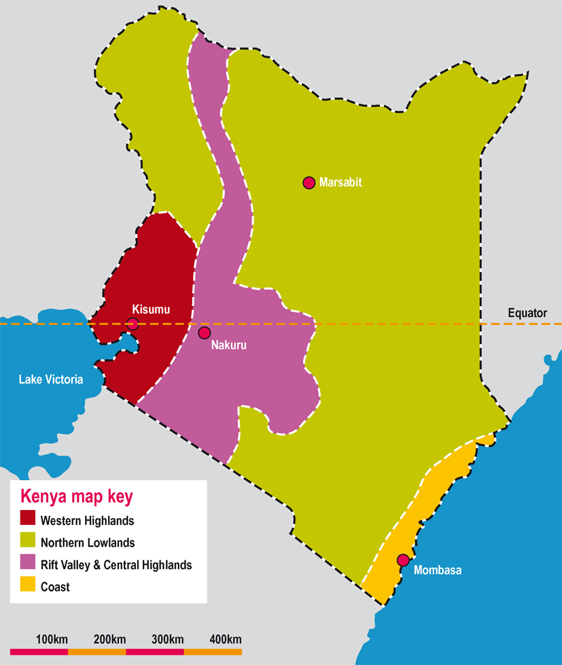
Kisumu is a city in the

-------------------------
The city of Mombasa is in the

---------------------------
Marsabit is a town in the

-------------------------
The town of Nakuru is in the

-------------------------

All these places are in Kenya, but their climates are different. Can you think of two places in our country that have different climates? Here’s a clue: Try thinking about altitude (this is how high a place is) or latitude (how far north or south of the equator a place is).

A challenge for bonus points!

