The Geological Timescale task
The Earth is about 4,600 million years old (or 4.6 billion years old). Dramatic changes in environment and climate have occurred throughout Earth’s long history; but we know more about changes that have occurred in more recent geological time than those that occurred in the more distant past. This is because geological processes eventually wear away and destroy old rock, which becomes replaced with new sediments and rock formations.
Go to the British Geological Survey website for an overview: http://www.bgs.ac.uk/discoveringGeology/time/home.html
To study different times in Earth’s history and the changes that occurred, scientists must have a common framework for talking about geological time – a Geological Timescale. This involves slicing up Earth’s history into a hierarchy of time intervals. The longest of these are Eons, and these are separated into different Eras. Eras are subdivided into Periods, which in turn are subdivided into Epochs.
Go to the British Geological Survey interactive Geological Timeline http://www.bgs.ac.uk/discoveringGeology/time/timeline/entertimeline.html and click ‘Enter’.
On this interactive, the 4,600 million year old Earth is compared with a 46 year old person for thinking about the relative times when different events have occurred in Earth’s history. Tip: hovering over each number gives general information which is enough for this task, but you can click on the numbers to open boxes that give further information.
- What was happening to the Earth in its first ‘year’? (A year here represents a 100 million years!) Tip: click through the ‘Next’ button until you can hover over ‘year 1’ of the circle.

- Hover over ‘years 6 & 7’ of the circle. How old are the oldest rocks still surviving on Earth’s surface? How long ago did the first living organisms appear?

- Click on ‘year 26’. How long ago did life first appear on land, and in what form?

- Go through ‘years 39 to 45’ and summarise how life was evolving over this time span in the space below. Notice how recent all of this is compared with the age of the Earth!

Now go to the Timechart part of the British Geological Survey website: http://www.bgs.ac.uk/discoveringGeology/time/timechart/home.html and start by clicking on the ‘Precambrian Timechart’. Notice the vertical ages in millions of years and the way this time line is divided into Eons, Eras, and Periods.
- What is the name of the earliest Eon? Do you know which god from Ancient Greek mythology this is named after?
- How many millions of years ago was the end of the Proterozoic Eon?

Now go back and then click on the ‘Phanerozoic Timechart’ (‘Phanerozoic’ means ‘evident life’ because from this point on, fossils become abundant and easily seen in rocks. The ‘zoic’ part in all of the names refers to ‘life’ – this word comes from Ancient Greek, as does our word ‘zoo’.)
- Complete this summary diagram by writing in the names of the three Eras of the Phanerozoic Eon, and then write in the names of the three Periods in the most recent Era.
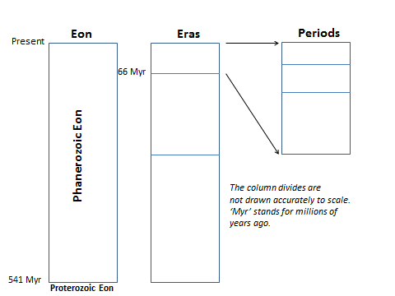
Also label in the ‘Myr ago’ numbers for the horizontal lines where it’s not shown already.
- Go to the BBC website http://www.bbc.co.uk/nature/history_of_the_earth and click ‘Magnify the last 600 million years’ and study this time line (also magnify the last 250 million years). On the sides of the diagram above, add brief notes about changes in life that have occurred. For example, note down when dinosaurs first appeared (they went extinct 66 million years ago). Notice how recent our early human ancestors are. Where it says ‘End of the Last Ice Age’, this really means the end of the last ‘glacial’ phase (which peaked with the Last Glacial Maximum) and the start of our present warm ‘interglacial’ phase.

