Resilience and Vulnerability in Climate Change and Farming
Meet Jinela Pineda
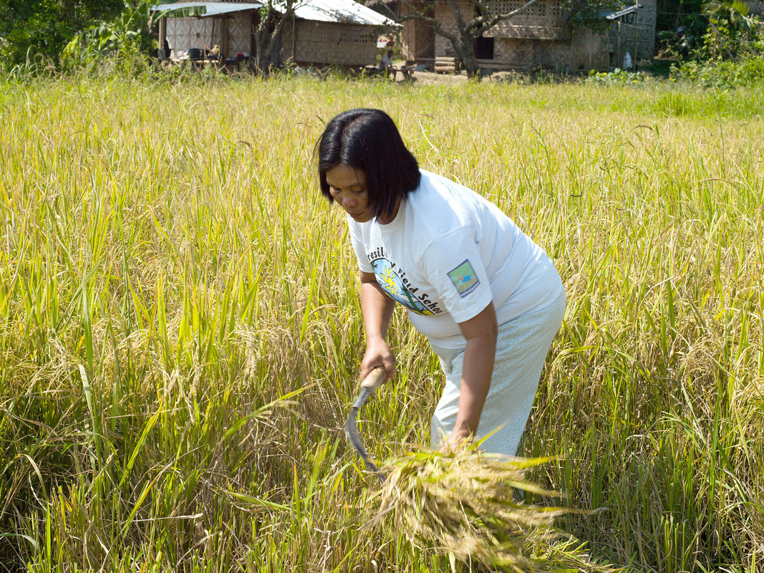

Jinela Pineda in her rice field © Tessa Bunney, Oxfam

Jinela Pineda is 50 years old. She lives with her husband and four of her eight children in central Mindanao.

“I have planted an eighth of a hectare of my land using System of Rice Intensification (SRI) and the rest using conventional farming practices. I harvested my fields yesterday and got just 30 sacks of rice. I should have harvested 100. The SRI planted rice gave me five sacks, which is much better than the rest of my land. Although I am disappointed I didn’t harvest more altogether I am very pleased with how the SRI trial went. Next time I plant I will use SRI on all of my land.
I have been a member of the local farmers’ group for six years and am currently the leader of the group. I like being the leader and being in the group gives me opportunities to earn money in other ways, which supplement my income”.
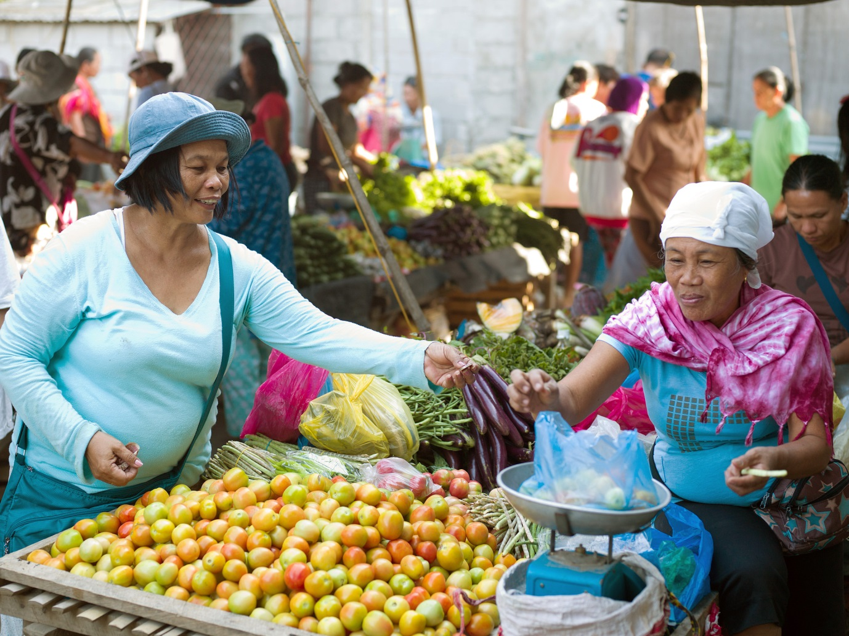
Jinela pineda at the local market © Tessa Bunney, Oxfam

“December to January is supposed to be a rainy season for planting rice but now we are seeing that instead of rain we have a drought in these months. There has been no rain again this year. I just harvested my rice and it’s partially failed because we haven’t had any rain. This means we will have much less money”

“I learned about alternative livelihoods at the field school and I have discussed this with the farmers’ group and told them not to keep depending on the rice farming for their only income. I told them they should look to other things like gardening and keeping livestock. I told them: I am the only one growing vegetables so I am selling them all to you but you could grow them too. I told them not to depend on buying things from me as they are already in debt, they should grow their own”.
“I have eight children and I plan to put them all through college. Three have already been to college and one has a very good job in Manila now. She is working in IT and is earning her own money, which is great”.
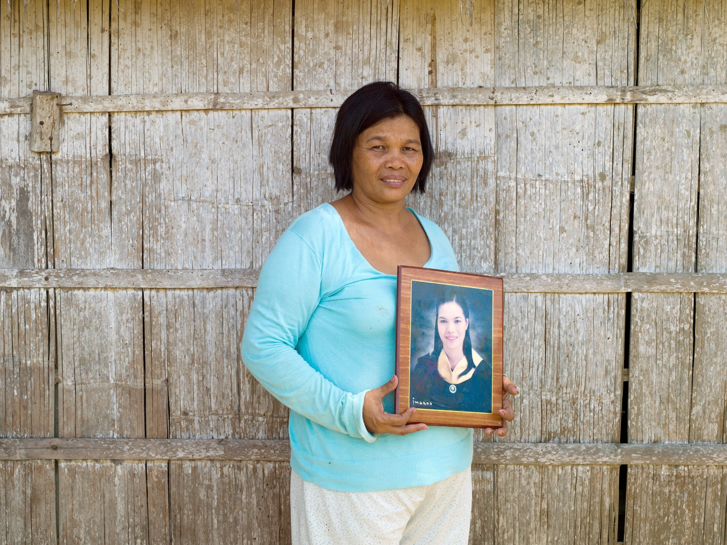
Jinela holds a photograph of her daughter’s graduation © Tessa Bunney, Oxfam

“I am very proud of what I have achieved and how I have managed to send my children to school and college. People here are turning to loans to survive because they don’t earn enough income from the rice. They have to use the money for just the basic things in life like food and school. The interest is 20% so they get themselves into a bad cycle. Nearly everyone here is in bad debt”.

“People who have taken loans have to work so much more to pay them back and then aren’t at home enough to make sure their children get through school. Families here need support from the government”.
“I have also started micro lending to support my shop. I give the farmers good rates and make it easier for them to pay it back but still it would be better for them if they didn’t have to take a loan at all. I think the answer is that people should get involved in other livelihoods like me, things like rearing pigs and other animals and growing vegetables.”

