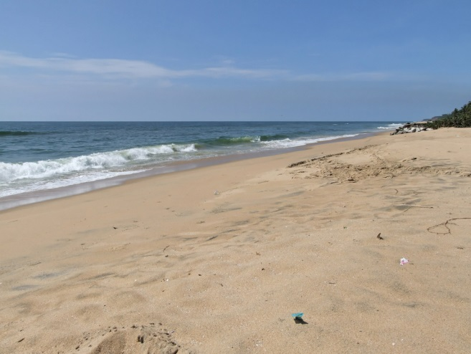
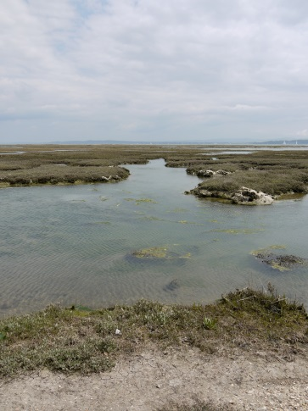
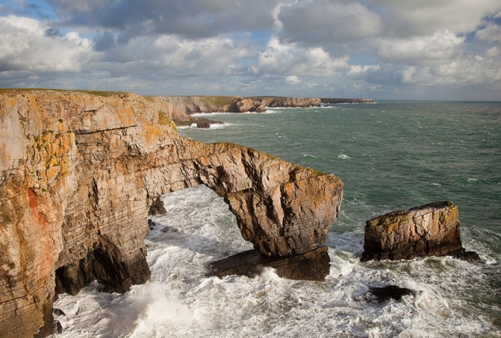
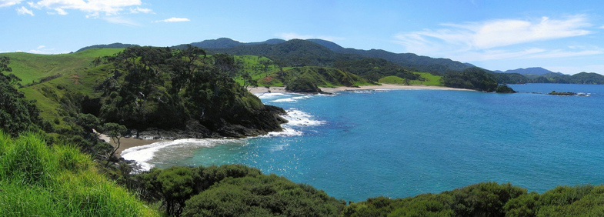
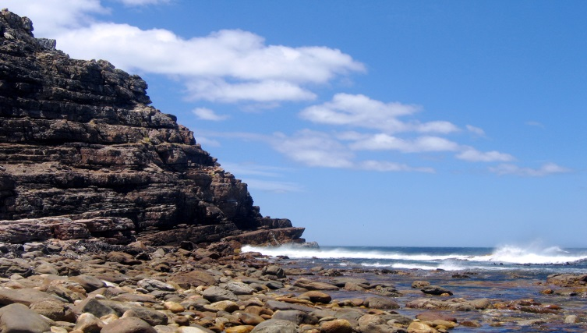
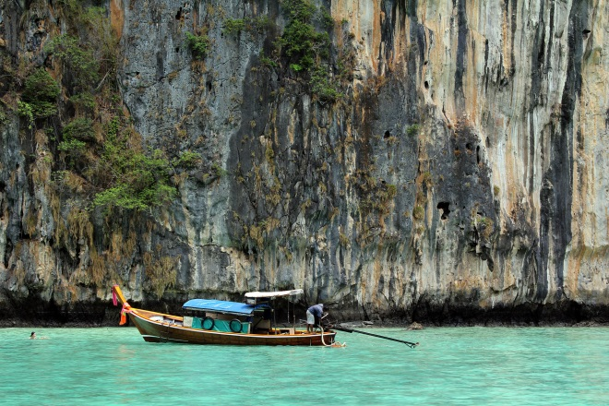
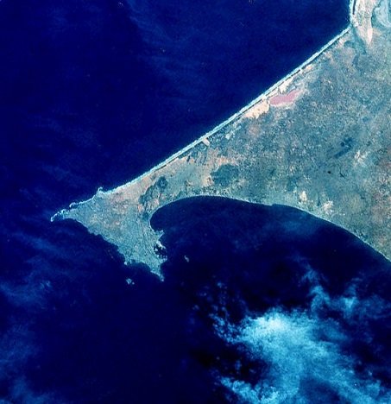
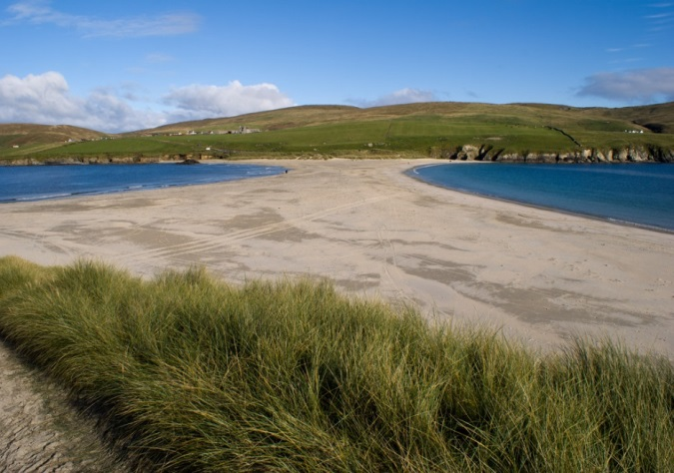
9. Cap-Vert, Senegal

St Ninian’s, Shetland, Scotland

2. Kerela, India

3. Keyhaven Nature Reserve, UK

4. The Green Bridge of Wales, Pembrokeshire

Coastal features

© Tristan Ferne

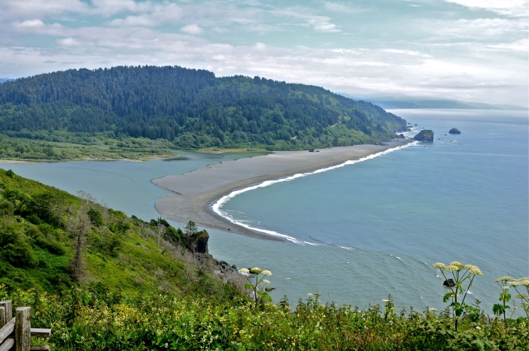
8. Klamath River Mouth, America
5. Elliot Bay, New Zealand

6. Cape of Good Hope, South Africa

7. Phi Phi Island, Krabi, Thailand

© Linda Tanner
© Linda Tanner

