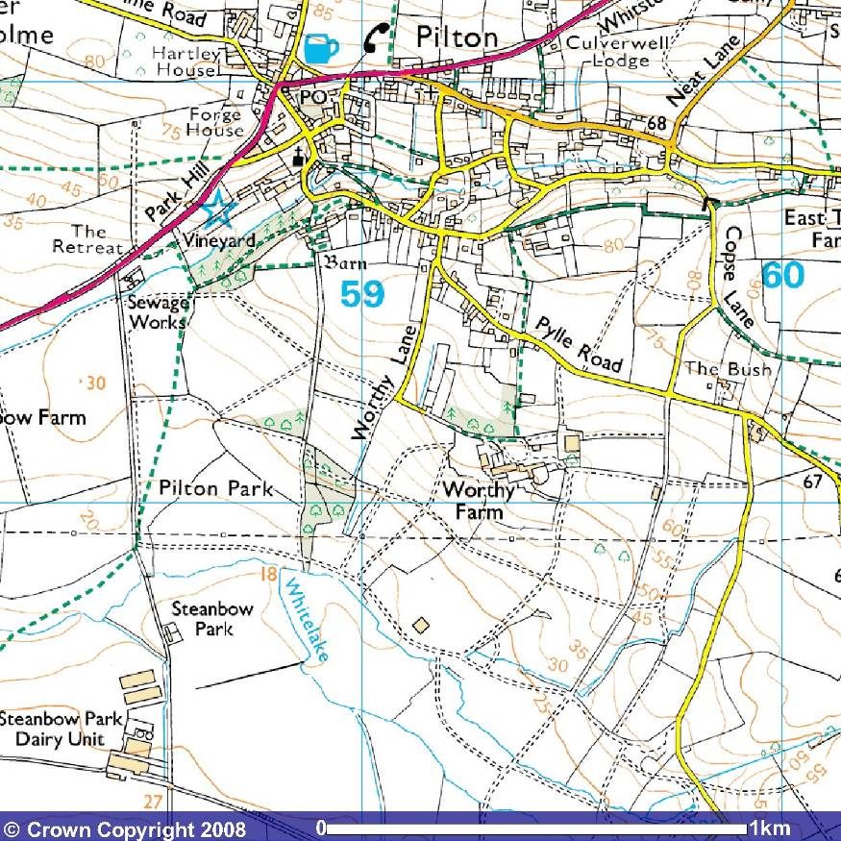
1
Glastonbury Festival
(Worthy Farm, BA4 4BY)

Flood Risk Report

________________________________________________________________________________________________________________________________________________
________________________
V Festival
(Hylands Park, CM2 8WQ)

Flood Risk Report

________________________________________________________________________________________________________________________________________________
________________________
Flood Alert!
What is the flood risk at each of these festivals?

2
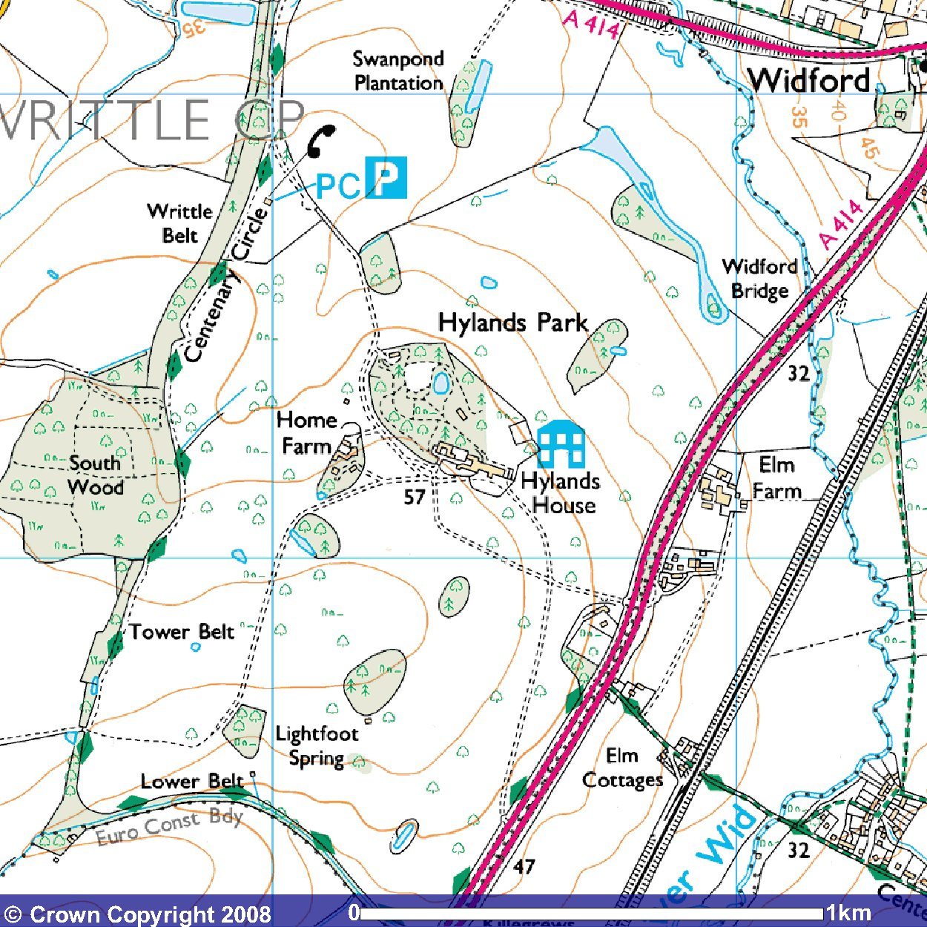

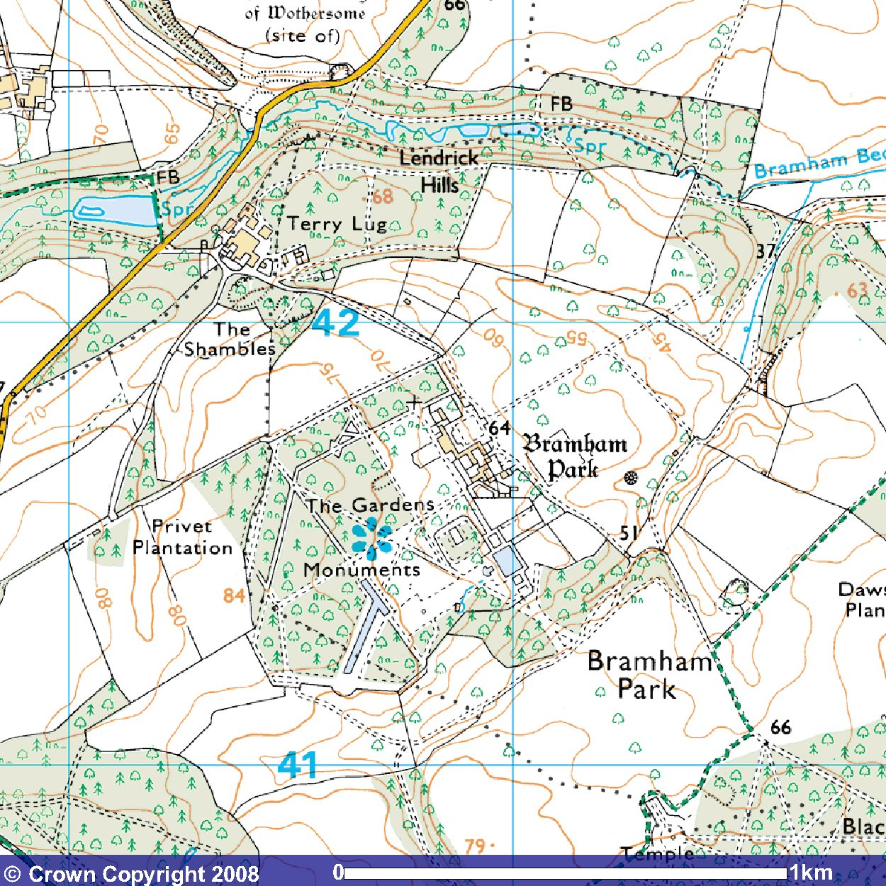
3
Leeds Festival
(Hylands Park, LS23 6ND)

Flood Risk Report

________________________________________________________________________________________________________________________________________________
________________________
Leeds Festival
(Bramham Park, LS23 6ND)

Flood Risk Report

________________________________________________________________________________________________________________________________________________
________________________

4
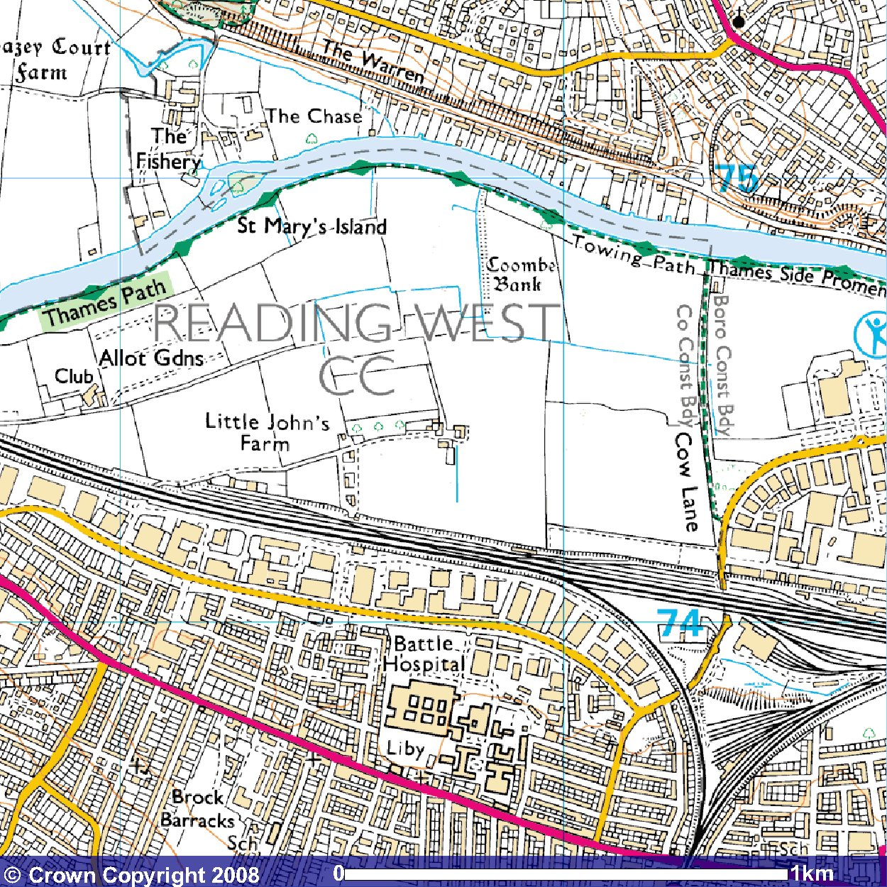
Reading Festival
(Little John’s Farm, RG1 8EQ)

Flood Risk Report

________________________________________________________________________________________________________________________________________________
________________________

5
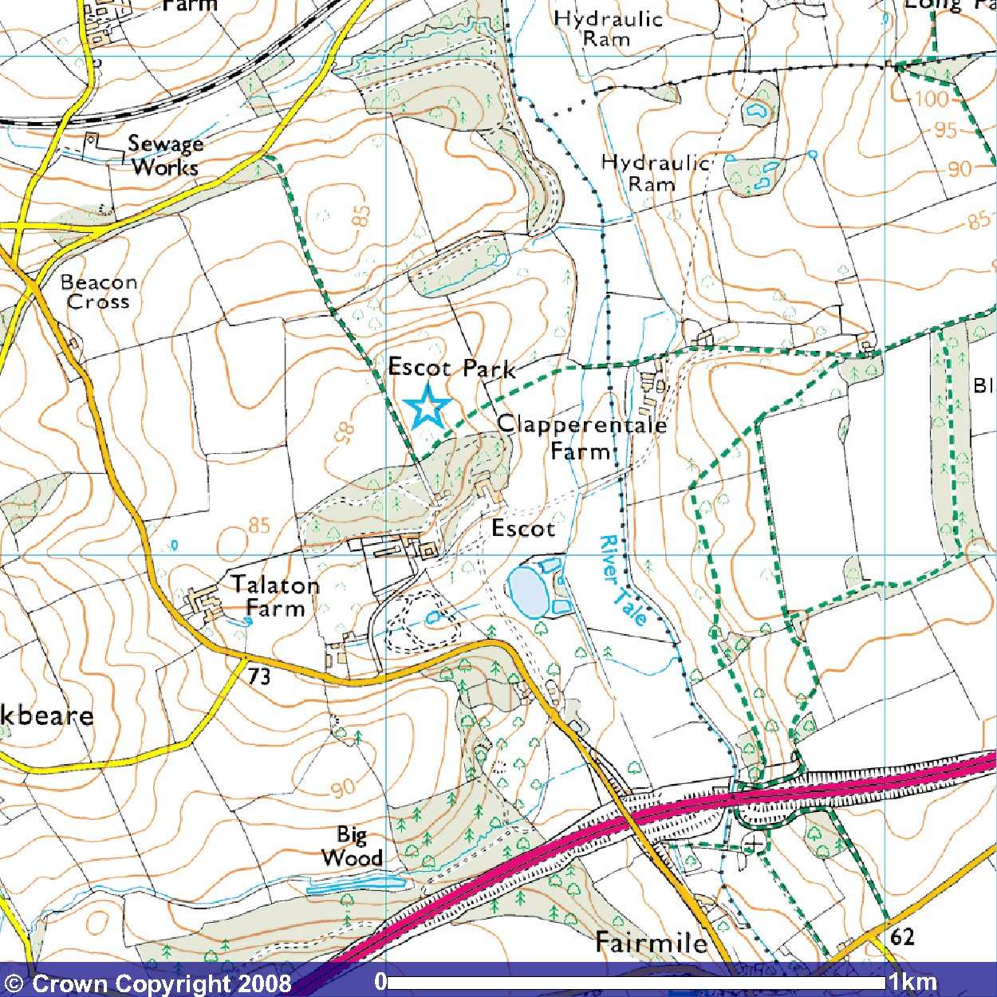
Beautiful Days Festival
(Escot Park, EX11 1LU)

Flood Risk Report

________________________________________________________________________________________________________________________________________________
________________________

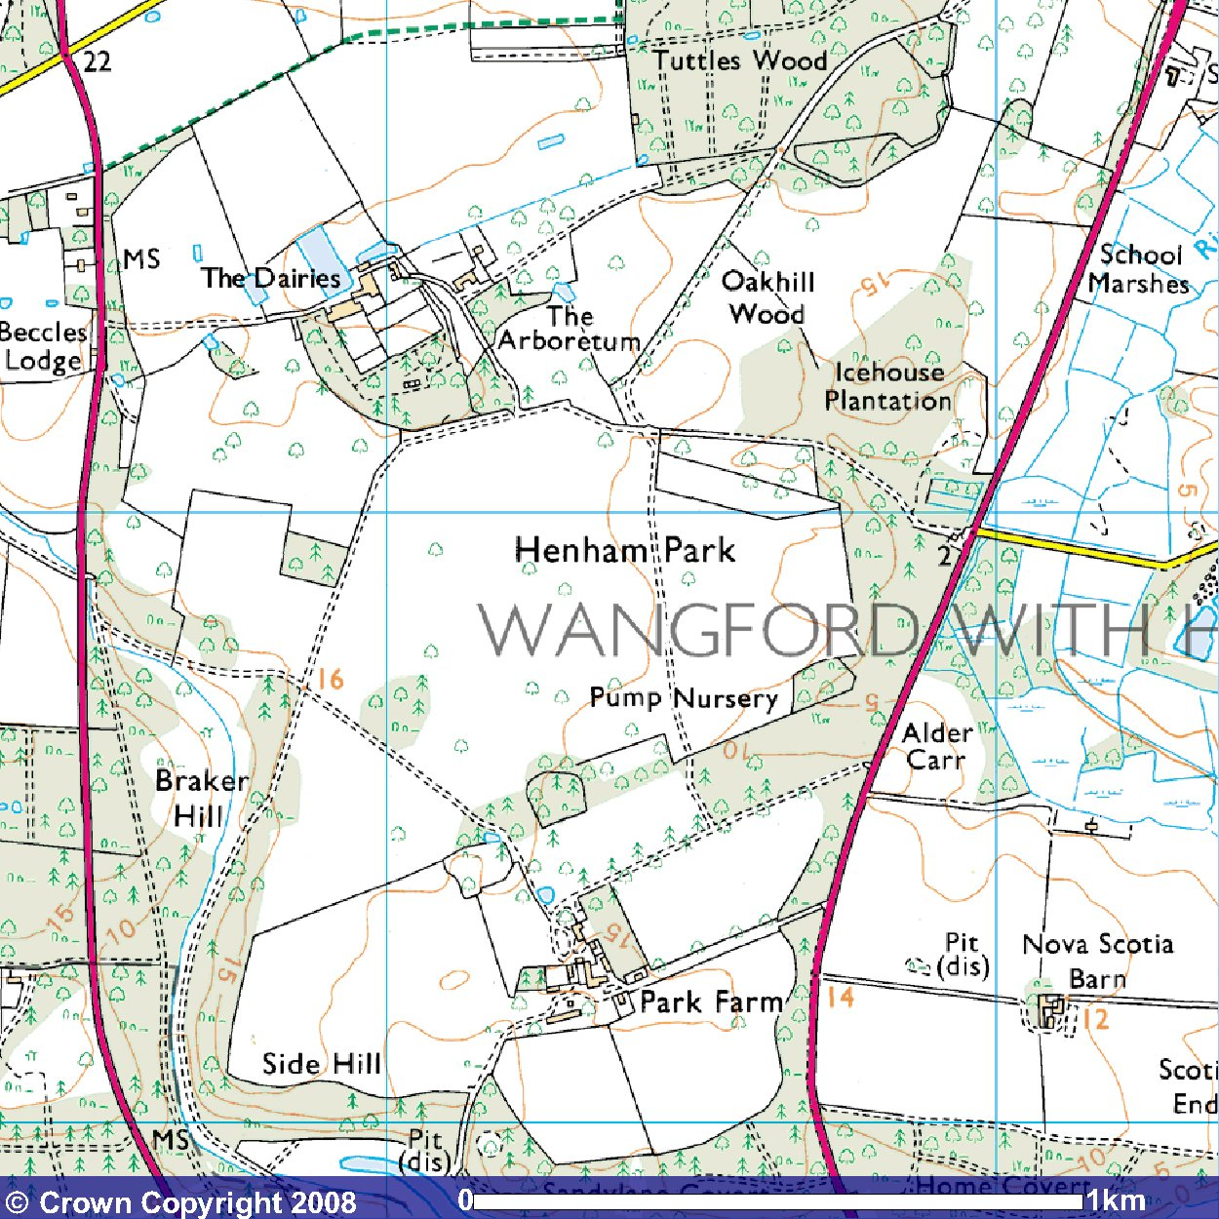
6
Latitude Festival
(Henham Park, NR34 8AN)

Flood Risk Report

________________________________________________________________________________________________________________________________________________
________________________
Images produced from the Ordnance Survey Get-a-Map service and reproduced with kind permission of Ordnance Survey and Ordnance Survey of Northern Ireland.



