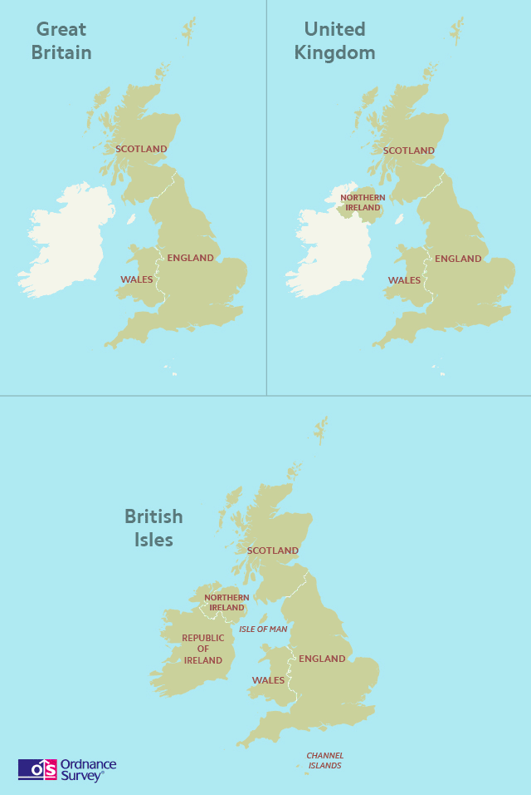
Lesson three: Great Britain, United Kingdom, or the British Isles?

