Abdullah Susi
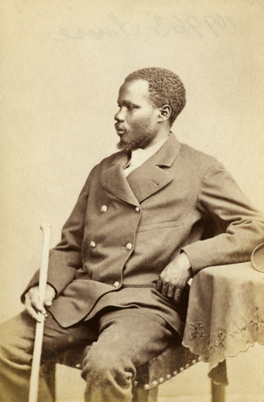Abdullah Susi IN 1874
Maull & Co. © Royal Geographical Society
1863 - 1864 | Worked on the Zambezi River in Shupanga in present-day Mozambique. Joined Livingstone’s expedition in 1863 as a wood-cutter. Sailed to India with David Livingstone on HMS Lady Nyassa.
1865 | Lived at Dr Wilson’s school in Bombay, India. It was here that he met James Chuma.
August 1865 | Susi and Chuma accompanied David Livingstone to Zanzibar.
1866 - 1873 | Travelled with Livingstone on his last journeys in East Africa and after his death helped to carry Livingstone’s body to the East African coast in 1873.
1874 | Susi arrived in England after David Livingstone’s funeral in Westminster Abbey. He visited Livingstone’s family and his account of Livingstone’s final days was compiled by Horace Waller.
June 1874 | Attended the Royal Geographical Society in London with James Chuma to receive medals for their work on expeditions in Africa.
October 1874 | Returned to Africa from England, worked for Universities Mission to Central Africa (UMCA) and the Church Missionary Society (CMS).
1879 - 1882 | Travelled with Henry Morton Stanley in expeditions on the Congo River. He was in charge of building a trading station at Leopoldville which later became Kinshasha, the capital of the Democratic Republic of Congo.
1883 - 1891 | Caravan leader for the Universities Mission to Central Africa (UMCA). In 1886 he was baptised, taking the name David.
5 May 1891 | Died in Zanzibar.

