Learning from the past: Changing the future
By comparing the two earthquakes of Tangshan (1976) and Sichuan (2008) you can see that there have been huge improvements in preparing and dealing with earthquakes in China.

However, thousands of people died in the Sichuan earthquake meaning that there are still further improvements that can be made to ensure further loss of life is prevented if an earthquake happens again in the region.
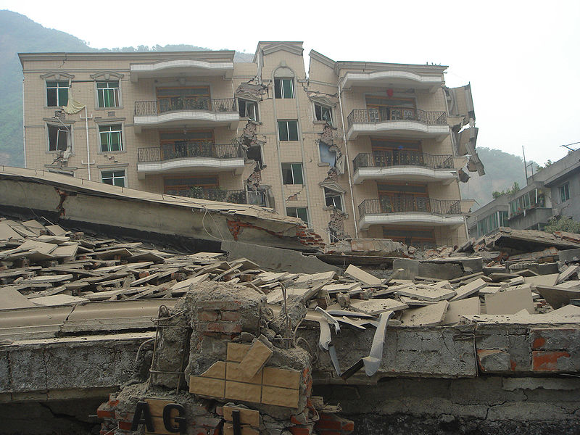

Earthquake task force
You work as part of the Chinese Earthquake Task Force (a group of geographers, geologists and scientists) and your job is to make recommendations of how to prevent loss of life due to earthquakes in the future. Read the email below and then write a response using your Venn diagram and any of the other resources used during this lesson.

From: | Jian Qin (jianqin@chinesegov.ch)
Sent: | 06 October 2009 18:40:21
To: | members@earthquaketaskforce.co.uk
To Task Force Members,

In 2008, China suffered a devastating earthquake in Sichuan Province which killed 70,000 people. We will suffer earthquakes again in the future as China is located in a tectonically active area. However, in the future we want to make sure that if an earthquake hits China, far fewer people are affected in this way. As part of the Earthquake Task Force, we need you to come up with some ideas/recommendations to make sure improvements are made. Please write an email response with your ideas. Please include:

- Ways to prevent buildings from falling down
- Ways to prevent accidents inside and outside buildings
- Ways to prevent bridges collapsing
- Ways to enforce any new regulations you suggest
- Ways to ensure the relief effort is swift and roads are not blocked
- Any other ideas to ensure a reduction in lives lost.

Please write an email with your suggestions ensuring that you outline your recommendations thoroughly.

I look forward to receiving your recommendations,
Jian Qin.



Image from Wikimedia Commons and licensed for use under Creative Commons License.

