Energy Teacher Factfile
Energy is an everyday need. Demand for energy has grown sharply in recent decades due to our increasing use of household appliances and personal electronics which require electricity to run. Many houses are packed with gadgets. We also use fossil fuels to power the one billion cars on the planet, and the industries that provide our jobs.
Energy is produced in different ways. Most students will be familiar with a secondary source: electricity. This can be produced using renewable or non-renewable sources. The balance of these is changing in response to rising energy prices, and EU targets on reductions of carbon emissions.
Energy is linked to a number of themes which are common to GCSE specifications.
These include:
Energy developments including planned windfarms, open-cast coal mining etc. have social, economic and environmental impacts (use the acronym SEE… can you ‘SEE’ the impacts)
Changing energy demand in response to our changing lifestyles, and how this is affected by globalisation.
Impact of changing energy balance e.g. coal mine closures and impact on community and need for regeneration of these areas - investment in regions
Climate change: link between use of fossil fuels and the changing nature of the atmosphere
Fuelwood: the clink between forests which are cut down for fuel, deforestation and possible flooding further down river e.g. on the slopes of the Himalayas
Energy efficiency in buildings as part of the sustainability agenda. This would include an examination of some of the developments in Dubai, such as Ski Dubai, and also the plans for stadia for the World Cup in 2022 in Qatar (a very long term project for geographers to follow as it develops)
Sustainability is a concept that is included in most of the specifications. This is about living today in such a way that we can continue to live in the future in the same way. If resources are depleted too quickly, or the environment is damaged by our actions this is not possible.

Ralitsa explored energy in a number of countries during her research. Students should be able to locate Bulgaria, and some of the locations mentioned during the lesson sequence.
The location of particular types of power station could be discussed e.g. nuclear power stations and their siting relative to areas of high population density.

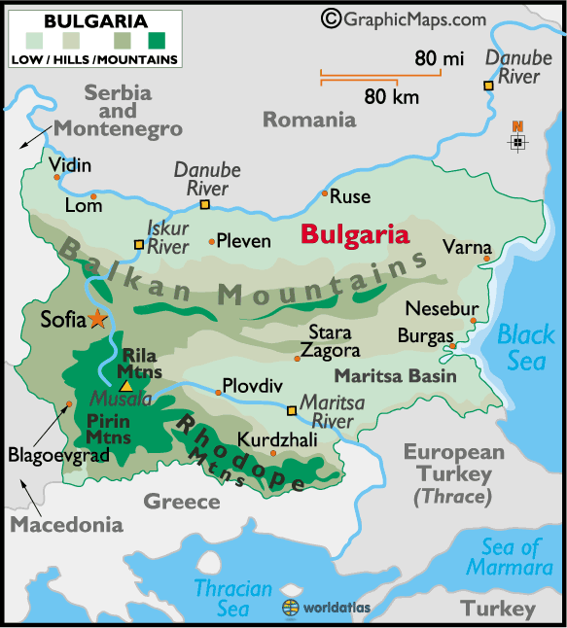
Extra resources:
For an additional resource relating to Bulgaria, which focuses on tourism, visit the KS3 Resources section of the Geography Teaching Today website
http://www.geographyteachingtoday.org.uk/ks3-resources/resource/geography-the-language-of-europe/turisam-v-bulgaria-tourism-in-bulgaria/
For a further look at energy, the Geographical Association’s new Top Spec book: ‘Energy: a burning question”
Available to buy from the GA shop
http://www.geography.org.uk/shop/shop_detail.asp?ID=698&section=4

