James Chuma
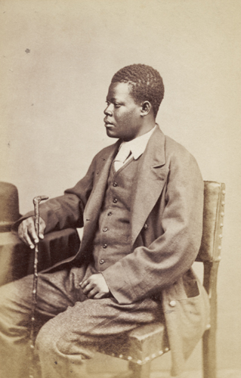James Chuma in 1874
Maull & Co.
© Royal Geographical Society

1861 | When aged about 11, he was released from slavery by David Livingstone and worked for the Universities Mission to Central Africa (UMCA) until 1864. The UMCA was a church society which sent British missionaries to Africa.
1864 | He travelled to India with Livingstone and other freed Africans on HMS Lady Nyassa.
1864 - 1865 | He lived at Dr Wilson’s school in Bombay, India. It was here that he met Abdullah Susi.
August 1865 | Susi and Chuma accompanied David Livingstone to Zanzibar.
1866 - 1873 | Travelled with Livingstone on his last journeys in East Africa and after his death helped to carry Livingstone’s body to the East African coast in 1873.
1874 | Chuma arrived in England after David Livingstone’s funeral in Westminster Abbey. He visited Livingstone’s family and his account of Livingstone’s final days was compiled by Horace Waller.
June 1874 | Attended the Royal Geographical Society in London with Abdullah Susi, to receive medals for their work on expeditions in Africa.
October 1874 | Returned to Africa, worked for the Universities’ Mission to Central Africa in Zanzibar.
1879 | Was selected to be caravan leader on expeditions from 1879 to 1880. A caravan leader was responsible for organising all of the people who made up the expedition party, including cooks, porters, guides, soldiers, interpreters and gun bearers.
1882 | Died in Zanzibar of tuberculosis at the age of 32.

