
Africa – a continent of contrasts
Lesson 6: Education in Ghana – moving forward

Ghana Stories - My typical school day

Ama

I normally wake up early in the morning, around 4.00am, so I can study a bit and do my household chores quickly so that I shouldn’t be late to school.

Before I get out of bed, I say my morning prayers. I sweep the house and it’s surroundings. I prepare my breakfast quickly, eat, then wash. I then wash my younger sister, dress her and take her to school. After taking her to school, I come back to put on my school uniform and leave for school. I always reach school around 6.30am. As soon as I reach school, I sweep my classroom – my normal task.

We go to first assembly at 7.00am to check the roll. The second assembly is at 7.15am where they give us important announcements. Our first lesson starts at 7.30am, and lasts for 80 minutes. We have five lessons each day. We go for break at 10.10am and return to our classrooms at 10.40am. During that time, I chat with my friends about what we were taught.

When we finish, I don't go straight home. I stay for private classes with one of our teachers. When I go home it's about 3.30pm. I have my lunch then go for water for the house. After that, I help my mother to prepare food for our supper.

After supper, I do my homework. My day ends at 10.00pm when I go to bed. I go to bed early because I have to wake up as early as 4 o’clock the following morning.
…………………………………………………………………………………………………………………………………………………..

Jacob

I always wake up at 4.00am. I say my morning prayers and wash my face and also brush my teeth. I then fetch three buckets of water from a borehole not far from my house. At 4.40am, I sharpen my cutlass and go to work in my backyard garden. I work for an hour then come back to the house to wash.
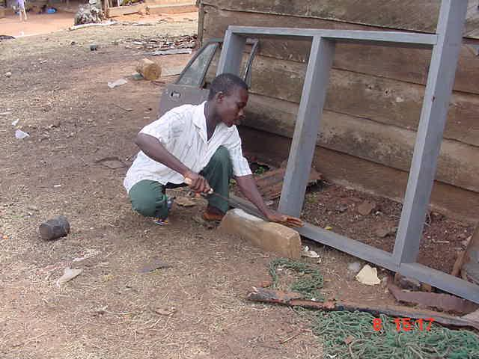
After washing, I pound the left over boiled cassava into fufu and eat it for breakfast. I put on my school uniform and set off to school at about 6.30am. I walk for about two miles to school.

We stay in the school for 6 hours and 45 minutes for our studies. I quickly run home immediately after school, where I eat then rest for 15 minutes. Afterwards I sharpen my cutlass again and at 3.30, I go to the farm and weed for two hours. After that I go home to wash plates and bowls for my grandmother whilst she prepares the meal. Jacob sharpening his cutlass

After washing the plates and bowls, I pound fufu again and we eat this with palm nut soup prepared by my grandmother for our supper. I wash again after eating. At 7.30pm I study for two hours then I go to bed, but before then I say my evening prayers and have a sound sleep. I go to bed early because I have to wake up early and do my house chores before coming to school.

Kwabena

On Wednesdays, I wake up early - between 3.30-4.00am - because I usually have a lot of work to be done before going to school.

Immediately I get up, I wash my face and brush my teeth and then go for water from a borehole. it takes me about one and a half hours to fetch just two buckets of water because water is difficult to come by in Asesewa. After this I sweep our compound, wash the kitchen utensils and then wash. At 6.30am, after breakfast, I set of for the school. Since my house is not far from the school, it takes me 5 minutes to get there.

In school, I help my colleagues to tidy up the compound until 7.00am. At 7.30 a bell assembles the students for worship. Students and teachers collectively praise and thank God through prayers and songs.

On my way home after school, I talk to my friends. As soon as I get home I go into the kitchen to have lunch. After that, I go to the borehole to struggle for some water.

At 4.15, I go out to play football with friends. I come back around 5.15 when my parents are home. At 6.30 I have my supper and get ready for studying. After that I watch television or a video till 10.30pm when I go to bed.

…………………………………………………………………………………………………………………………………………………..

Martha

My typical school day, Monday, starts as early as 4.30am, the time I get up. Waking up early provides me with ample time to execute my numerous household responsibilities, which include: sweeping the house and fetching four buckets of water from a well about 400m away from my house.

I finish around 6.30am, warm water and wash, then have a cocoa drink as breakfast. I put on my school uniform (which I ironed the previous night) and leave for school. Form 3 girls put on short sleeves with khaki skirts to match, whereas Forms 1 and 2 girls wear long simple dresses. Also, Form 3 boys wear trousers but their juniors wear shorts.

It takes me 15-20 minutes to walk to school. I usually get to campus around 7.00am. Because I’m a final year student I don’t go for roll calls but head straight to my classroom where I chat for about 10 minutes with my friends.
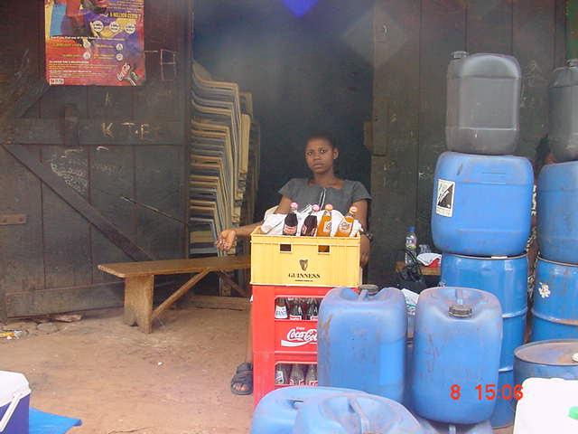
During break, my friends and I buy and eat kenkey (boiled corn dough) and fried fish. I’m studying four core subjects (English, Mathematics, Integrated Science and Social Studies) and four electives (Economics, Geography, French and Dangme - the main language in Asesewa).

After school on Mondays I stay behind for an extra hour of English Language. By the time I get home, it's about 400pm. I change and go straight to our soft drink shop to sell till about 6.30pm, when my supper is brought to me at the shop. Martha selling soft drinks

About 7.30, my mother comes to relieve me, so I can go home to do school assignments and to watch television for a while before going to bed at 10.00pm. I end my day early to enable me have enough rest and to wake up early the next day.

Narki
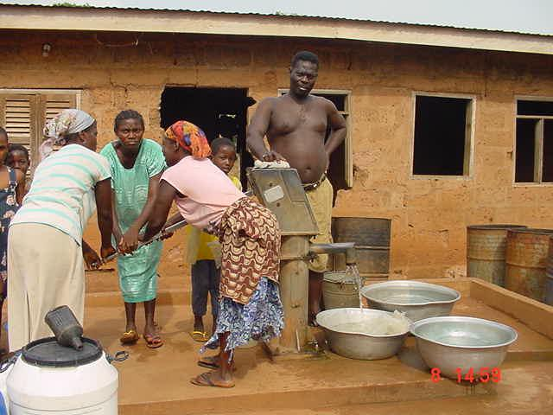
Normally, I wake up at 4am so I have time to do my work and prepare for school. I study for 30 minutes. I go to the borehole twice for water, which is 30-minute walk from my house.

I then sweep the house and take the rubbish to a nearby refuse dump. I make breakfast for my family. I wash and dress. Around 6.30am I eat breakfast and leave for school. It takes me about 30 minutes to get to school by foot since we have no school bus.

Collecting water from the borehole

At roll call, students not present do not get numbers - they are identified and punished later in the day. A bell is rung to signify the end of classes.

After school, I wait for my friends and walk home with them, since they also don’t wait on campus after school. On Thursdays, though, we have computer class at 2.15pm so we go home at 4.00pm.

At home, I do my homework and go for water twice more. Sometimes, I fetch water for my aunt who is 40 minutes away from us. I then prepare supper for the family. Before 6.00pm I finish preparing it and enjoy eating it with my family. I wash the cooking utensils and pack them in the kitchen cupboard. After that I wash. By 7.00pm I am ready to read over notes given at school.

I study for two hours and watch television for an hour, especially on Tuesdays. My day ends at 10.10pm because I have to get up early the next day and go to school as well.

…………………………………………………………………………………………………………………………………………………….

A typical school timetable:
Periods/ Days | 1 | 2 | 3 | 4 |  | 5 | 6 | 7 |  | 8 | 9
Monday | Economics |  | Mathematics |  | B  R  E  A  K | English |  | Geography | BREAK | Dangme
Tuesday | Social Studies |  | Geography |  | B  R  E  A  K | French |  | - | BREAK | Dangme
Wednesday | Worship |  | French |  | B  R  E  A  K | English |  | Social Studies | BREAK | Integrated Science
Thursday | Dangme |  | English |  | B  R  E  A  K | Economics |  | Mathematics | BREAK | Geography
Friday | Economics |  | French |  | B  R  E  A  K | Mathematics |  | Integrated Science | BREAK

Dangme is a local Ghanaian language
……………………………………………………………………………………………………………………………………………………

Rahseda

I wake up sometimes at 4.00am. The moment I wake up, I sweep the house and wash the cooking utensils. After that I go to the well or the borehole to fetch water. I go about three times before it is 5.00am. The well and borehole are our main source of water, as well as rainwater. In the dry season water is scarce at Asesewa.

When water is scarce, I don’t get enough time to study, so I wash and go to school at 6.00am. Before I go to school, I make sure that I wash my little sisters and brothers before I leave the house. At 6.30am I’m already at school, where I greet friends then sweep our classroom.

We clean litter from the compound before 7.15am - second assembly. At break, I eat with my friends at the canteen and then I chat with my friends.

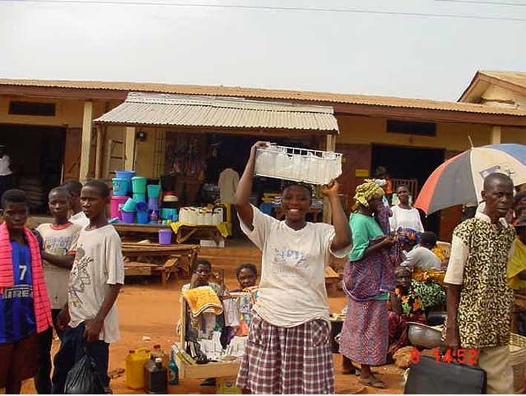
After school I eat lunch then go to the well to fetch water again. Then I make dinner for my family.

Fridays and Mondays are market days - on these days after school I go to the market and sell kenkey. Sometimes I sell ice. I normally come home around 9.30-10.00pm on market days.

I study for about two hours before I go to bed at 10pm (apart from Fridays and Mondays). We don’t have a television to entertain ourselves so I wash and go to bed. I go to bed early because I want to get up early.
Rahseda selling ice after school at the market

…………………………………………………………………………………………………………………………………………………….

Another typical school timetable:

 | 7.30-8.50 | 8.50-10.10 | 10.10-10.40 | 10.40-12.00 | 12.00-12.40 | 12.40-12.55 | 12.55-2.15
Mon | English | French | BREAK | Dangme | Dangme | BREAK | Maths
Tues | Dangme | Economics | BREAK | Integrate science | Maths | BREAK | French
Weds | Worship | Integrated science | BREAK | Geography | French | BREAK | Maths
Thurs | Economics | Geography | BREAK | French | - | BREAK | Social studies
Fri | English | Economics | BREAK | Geography | Dangme | BREAK | Games

………………………………………………………………………………………………………………………………………………….

All student stories sourced from the Plan-UK website with permission.



