Ghana Education Reform 2007

Key points of the new education system:

1. Universal Basic Education shall now be 11 years, made up of:

2 years of Kindergarten
6 years of Primary School
3 years of Junior High School (JHS)

2. The medium of instruction in Kindergarten and Lower Primary will be a Ghanaian language and English.

3. At the basic level, emphasis shall be on Literacy, Numeracy, Creative Arts and Problem Solving Skills.

4. After JHS, students may choose to go into different streams at Senior High School (SHS), comprising General Education and Technical, Vocational and Agricultural and Training (TVET) or enter into an apprenticeship scheme with some support from the Government.

5. A new 4-year SHS will offer General Education with electives in General, Business, Technical, Vocational and Agriculture options for entry into a tertiary institution or the job market.

6. Technical, Vocational and Agricultural Institutions will offer 4-year courses including the core SHS subjects.

7. Teacher Training Colleges will be upgraded and conditions of service of teachers improved, with special incentives for teachers in rural areas.

8. Metropolitan, Municipal and District Assemblies (MMDAs) shall be responsible for the infrastructure, supervision and monitoring of Basic and Senior High Schools.

9. A new National Inspectorate Board (NIB) outside the Ghana Education Service (GES) but under the Ministry of Education, Science and Sports (MOESS) shall be responsible for periodic inspection of Basic and Secondary Schools to ensure quality education.

10. Free Compulsory Universal Basic Education (FCUBE) and cost-sharing at the Senior high and tertiary levels shall be maintained.

11. Educational services will be widened to include Library and Information, Guidance and Counselling and Distance Education.

12. The Private Sector will be encouraged to increase its participation in the provision of educational services.

13. Greater emphasis will be put on Information and Communication Technology (ICT) and Science and Technology.

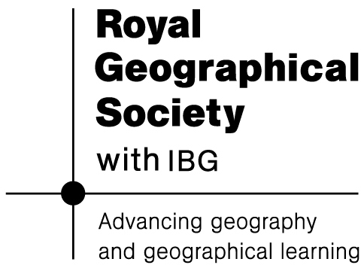

14. Special Needs Education will be improved at all levels.

