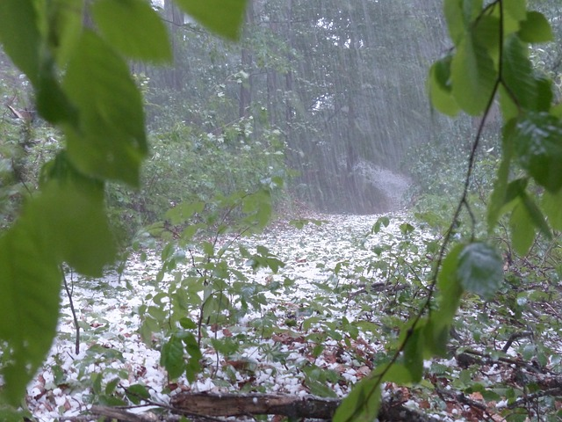  A hail storm damages your corn crop.  Lose 10 beans | 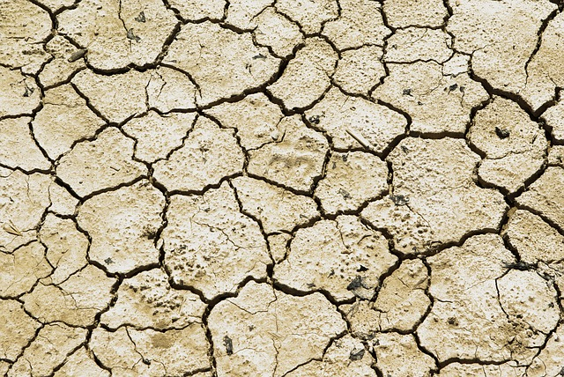  Drought leads to a poor crop yield.  Lose 10 beans | 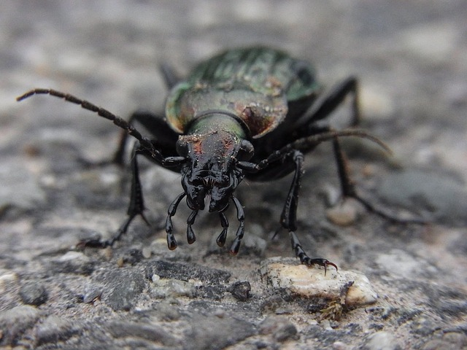  Beetles attack your crops.  Lose 15 beans
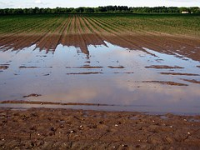  A flood damages all of your crops/kills livestock.  Lose half of your beans | 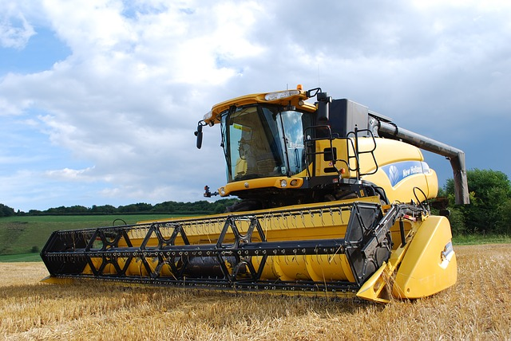  Demand for crops for industrial purposes leads to more profit.  Gain 10 beans | 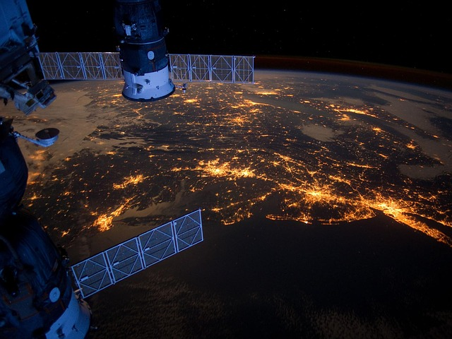  Access to satellite imagery helps you monitor your land more effectively.  Gain 5 beans
  Government provide subsidies for growing crop.  Gain 20 beans |   Competition from China pushes the price of rice down.  Lose 10 beans | 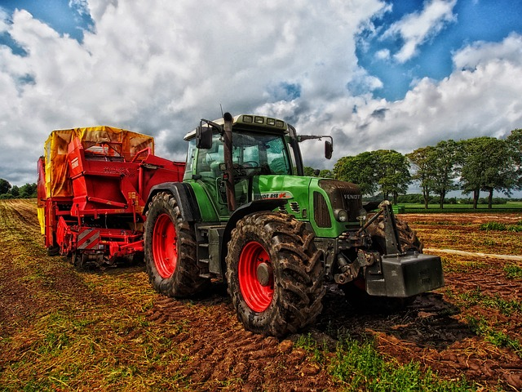  You can’t find enough workers to operate your new tractors.  Lose 5 beans.
  New more efficient tractors allow faster harvesting of crops.  Gain 5 beans. | 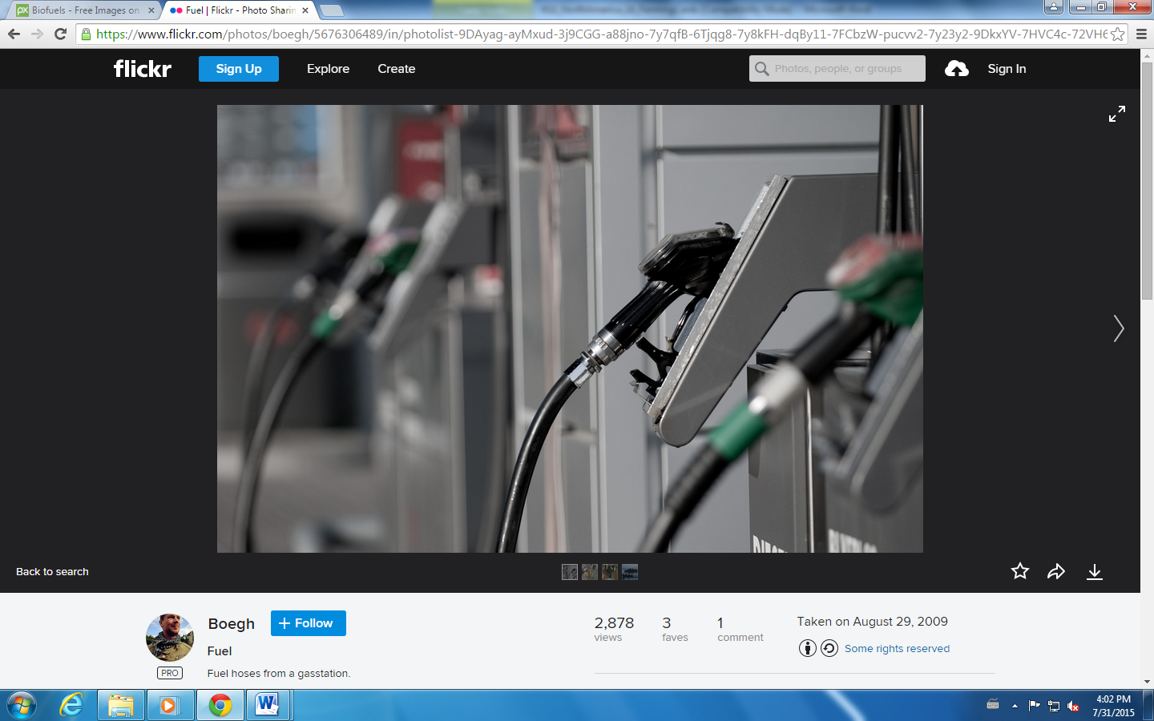  Demand for biofuels means greater demand for your crop.  Gain 10 beans | 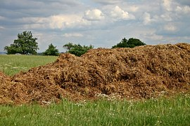  The cost of fertilisers has increased.  Lose 3 beans
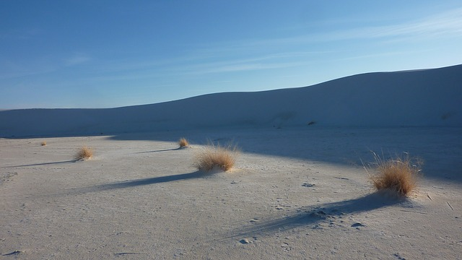  You experience drought.  Lose half your beans | 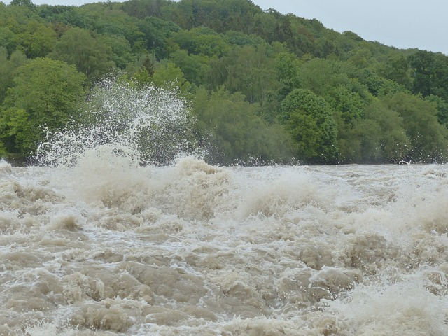  A nearby river floods and contaminates your soil. You lose most of your crop.  Lose 20 beans | 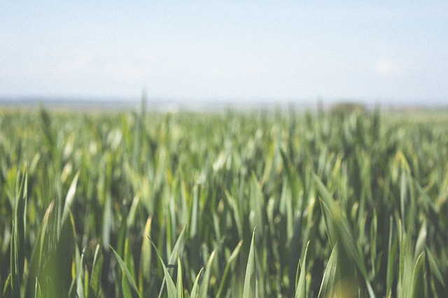  New hybrid varieties of crop lead to greater yields.  Gain 10 beans
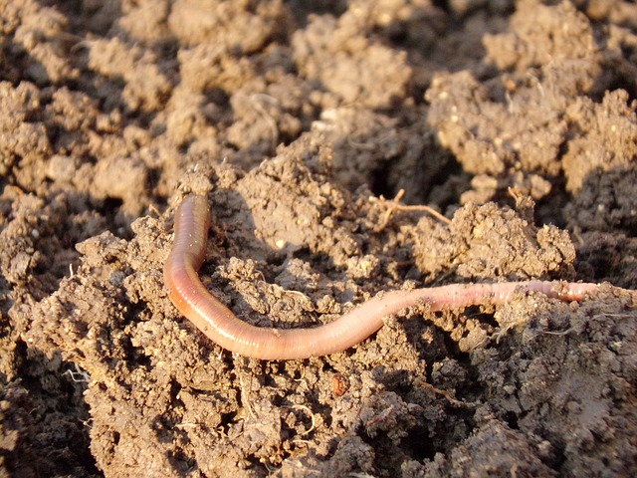  Access to soil sensing technologies allows you to monitor your soils effectively and plant crops at the right time which leads to increased yields.  Gain 10 beans |   Market prices for your crops are up.  Gain 15 beans. | 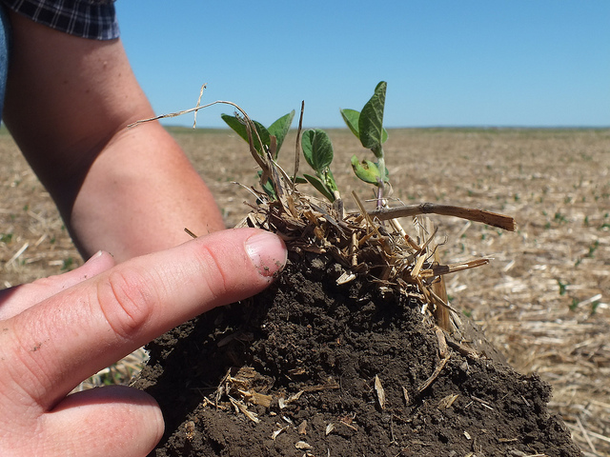  Government program provides a scheme to encourage young people to train in agricultural skills.  Gain 5 beans

This page does not need to be printed; for image reference only.
Hail storm: https://pixabay.com/en/hail-storm-thunderstorm-forest-123042/
Drought: https://pixabay.com/en/drought-earth-desert-aridity-711651/
Beetle: https://pixabay.com/en/animal-insect-beetle-ground-beetles-341154/
Flood: https://pixabay.com/en/arable-field-flood-wet-ground-406153/
Industrial crops: https://pixabay.com/en/combine-harvester-agriculture-702413/
Satellite imaging: https://pixabay.com/en/united-states-atlantic-coast-night-92351/
American Flag: https://pixabay.com/en/flag-american-america-united-states-268505/
Chinese lantern: https://pixabay.com/en/chinese-lantern-lampion-lantern-455760/
Tractor: https://pixabay.com/en/tractor-grain-mixer-rural-denmark-385681/
Faster Tractors: https://pixabay.com/en/speedometer-speedo-rush-vollgas-653246/
Biofuels: https://www.flickr.com/photos/boegh/5676306489/in/photolist-9DAyag-ayMxud-3j9CGG-a88jno-7y7qfB-6Tjqg8-7y8kFH-dqBy11-7FCbzW-pucvv2-7y23y2-9DkxYV-7HVC4c-72VH69-8BzsyS-rwXX4Z-opphz4-jG2cGW-9EcC54-oKnJLY-9EfnU5-5tb3cL-8Z3LVC-psJEKd-91Xo9j-5w8zyR-oWKHBP-o8cZGa-8Xu88c-8WTrro-ukKmGW-ryyuyh-ejkAgg-fE6Bdc-fEoc3G-dts3n4-51tHaF-av4mx9-ahwjkZ-oFXktr-km5Dzy-nE4Lvt-67aPui-9VTAzN-7y23rn-e2zZgE-dBWuv3-av4kg9-3BFYxy-2kpX
Fertiliser: https://pixabay.com/en/dung-crap-space-crap-agriculture-500353/
Second drought: https://pixabay.com/en/desert-sand-dunes-dune-dry-hot-293906/
River flood: https://pixabay.com/en/high-water-wave-inject-strudel-123205/
Hybrid crop: https://pixabay.com/en/farm-fields-crops-green-rural-691529/
Soil: https://pixabay.com/en/earthworm-soil-dirt-macro-686592/
Market prices: https://pixabay.com/en/advertise-background-best-discount-768067/
Government encouraging youth: https://www.flickr.com/photos/nrcs_south_dakota/7166253549/in/photolist-bVfVvF-nNCUE2-ohBvNY-oht6qs-rS2d1Y-r75Lpq-etV6fy-oDiNsx-xyksdL-omPkmV-o2EFGs-xzL9Lp-xhDY4V-xhxKKQ-bDb4Jd-azdrNA-xhxPHC-xzaj1R-xzaadv-xwQXdh-xzLvUB-xykxCd-xhxV47-5osr4e-byHgqc-efG13r-ekn75p-aAVsX6-7bSsjv-ci91R9-eiexUA-vwD22m-ci91Jh-dAErhE-dAyX7a-dAyXqB-dAySFP-dAEndu-dAEkQY-ci923w-ci92id-dAyTgz-dAEnu3-dAEmpU-dAySfk-dAyWKR-dAyS7k-dAyWRB-dAySbM-oBh4Fq

