Lesson six: Global Trade End of Unit Quiz
Answers

Use the Every Country’s Highest Export World Map to help answer the following questions.

- Define ‘trade’. When is trade described as ‘global’?

Trade is the buying and selling of goods and services we want and need.
Trade is described as global when goods and services are exchanged internationally (from one country to another).
(2)

- Label the arrows with ‘import’ and export’.
Import
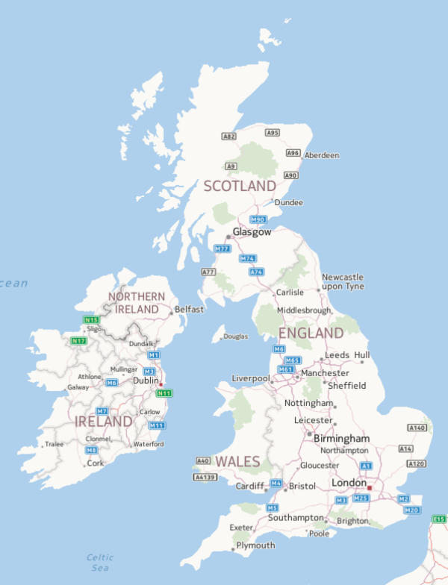
Export
(2)

- List two key things that allowed trade to become global.

- Improvements in transportation to move goods long distances.
- Better communication (internet, telephone) to communicate with people in other parts of the world.
(2)

- Why do we import some foods into the UK such as pineapples?

We cannot grow pineapples in the UK because they need a tropical climate. (1)

- Are the European countries Germany, Italy, Switzerland and the UK more or less developed countries?

More developed countries. (1)

- Greenland’s highest-value export is fish. Give one physical feature of Greenland that determines the country’s highest-value export.

Greenland is an island/coastal country (location). There are high volumes of fish in the ocean around Greenland (natural resources).

(1)
7) Give a benefit to buying fairtrade.

- Fairtrade helps protect the environment.
- Fairtrade supports communities develop and improve their lives.
- Fairtrade pays workers a fair wage for their work and goods they produce. (1)

9) Name two goods that the UK exports to other countries.

Any from: medicines, petrol, wars, oils, aircrafts, spacecrafts, communication technology, chemicals, scientific instruments, alcoholic beverages.

(2)

Total marks: /12

