Lesson 3: The formation of mountains
Factsheet for teachers

Vocabulary
This lesson uses the following geographical terms. These should be used and explained to pupils as the lesson is taught.

Core, mantle, crust These are the main chemical layers of the Earth. These are described in more detail below.
Molten rock Rocks that are in a liquid form.
Viscous Viscosity is a measure of how thick or thin a liquid is. The higher the viscosity, the thicker the liquid; the lower the viscosity, the thinner the liquid. If a liquid is described as viscous it is thick. The mantle is a viscous solid that flows slowly with time.
Magma Magma is molten rock from the mantle. Magma is within the surface of the Earth. Magma becomes lava only once it flows out over the surface land, for example with a volcanic eruption.
Plates The Earth’s outer shell or lithosphere (made up of the crust and uppermost part of the mantle) is broken up into many different pieces or tectonic plates. There are eight major plates and many more minor plates. These plates move across the rest of the mantle beneath.
Plate boundary Where tectonic plates meet.
Plate tectonics This is the theory of the movement of the plates that make up the Earth’s outer shell or lithosphere.
Convection currents It was long thought that convention currents within the mantle, driven by the Earth’s internal heat, caused the Earth’s plates to move. This theory is now largely out of favour with plate movement thought to be helping to drive convection currents in the mantle. There is still much debate about the true mechanism.
Faults/fault lines These are cracks in the rocks that make up the Earth’s crust. When these are evident blocks of the crust can be forced in different directions- up, down or stacked on top of one another- along the faults. Faults can occur at scales of a few centimetres or, as in the case of fault block mountains, at scales of tens of kilometres.
Converge When two plates move towards each other
Diverge When two plates move away from each other
Anticlines These are the upward folds of a fold mountain.
Synclines These are the downward folds of a fold mountain.
Weathering This is the process of chemical decay or mechanical breakdown to rock on the Earth’s surface without involving movement. Water can penetrate rock and chemically break down the minerals. When water freezes in winter, it expands in joints, weakening the rock and leading the rock to crumble.
Erosion This is the process whereby rocks are worn away through the action of rivers, ice, wind and the sea involving the transport of weathered materials.
Rock strata Layers of rock, one above the other, that form the crust rather like the layers in a cake.

The Structure of the Earth
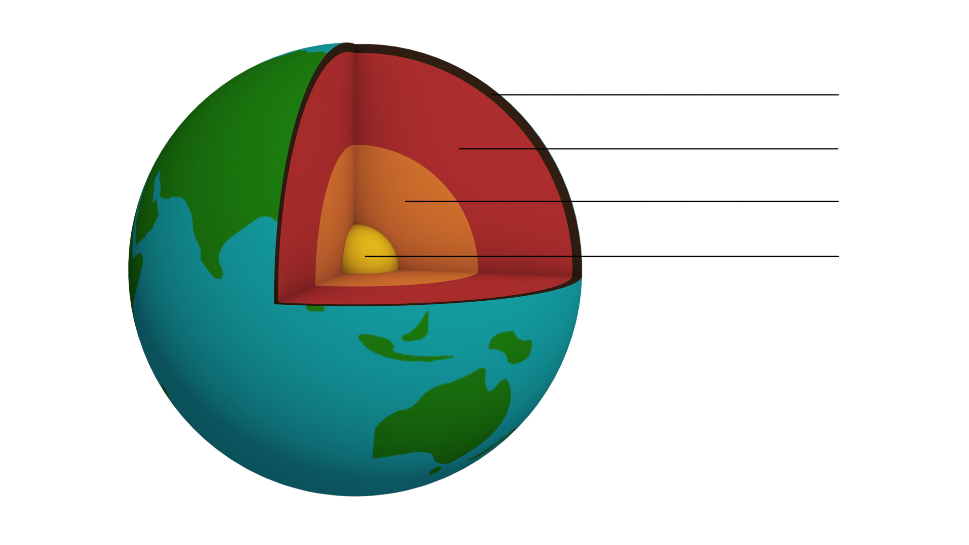
Crust
Mantle
Outer core
Inner core
Below is a diagram to show the difference between a ‘chemical’ classification of the Earth’s structure and the ‘mechanical’ layering associated with plate tectonics © of ESEU.
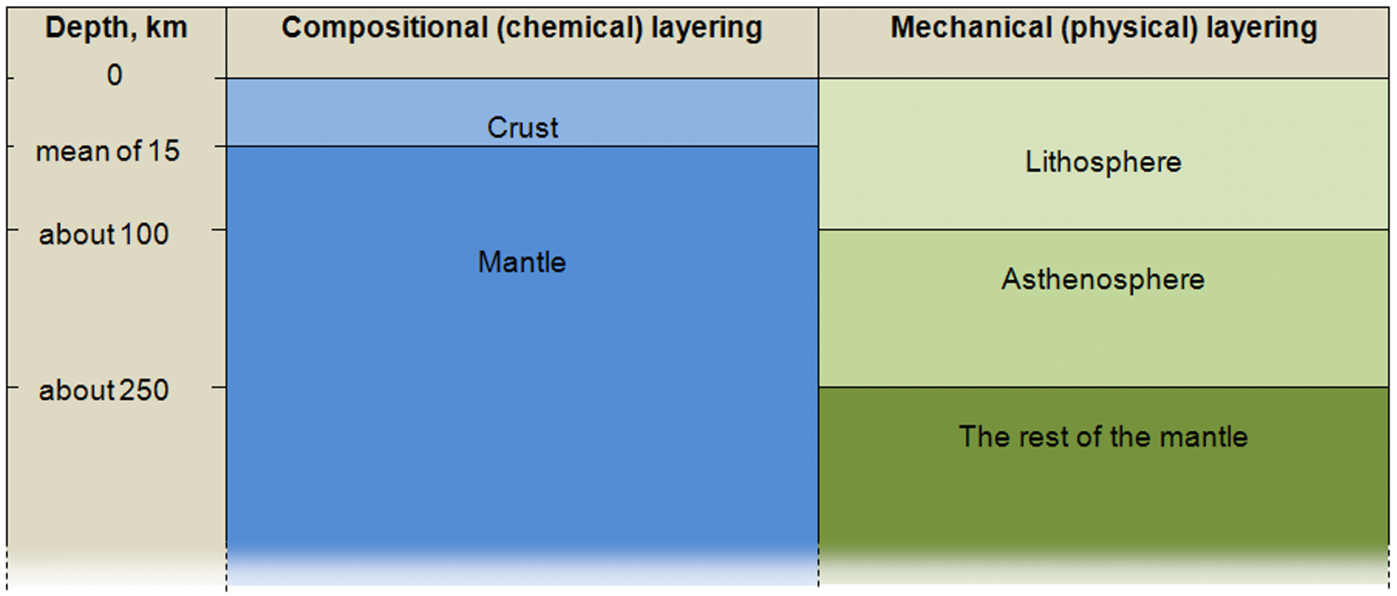
Inner core
The inner core is the centre. It is primarily a solid ball of iron. It has a temperature of 5500^{O}C- almost as hot as the outer layer of the sun, which has a temperature of 6000 ^{O}C. The inner core has a thickness of 1220km. (A distance of 1220km is equivalent to London to Ben Nevis- the UK’s highest peak- and back again). The inner core is solid due to the pressure exerted on it from the other layers.

Outer core
The outer core is composed of iron and nickel. Unlike the inner core, the outer core is liquid. It has a similar temperature to the inner core.

Mantle
This is the thickest part of the Earth, at 2900km. The mantle is viscous and composed of solid rock which can flow over geological time under high pressures and temperatures.
A useful analogy is to think of the mantle as having the consistency of a solid like Blu-tack. It is composed of many different rocks and minerals including iron, magnesium, nickel, silicon and oxygen.

Crust
This is the outer layer of the Earth’s surface. It is the thinnest layer, between 0-70km. It is composed of solid rock and rests on the top layer of the mantle. It is in the crust (and the very upper layer of the mantle) that mountains are formed. When it comes to depth, think of the crust as the skin of a tomato, or the thickness of a postage stamp stuck on a football.

In order to help pupils appreciate, and visualise, the thickness of each of the layers use Google Earth. The ruler function on Google Earth can allow you to measure the distance from your school to any other location.
Plates and Plate Tectonics
The Earth’s outer shell (crust and uppermost part of the mantle – the lithosphere) is not one smooth unbroken layer. Rather it is made of different sections called plates (like a cracked egg shell).
There are eight major plates: Eurasian, Pacific, Indo-Australian, Antarctic, Nazca, North American, South American and African.
Tectonic (or lithospheric) plates can be continental (with part of the plate composed of granitic continental crust) or oceanic (where the plate is mainly basaltic ocean crust ). For the most part continental plates mark the boundaries of the seven continents (in the case of the North American plate, the South American plate, the Antarctic plate).
In other cases the plates include more than one politically defined continent (the Eurasian plate). An example of an oceanic plate is the Nazca.
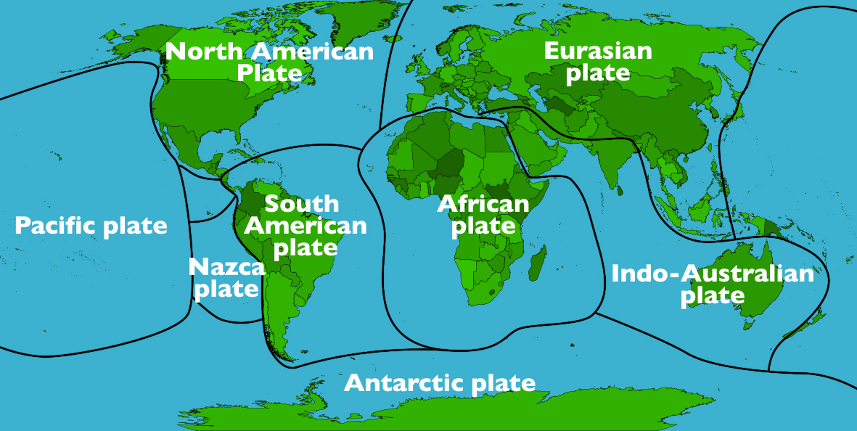
Tectonic plates are pieces of the Earth’s crust and the upper mantle- the lithosphere.

Convection currents
The Earth’s plates are constantly moving; on average, this movement is between 1 and10 cm per year. Be careful, because many pupils may incorrectly assume that the continents are floating on the oceans, or that the plates float on a liquid mantle.
The mechanism by which tectonic plates move is still a subject of much debate among Earth scientists. The Earth is dynamic thanks to its internal heat, which comes from deep within the mantle from the breakdown of radioactive isotopes. It was long thought that this resulted in convection currents in the mantle which were responsible for the movement of tectonic plates across the Earth’s surface – this is still the most common idea illustrated in many textbooks and on the internet. However, with modern imaging techniques this theory is now largely out of favour.

It is now accepted that plates and the mantle are a coupled system with plates moving by a process known as 'slab pull' which helps to drive mantle convection patterns rather than the other way around. Newly formed oceanic lithosphere at mid ocean ridges is less dense than the asthenosphere, but becomes denser with age as it cools and thickens. This causes it to sink into the mantle at subduction zones, pulling slabs of lithosphere apart at divergent boundaries and resulting in sea floor spreading or rifting.
Where slab pull is not the main plate driver, ‘ridge push’ is another possibility. As the lithosphere formed at divergent plate margins is hot, and less dense than the surrounding area it rises to form oceanic ridges. The newly-formed plates slide sideways off these high areas, pushing the plate in front of them resulting in a ridge-push mechanism.

How plate movement operates is being revised all the time as scientists unearth new evidence, however, the detail still remains highly controversial. Pupils should be made to feel confident that in science we don’t know all the answers.

Visit the Earth Learning website to access pdfs on Plate driving mechanisms, Slab pull and What drives plates.
Converging Plates
Occasionally two plates move closer to each other, or converge; this creates intense pressure, causing the plates to buckle in different ways. This process forms a mountain.
This lesson will concentrate on three types of mountain: fold mountains, fault block mountains and dome mountains. These are generally formed within the main body of the plate, rather than at the boundaries.
Another type of mountain, formed at plate boundaries, is a volcano. Volcanoes will be the subject of Lesson 4 and Lesson 5. Earthquakes, the subject of Lesson 6, are also formed at plate boundaries. The Factsheets accompanying these lessons will cover this in more detail.
Fold mountains
These are the most common type of mountain. As two plates move towards each other they buckle and the crust pushes upwards along faults, forming a mountain. Fold mountains are generally formed between 40-50 million years ago, which is geologically-speaking, young. They are often high with steep faces. Examples of fold mountains include The Himalayas, The Andes, The Rockies and The Alps.
The Himalayas: The Himalayan range was formed 50 million years ago when the Indo-Australian plate collided with the Eurasian plate and continues today. Mount Everest, located in the Himalayan range, is a fold mountain and is the highest mountain not only in Asia, but on Earth at 8849 metres above sea level. It is just one of 30 peaks of the Himalayan range. The Himalayan range covers an area of about 594,400 sq km of Pakistan, India, Tibet, Nepal and Bhutan. Everest itself is located on the border of Nepal and Tibet.
There are fossilised sea shells and marine deposits within the rocks of Mount Everest, where once the plate was at sea level, before slowly being forced upwards. Mount Everest continues to grow higher at the rate of 4mm per year as the plates continue to move.
The Andes: The Andes Mountains are located in South America, along the western coast of the continent and stretch 7000 km. They extend from north to south through seven South American countries: Venezuela, Colombia, Ecuador, Peru, Bolivia, Chile, and Argentina.The highest peak in South America, at 6962 metres, is Mount Aconcagua, which is part of the Andes range. The Andes were formed when the Nazca plate collided with the South American plate.
The Rocky Mountains or Rockies: The Rocky Mountains are located in North America, along the west of the continent. The range stretches for 4,830 km, from British Columbia in Canada, southwards to New Mexico in the United States. In places the Rockies are almost 500km wide. The Rocky Mountains were formed 55-80 million years ago. Limits to the extent of the Rockies are debated- some consider the range extends into Alaska, north of Canada. The Rockies were formed when the Pacific plate collided with the North American plate.
The Alps: The Alps are located in Europe. The range stretches 1200km through eight countries: France, Monaco, Italy, Switzerland, Liechtenstein, Germany, Austria and Slovenia. In places it is 250km wide. The highest mountain in western Europe, at 4810m, is Mont Blanc which is part of the Alps range and is on the border of France and Italy. The Alps are estimated to be 30-40 million years old and were formed when the African plate and the Eurasian plate collided.
The upward folds are known as anticlines, and the downward folds are called synclines.
Fault block mountains
These are formed by later extension or stretching of the crust in some fold mountain zones. This causes the crust to cracks along lines of weakness called fault lines. The crust then breaks into blocks, which are pushed upwards.
The Sierra Nevada: An example of fault block mountains is the Sierra Nevada mountain range in California, USA. The range is located in eastern California and stretches for 640km. The highest peak of the Sierra Nevada is Mount Whitney, at 4418 metres. The mountains are primarily composed of granite. The Sierra Nevada range was the site of the American gold rush in the 1840s.
The block, or section, in between the fault lines can also be pushed down. In this case a rift valley is formed, such as the Great Rift Valley in Kenya.
Dome mountains
Dome mountains are the result of a great amount of molten rock (magma) pushing its way up under the Earth’s crust. Without actually erupting onto the surface, the magma pushes up the overlaying rock strata which then bulge upwards. Eventually the magma cools and forms hardened rock.
The Black Hills mountain range: An example of a dome mountains is the Black Hills mountain range in South Dakota, USA. The highest peak in the range is Harney peak at 2208 metres. Mount Rushmore, also in the Black Hills, is another example a Dome Mountain, at 1745 metres. It is famous for having the four American presidents, George Washington, Thomas Jefferson, Theodore Roosevelt, and Abraham Lincoln carved into its face. The carving took 14 years and was completed in 1941.

