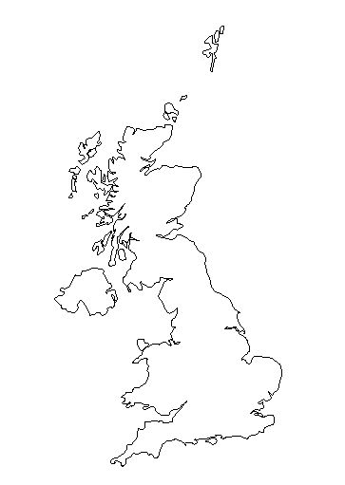
Lesson two: Main Activity
Map of the UK

Three Peaks Challenge: Travel Log

Leg of Journey | Distance (kms) | Direction | Duration (hours & mins)
Physical and human landscapes/features encountered:
London – Birmingham

Birmingham – Snowdon

Snowdon – Lancaster

Lancaster – Scafell Pike

Scafell Pike – Glasgow

Glasgow – Ben Nevis

