Resilience and Vulnerability in Climate Change and Farming
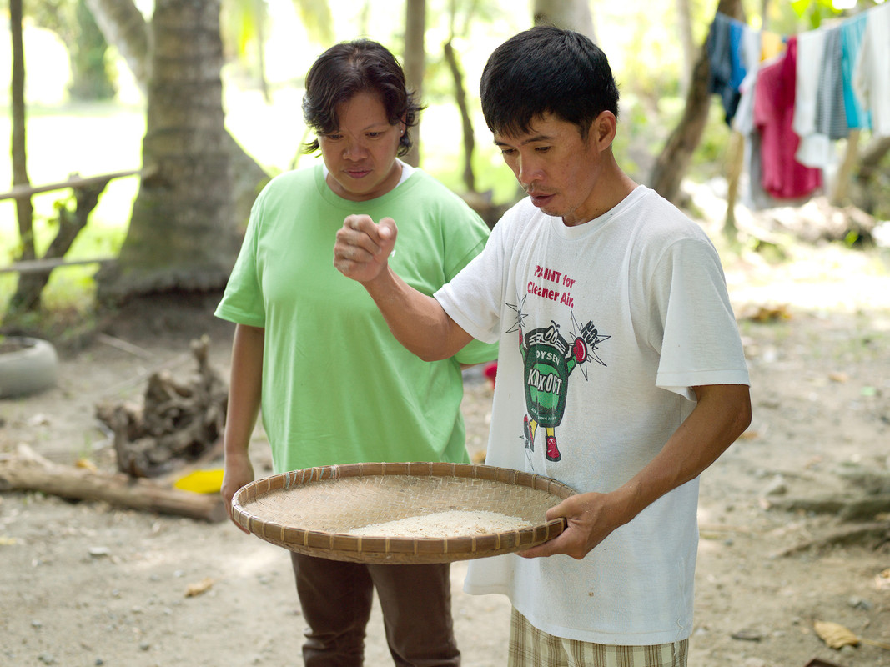
Meet Gary Castanares

Gary shows Oxfam programme officer Ana how to hand mill rice © Tessa Bunney, Oxfam
Gary Castanares is 37 years old. He lives in Daguma village, near Esperanza on the island of Mindanao in the Philippines. Gary has attended Oxfam’s field school where he learned about System of Rice Intensification (SRI) farming.
"People have been laughing at us for using the new technique but I am hoping that soon I will be the one laughing when we are making more money from our crops. I won’t be discouraged.
Before I was taught about SRI I was becoming discouraged as we were spending so much money on farming inputs such as fertilizers and pesticides. I was asked if I’d like to go to the field school and when I saw their fields I was totally amazed. I couldn’t believe you could make fertilizer for free. The cost of inputs was so little. It is amazing. I can make fertilizer from my own household waste now.”
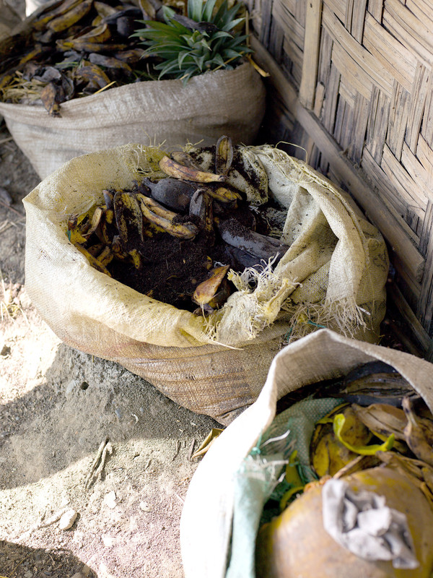
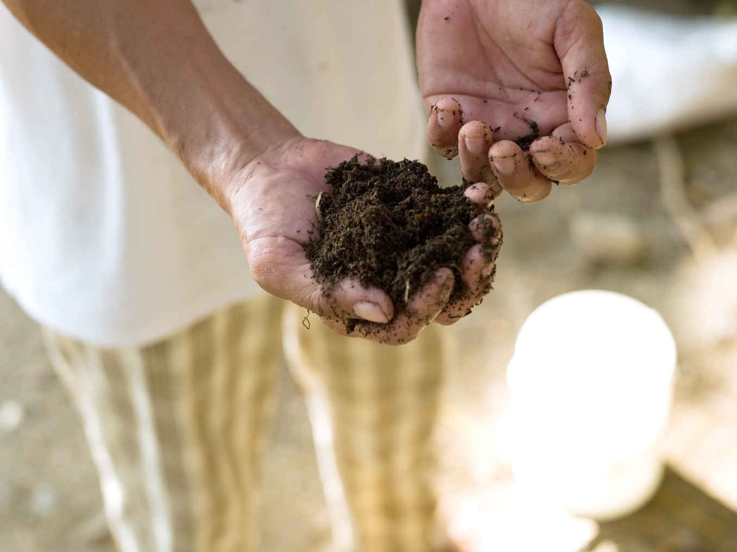Gary’s homemade organic fertilizer © Tessa Bunney, Oxfam

“In 2012 our farm was affected by Typhoon Pablo (also known as Washi), all of our crops were bent in half and destroyed, our village was flooded and a portion of our house was washed away. That year our crops failed and so we turned to our ducks, pigs and chickens to survive. I have since learned about other ways to diversify with vegetable gardening at the field school. I hope that when other people see me trying new things they will also try.
I used to produce 65 sacks of rice a year but now with SRI I am hoping to produce 100 sacks. Of all the rice varieties my favourite is Magnolia. It grows really tall and produces lots of seed.

I can say that I am in love with farming and I especially love learning about organic farming. The hardest thing for us living here is putting in so much hard work only to see our crops fail and not make a profit. With the introduction of SRI I see hope again in farming. I know I won’t ever be rich but we will at least be comfortable. I hope to give my children an education and maybe one day they will choose to follow in my footsteps. I think it is important to help each other in a community and share learning. I see that happening a lot more these days, which is good."

