Where would you find a house like this?

Think about the climate in these countries. Can you match the house to its location?

A. Kulusuk, Greenland
B. Connemara, Ireland
C. Tyrol, Austria
D. Santa Fe, New Mexico
E. Ibiza, Spain
F. Mli, Mali

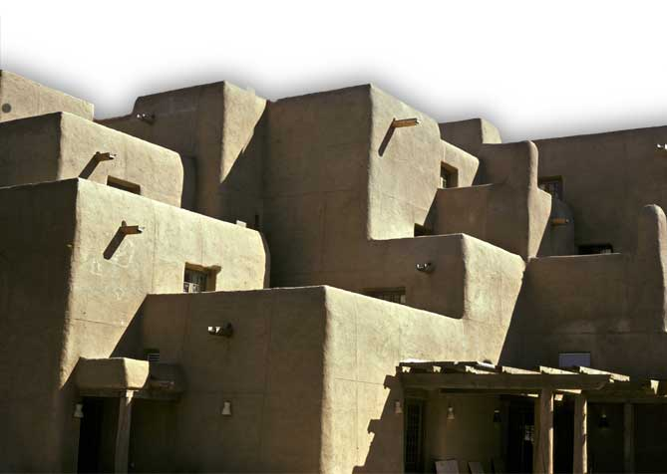
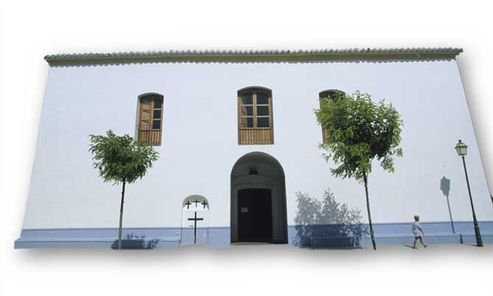
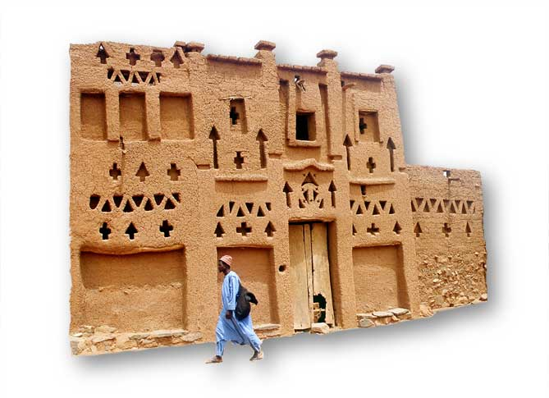

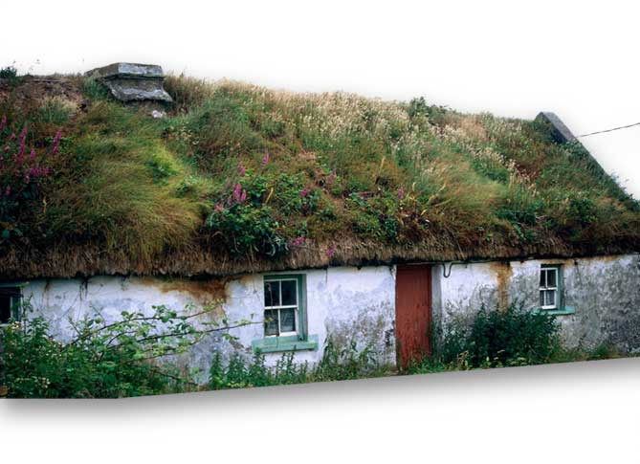

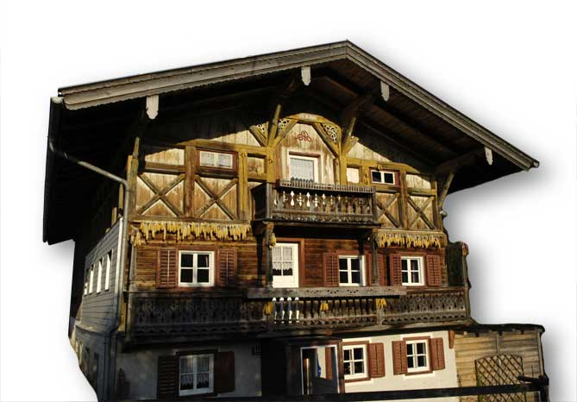

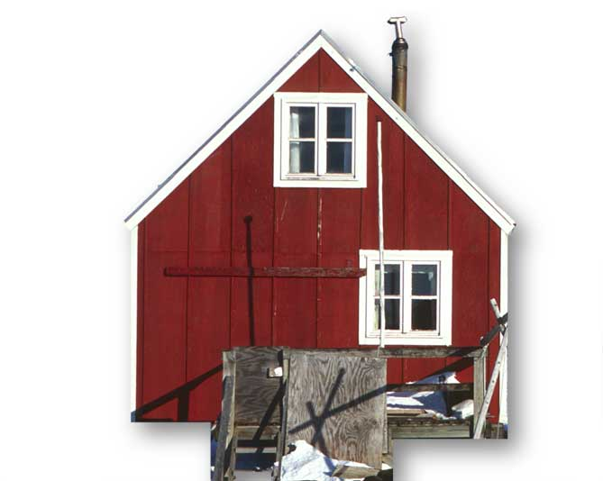

- What materials is each house made from?
- Why is the material suitable for the local climate?
- What other features make it suitable for the local climate?

