Sidi Mubarak Bombay
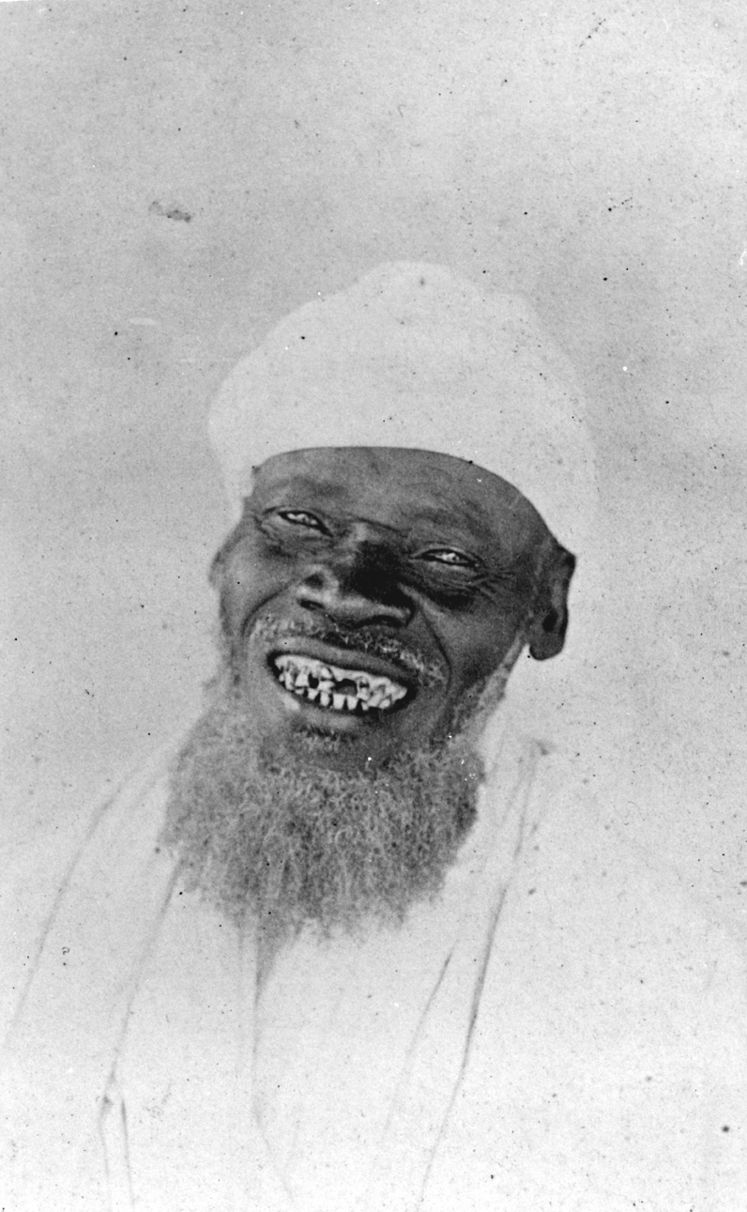
Sidi Mubarak Bombay
© Royal Geographical Society

1820 | Born in the Yao kingdom in East Africa, on the border of what is now Tanzania and Mozambique.
1832 | Captured by Arab slavers as a young boy. After being captured he was made to march to the slave market in Kilwa, where he was sold. He never saw his family again.
c.1832 - 1855 | Once the slaves had been sold they were put on ships called 'dhows'. These ships took them to work on farms in countries around the Indian Ocean. On the farms they were beaten and forced to work. Sidi Mubarak Bombay was put on a dhow and sent to the Gujarat area of India. His owner gave him the slave name of 'Mubarak'. He spent many years in India and learnt to speak Hindi. When his owner died, he became a free man and returned to Africa on a ship.
1857-1863 | In Zanzibar, he joined the army of the sultan. In 1857, he was recruited by the explorer John Hanning Speke as a guide for his expedition (with Richard Burton) to find the source of the River Nile. They communicated with each other in Hindi and English, the two languages they could both speak. He also joined Speke for a second expedition with James Grant (1860-3).
1873 | He travelled from the East Coast of Africa to the West on foot. During his life he covered approximately 9,600 kilometres (much of this on foot) and became the most widely travelled man in Africa.
1876 | He received an award from the Royal Geographical Society in recognition of the help he gave to Speke in searching for the source of the River Nile.
1885 | In 1885, he died in Africa at the age of 65.

