Lesson five teacher notes
In this lesson, students will study global interactions between Russia and other places, including the European Union and China. These interactions include the exchange of fossil fuels for money. Other countries depend on Russia for the natural resources they need. In turn, financial flows, generated by gas and oil sales, make Russia richer. However, much of the petrodollar wealth is concentrated in the hands of a few individuals and corporations, sometimes referred to as the oil oligarchs (an oligarchy is a power structure where power lies in the hands of a small group of people).
- They will continue to consider important connections in human geography between different places, creating a state of inter-dependency.
- In terms of skills, they will develop an ability to plot proportional arrows and deign choropleth maps.
- They will think critically about the reasons why Russia’s neighbours in Europe have strived to build a good geopolitical relationship with Russia

Russian gas and oil exports
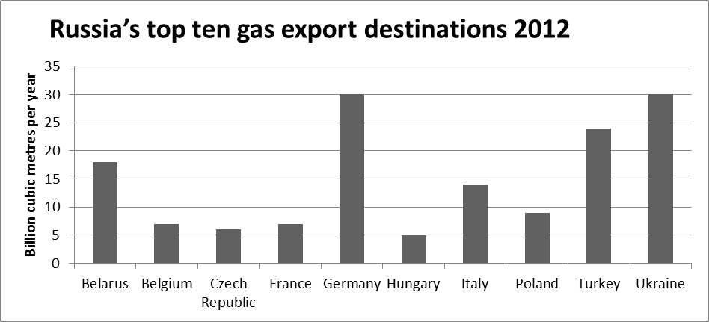
Source: BP

Russia’s top five oil export destinations 2012
 | Barrels per year
Belarus | 157 million
Poland | 172 million
China | 175 million
Netherlands | 201 million
Germany | 250 million
Source: US Energy Information Administration
Imports from Russia as a percentage of total imports of natural gas, 2012
Austria | 71
Bulgaria | 100
Czech Republic | 100
Estonia | 100
Finland | 100
France | 16
Germany | 36
Greece | 60
Hungary | 44
Italy | 28
Latvia | 100
Lithuania | 100
Netherlands | 11
Poland | 80
Romania | 86
Slovakia | 99
Slovenia | 28
UK | Unknown
Source: Financial Times
Keeping an eye on Russian-Chinese deals
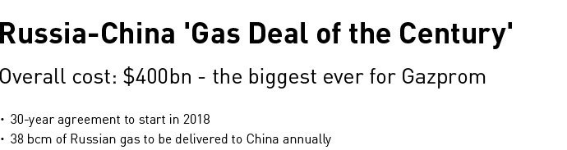
Source Global Research website: http://www.globalresearch.ca/global-geopolitics-and-the-russia-china-gas-deal-of-the-century/5383286

Gas
Russia is the second-largest producer of dry natural gas and third-largest liquid fuels producer in the world. Despite its significant reserves of coal, it produces only a modest amount of coal. Russia's economy is highly dependent on its hydrocarbons, and oil and gas revenues account for more than 50% of the federal budget revenues.
Russia is a major producer and exporter of oil and natural gas, and its economy largely depends on energy exports. Russia's economic growth continues to be driven by energy exports, given its high oil and gas production and the elevated prices for those commodities. Oil and gas revenues accounted for 52% of federal budget revenues and over 70% of total exports in 2012, according to PFC Energy.
Russia was the world's third-largest producer of oil (after Saudi Arabia and the United States). Preliminary data for 2013 show that Russia still is the third-ranked producer of total liquids, with average production at 10.5 million barrels per day (bbl/d) through September 2013. Russia was the second-largest producer of natural gas in 2012 (second to the United States).
Russia is the third-largest generator of nuclear power in the world and fourth-largest in terms of installed capacity. With ten nuclear reactors currently under construction, Russia is the second country in the world in terms of number of reactors under construction in 2012, according to the International Atomic Energy Agency.
Russia consumed 32.77 quadrillion British thermal units (Btu) of energy in 2011, the majority of which was in the form of natural gas (56%). Petroleum and coal accounted for 19% and 14%, respectively.
Oil
Russia was the third-largest producer of liquid fuels in 2012, following the United States and Saudi Arabia. During that year, liquid fuels production averaged 10.4 million bbl/d.
Russia's proven oil reserves were 80 billion barrels as of January 2013, according to the Oil and Gas Journal. Most of Russia's resources are located in Western Siberia, between the Ural Mountains and the Central Siberian Plateau and in the Volga-Urals region, extending into the Caspian Sea. Eastern Siberia holds some reserves, but the region has had little exploration.
In 2012, Russia produced an estimated 10.4 million bbl/d of total liquids (of which 9.9 million bbl/d was crude oil), and it consumed roughly 3.2 million bbl/d. Russia exported over 7 million bbl/d in 2012, including roughly 5 million bbl/d of crude oil and the remainder in products. Russia's pipeline oil exports fall under the jurisdiction of Transneft, the state-owned pipeline monopoly.
Source: CIA, World Factbook

Who is getting wealthy?
Russia's oil production by company, 2012 (shows oil only, and not gas production)

Company | Thousand barrels /day
Rosneft | 2,448
Lukoil | 1,670
TNK-BP | 1,493
Surgutneftegaz | 1,223
Gazprom Neft | 626
Tatneft | 518
Slavneft | 356
Gazprom | 314
Bashneft | 307
Russneft | 295
PSA operators | 283
Novatek | 85
Others | 697
Total | 10,315
Source: http://www.eia.gov/countries/analysisbriefs/Russia/russia.pdf
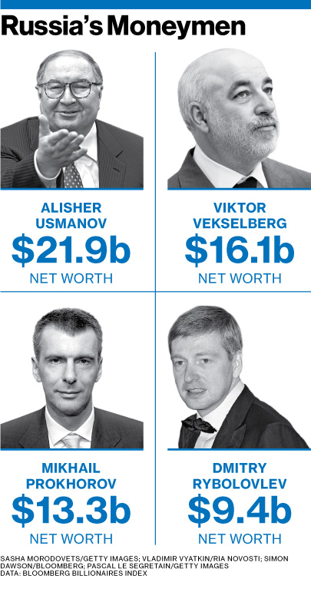
Source Business Week website: http://www.businessweek.com/articles/2013-02-28/russias-oligarchs-ditch-oil-and-gold-to-pile-up-cash

110 very rich Russians
‘With just 110 individuals holding 35% of the country's riches, Russia has the highest level of wealth inequality in the world (with the exception of some small Caribbean nations that have resident billionaires). There's a stark contrast between that and the world average, where billionaires hold around 1-2% of wealth. Globally, for every US$170bn in household wealth there is on average 1 billionaire. In Russia, there is just US$11bn in household wealth for every billionaire in the country.’
Here are the top 30. How many have oil and gas wealth?
Russian Rankings | World rankings | Names | Sources of wealth | Net worth (USD billions)
1 | 45 | Alisher Usmanov | steel, telecom, investments | 18.6
2 | 50 | Mikhail Fridman | oil, banking, telecom | 17.7
3 | 51 | Viktor Vekselberg | oil, metals | 17.1
4 | 68 | Vladimir Lisin | steel, transport | 15.1
5 | 73 | Leonid Mikhelson | gas, chemicals | 14.7
6 | 74 | Vladimir Potanin | metals | 14.6
7 | 77 | Gennady Timchenko | oil & gas | 14.4
8 | 89 | Vagit Alekperov | LUKoil | 13.1
9 | 109 | German Khan | oil, banking, telecom | 11.4
10 | 110 | Sergey Galitsky | retail | 11.2
11 | 117 | Andrey Melnichenko | coal, fertilizers | 10.9
12 | 119 | Mikhail Prokhorov | investments | 10.5
13 | 120 | Alexei Mordashov | steel, investments | 10.5
14 | 135 | Roman Abramovich | steel, investments | 9.5
15 | 151 | Alexey Kuzmichev | oil, banking, telecom | 8.8
16 | 152 | Dmitry Rybolovlev | fertilizer | 8.8
17 | 160 | Andrei Skoch | steel | 8.2
18 | 161 | Yevtushenkov | telecom | 8.2
19 | 173 | Oleg Deripaska | aluminum, utilities | 8.0
20 | 215 | Suleyman Kerimov | investments | 6.7
21 | 221 | Iskander Makhmudov | mining, metals, machinery | 6.5
22 | 235 | Leonid Fedun | Lukoil | 6.2
23 | 238 | Pyotr Aven | oil, banking, telecom | 6.2
24 | 242 | Filaret Galchev | construction materials | 6.1
25 | 277 | Sergei Popov | banking | 5.4
26 | 366 | Samvel Karapetyan | development | 4.3
27 | 398 | Alexander Abramov | steel, mining | 4.0
28 | 409 | Arkady Rotenberg | construction, pipes, | 3.9
29 | 421 | Igor Kesaev | tobacco distribution, retail | 3.9
30 | 438 | Andrei Guriev | fertilizers | 3.8

Source Guardian website: http://www.theguardian.com/news/datablog/2013/oct/09/worlds-wealthy-where-russia-rich-list

