Science in Antarctica

Nearly all of the people who live and work in Antarctica are scientists or support staff. There are 5000 in summer and 1100 in winter. 18 countries work in 25 research stations on the continent and nearby islands. Britain is represented by the British Antarctic Survey.

The 1998 ‘Environmental Protocol to the Antarctic Treaty’ designated Antarctica as a ‘natural reserve devoted to peace and science’ and also gave priority to science over all other activities.

Antarctica is so interesting to scientists because it is the world’s last great wilderness which has a huge impact on the world’s climatic and ocean systems.

History of science
In 1895 the International Geographical Congress in London promoted Antarctic exploration which led to fifteen major national expeditions. In 1899 a British expedition led by a Norwegian established the first over-wintering land station at Cape Adare. In the early twentieth century expeditions such as those of Scott and Shackleton combined scientific discovery with quests for adventure.

In 1957 the International Geophysical Year boosted Antarctic scientific research and international co-operation by bringing research teams from 12 countries into the area. This led the way to the Antarctic Treaty in 1961.

In 1958 the Scientific Committee on Antarctic Research (SCAR) was set up to co-ordinate international activities. It is based in Cambridge, England.

Research stations
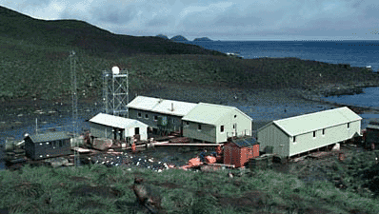
All the stations in Antarctica and the islands are self contained communities. There are living and working spaces including a kitchen area with large food stores, workshops and hospitals. The stations make their own electricity using diesel generators and use a satellite link to communicate with the outside world.
Bird Island Research Station, South Georgia© BAS

There are concerns about the environmental impact of the research stations. A Greenpeace report drew attention to the fact that the stations tend to be build on the 2% of Antarctica that is ice free on the coast which is also where most of Antarctica’s wildlife can be found. Waste disposal, storage of fuel and the building of roads and airstrips can have a profound effect on such a pristine landscape.

British Antarctic Survey
BAS is one of the longest running scientific teams in Antarctica. It has three permanently occupied research stations, two in Antarctica and one on South Georgia.

Since 1990 it has planned its scientific programmes on a five year cycle. Recent programmes include:

- The influence of the Antarctic ice sheets on global systems
- Studying marine ecosystems
- Looking at species that live in extreme conditions

Ozone hole
One of the most famous scientific discoveries by the BAS was of the Ozone Hole over Antarctica in 1985. This is studied at Halley station. Its discovery led to an international agreement to stop the use of chlorofluorocarbons (CFCs) which were found in spray cans, fire extinguishers, refrigerators and air conditioning. The CFCs were destroying ozone gas which protects all living things from damage by ultra-violet radiation from the sun.

Find out more

www.antarctica.ac.uk British Antarctic Survey
www.scar.org Scientific Committee on Antarctic Research

Compiled by Kim Stephenson

