
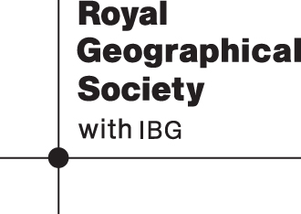
Glastonbury Tour – True or False? - Map extract

Below is a 1:50000 Ordnance Survey map extract of the Glastonbury area. Use it to help you to answer the True or False questions about Glastonbury.

Image reproduced with kind permission of Ordnance Survey and Ordnance Survey of Northern Ireland.
