At Risk

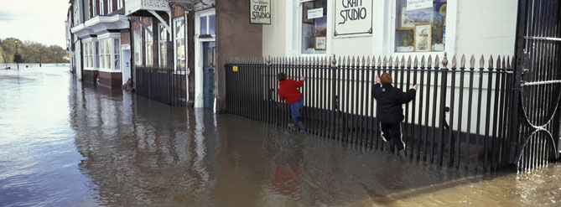
When sea-level rise is mentioned, it is easy to be complacent and think, “it won’t affect me”, the reality of it is, that no one in the UK is more than 75 miles from the sea. This means that, as an island nation, we should take this threat extremely seriously. In fact the sea has already consumed villages that once existed in the United Kingdom and hundreds of homes are currently under threat from the shifting shorelines.

To find out if your home is under threat then just follow the link below, this takes you to the website the Environment Agencies Flood Map, a £30 million pound project which you can use to show a flood map of your street.

- http://www.environment-agency.gov.uk

Places in Danger

All around the coasts of the United Kingdom there are houses, families and businesses under threat from rising sea levels. As the sea eats away at coastlines through erosion, the land beneath their homes is disappearing. Here are a couple of examples.

Slapton, Devon

In Slapton, Devon the rising seas and increased flooding are causing concern for residents and conservationists. Flooding in 2001 badly damaged the coastal road and further floods could damage the largest freshwater lake in Southwest, which is situated just behind the coastal road. Further along the coast the village of Hallsands was suddenly swept away by a storm and there are fears that this may be a regular occurrence due to climate change.

South East England
Rising sea levels will place Hastings and other parts of the East Sussex coast under threat of severe flooding. People in Lewes and Uckfield, remember only too clearly the destructive power of the floods that visited the South East in 2000.

Climate change and global warming have already affected much of this region. If the estimates are accurate, then much of the existing housing will be threatened, let alone the many new builds proposed under the South East Plan.

Planning guidance directs all new developments away from flood plains but the pressure for new home building in the South East region and the numbers involved, means that local authorities and development companies may have no choice but to build in less than ideal areas.

30% of development sites planned for 2016 - 2031 will be in flood risk areas.

Links

- http://www.defra.gov.uk/environ/fcd/default.htm
The proposed shoreline management plan from Defra, which provides detail of the problem and possible management.

