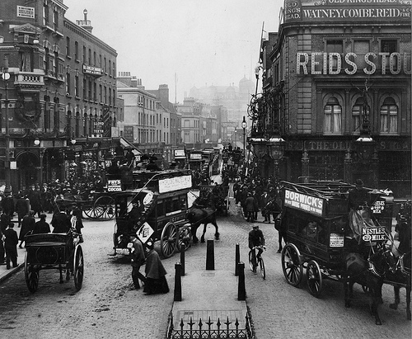
Our Place in History

Lesson 5: School history

Key ideas:
- Education has changed over time.
- The place of the school in local history can be investigated.

Starter activity:
School in the late 19th Century
The aim of this lesson is to investigate an aspect of local history which pupils are very familiar with – their school – and to compare their experiences with those of previous generations. Pupils should look at the image on the front page of the Channel 4 microsite Victorian Schools which shows a school at the end of the 19th Century. They should compare this image with their own experiences of school today, picking out in particular any similarities and differences they notice. They should then look at the school timetable from 1899 (click on the ‘timetable’ link). How does this compare to their timetable? More can be found out about the subjects by clicking on each one. Pupils could carry out a series of ‘drill’ activities or ‘dictation’ to give them an idea of what it might have been like to be at school in the late 19th Century.

Main activity:
Anniversary front page
In this task, pupils are going to produce an anniversary newspaper front page for the school. Clearly, some schools will have a long history whilst others will be much newer and also the amount of archive information held by schools will vary. As a starting point, pupils could interview staff to find out how the school has changed since they started teaching there. They could interview a variety of teachers and support staff at different stages of their careers to study change over time. Local newspapers may also have archive articles about the school and so this could be another important source of information.

Plenary:
My front page
This activity encourages pupils to evaluate their work and to suggest improvements for the future. Pupils complete a card with a photo of themselves and responses to how they feel they have completed the anniversary front cover. These can subsequently be used for display.




