Feeding the 9 billion: Lesson 1 Resource Sheet

Starter

Key facts

- The population today is 7.2 billion. This is expected to rise to 9.2 billion by 2050
- 2.6 million children under 5 die from malnourishment each year
- 850 million people in the world are undernourished
- One of the Millennium Development Goals agreed by the UN is to reduce the proportion of people experiencing hunger by 50% by 2015
- 1 billion people are micro-nutrient deficient
- By 2050 70% more food will need to be produced to cope with a population of 9.2 billion people
- The UK wastes 15 million tons of food across the food chain every year.

Key terms

Food security | Large-scale farming based on commercial principles
Sustainability | Development which meets the needs of the present without compromising the ability of future generations to meet their own needs
Food poverty | Extreme scarcity of food
Malnutrition | The inability to afford, or to have access to food
Famine | Lack of proper nutrition, caused by not having enough to eat, not eating enough of the right things, or being unable to use the food that one does eat.
Agribusiness | When all people at all times have access to sufficient, safe, nutritious food to maintain a healthy and active life

Answers
Food security | When all people at all times have access to sufficient, safe, nutritious food to maintain a healthy and active life
Sustainability | Development which meets the needs of the present without compromising the ability of future generations to meet their own needs
Food poverty | The inability to afford, or to have access to, food to make
Malnutrition | Lack of proper nutrition, caused by not having enough to eat, not eating enough of the right things, or being unable to use the food that one does eat.
Famine | Extreme scarcity of food
Agribusiness | Large-scale farming based on commercial principles

Activity 2

 | Description | Explanation | Sustainable management option
Global population change 1950 – 2050
Global climate change between 1950-2050

Change in the price of wheat 1950-2050

Percentage of world population who are malnourished 1999-2001

Change in global food consumption 2005-2015

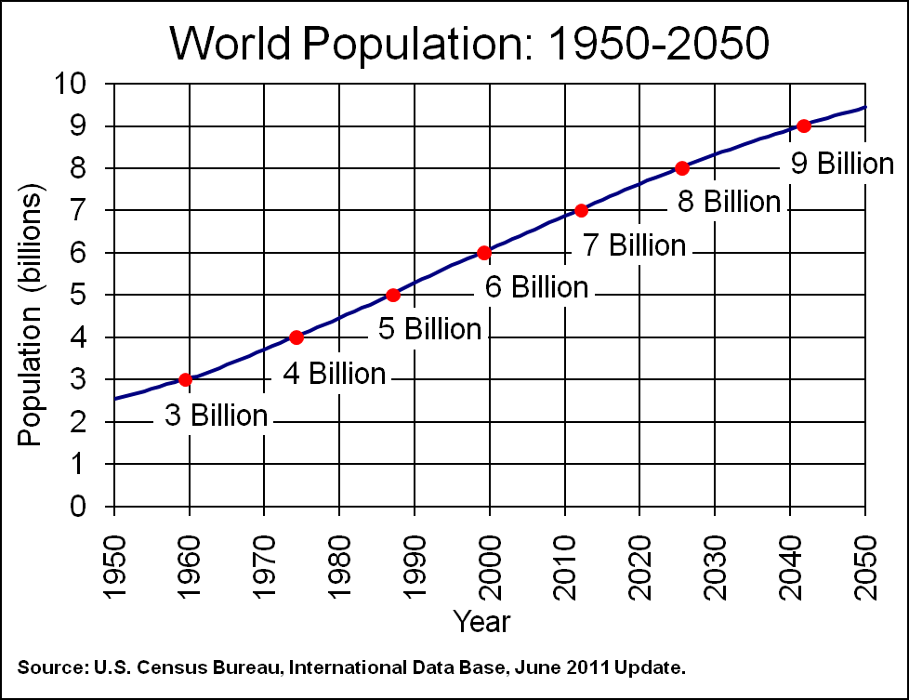

Source: US Census Bureau

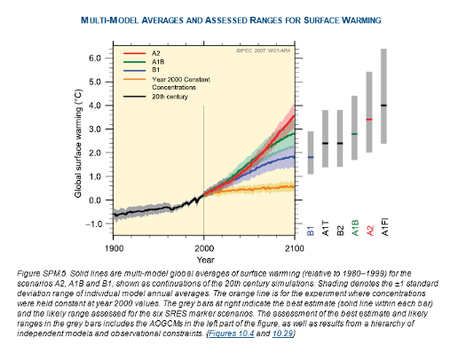

Source: IPCC http://www.ipcc.ch/publications_and_data/ar4/wg1/en/spmsspm-projections-of.html

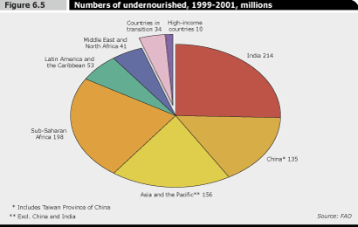

Source: World Bank http://www.worldbank.org/depweb/english/beyond/global/chapter6_2.html
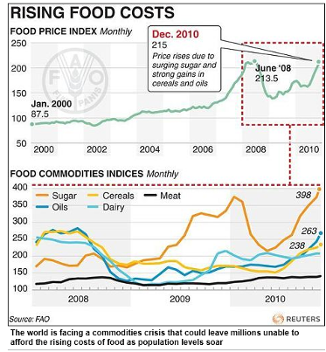

Source: Reuters http://www.dailymail.co.uk/sciencetech/article-1350009/Food-prices-rocket-50-global-hunger-epidemic-causes-riots-famines.html

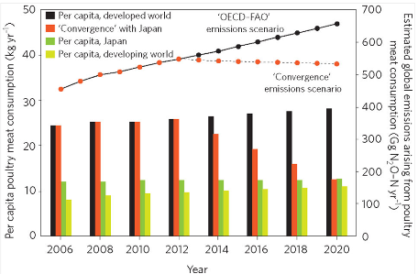
Source : Nature http://www.nature.com/nclimate/journal/v2/n6/fig_tab/nclimate1458_F3.html

