Garden design template

Here is a template to help you get started designing your garden. On the next page is a basic garden background, and on following pages are objects you can copy onto the background, and then resize, recolour and reposition them to build up your design.

If you want to add more features, you could add images of your own, or even design your garden on paper, and draw onto it or cut out pictures from old magazines to make a collage.

Don’t forget to label your design to clearly say what plants and other items you are using, and remember it’s a garden for the future!

Here’s a simple example:

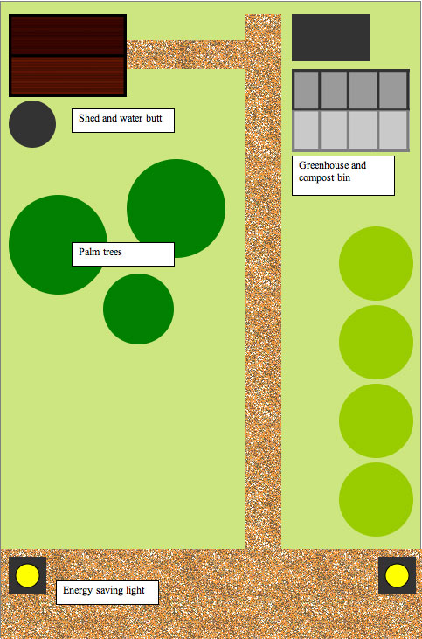

Surfaces
You can use these textures to make the surfaces for you design.
Drag or copy them onto the template, and resize them to whatever size and shape you want.

Wooden decking

Brick paving

Gravel

Plants
You can use these shapes to plan where your plants should go. Drag or copy them onto the template, and resize (and if you want to, recolour) them to represent different trees, bushes, smaller plants or maybe vegetables.

Objects
You can use these shapes to plan where different objects in your garden should go. Drag or copy them onto the template and position them in your design.

Greenhouse

Shed

Compost bin

Water butt

Energy saving lights

