Newham Fact sheet
Where is Newham?
A large area of the Lea valley development area is in the London Borough of Newham
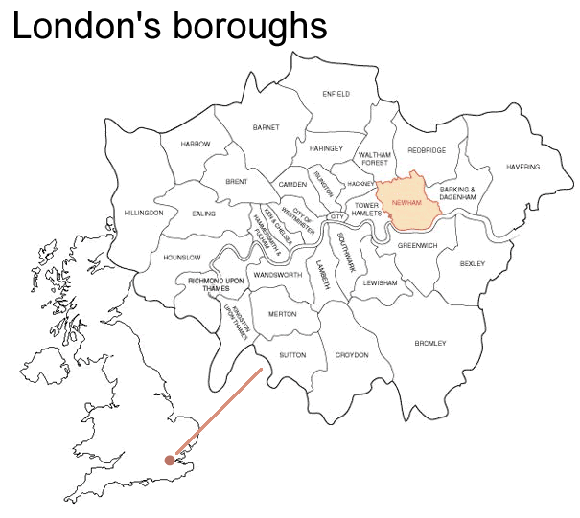

A census is the process of obtaining information about every member of a population. Information about people like their housing, if they have a job, and their age is collected.

Census Data Newham
Population density
Persons per hectare | Area (hectares)
Newham | 68.8 | 3,622
London | 47.3 | 157,208
GCSE Grades
% with 5+ GCSEs | Newham | London
Grades A* to C | 51.0% | 57.1%
Grades A* to G | 94.2% | 90.2%
Average Family Income
2003/2004 | 2004/2005
Newham | £27,600 | £28,948
London | £34,625 | £37,073
Crime Figures
 | Newham | London
Vehicle Crime | 33.5 | 27.8
Violence Against Person | 32.7 | 28.2
Street Crime | 10.5 | 7.0
Residential burglaries | 8.0 | 8.8
Sexual offences | 1.8 | 1.5
Economic activity
 | Newham | London
Economically Active | 63.7% | 74.7%
Economically Inactive | 36.2% | 25.3%
Unemployment | 7.8% | 4.5%

For more information about Newham try this website.
http://www.go-london.gov.uk/boroughinfo/borough.aspx?bid=25

