Flood risk in London

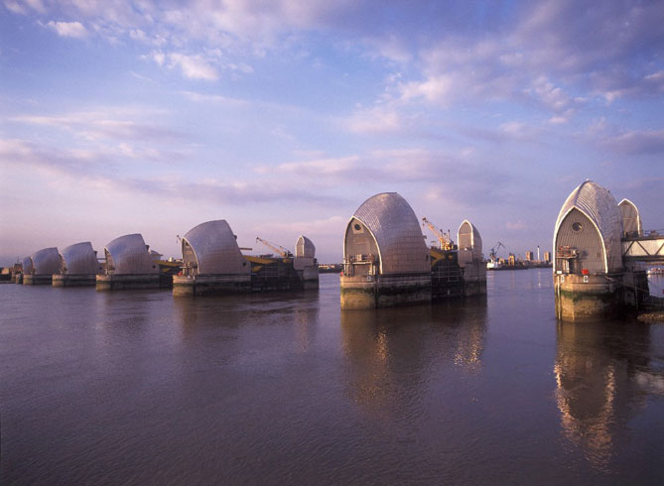
What could happen to London in the future?

Floods will become worse than usual. The Thames Barrier won’t be able to hold because the water will be rising higher and more often.
The emergency services might not be able to cope and over 30,000 families could be affected

What are some of the reasons why flooding in London could become a problem?

- More housing built on the floodplains means there will be more people to get affected.
- Sea levels are rising due to climate change that means the water level is getting higher every time the tide comes in.
- Flood defences are funnelling high tides towards London
- Storm surges will make more water come towards London
- Heavy rain can’t run away fast enough!

How long until the risk of flooding gets really bad?

By 2050 it is predicted that the Thames Barrier will have to close every high tide – that’s twice a day, in order to prevent flooding. On very high tides it will come over!

What could be the solutions?

1. Physical solutions (eg. building more flood defences)

- Build sea walls – This will hold back the water but it is very expensive and you have to keep building the walls higher and higher.
- Building flood defences down the estuary towards the sea means that incoming tides are funnelled up towards the city.

2. Natural solutions (eg. letting the floodplain revert back to how it would be without humans)

- Salt marsh is a natural flood defence. It soaks up the energy of the tide so that the sea water does not go any further.
- New salt marshes could be made where ole ones have been lost if we let some areas of land flood. This means losing agricultural land (from which people make money!)
- It will be good for birds and other wildlife.

3. Political solutions (eg. things that the Government or local authority could do to prevent flooding becoming such a big problem)

- The local authority has the power to make developers go back and improve the designs of their buildings to reduce the impact of flooding.
- The Environment Agency is making computer models to show which areas are most at risk of flooding.
- The Environment Agency does not have the power to prevent development in the floodplain even though it is responsible for protecting people from flooding. They need more money to improve flood defences.
- The Government has control of much bigger issues that could help reduce the causes of climate change. They also control how much money the Environment Agency has.

