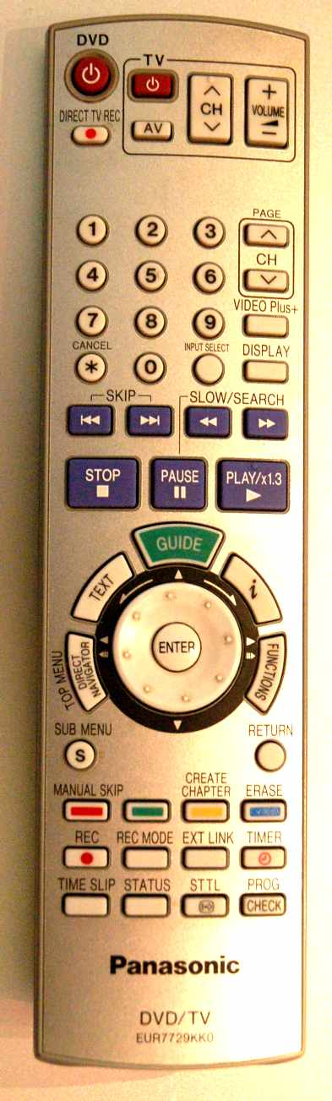
A producer is a worker who makes goods and services for other people to use and enjoy. This work can be in agriculture (growing food), manufacturing (making and assembling products such as pens, light bulbs or TVs) or services (providing a service such as legal advice). The service sector also includes creative arts such as music and film-making.

A consumer is someone who purchases and enjoys the use of commodities (items including manufactured goods and food). Definitions of ‘consumer’ can be widened to also include the purchase and / or enjoyment of music, film and TV, art, leisure, tourism and professional services.

Food miles This is a measure of how far food has travelled to reach a consumer. Some food is produced locally and may only travel a few miles.
However, most supermarkets buy food from far-away places, such as asparagus from South America, which travels thousands of miles to the UK.

Carbon footprint A measure of how much carbon dioxide is used e.g. by transporting a product from one place to another. Carbon dioxide is released when fuel is burned and for this reason it is better for the environment if we avoid consuming food and goods with a high carbon footprint. This is because too much carbon dioxide in earth’s atmosphere is causing the planet to slowly heat up.

