Ordnance Survey map interpretation task sheet
The OS map extract here focuses on Helvellyn and its surrounding area in the English Lake District. Helvellyn is one of the highest peaks in England reaching an altitude of 950 metres above sea level. The English Lakes North Eastern area 1:25 000 scale map in the Outdoor Leisure 5 series includes Helvellyn and a wider area.
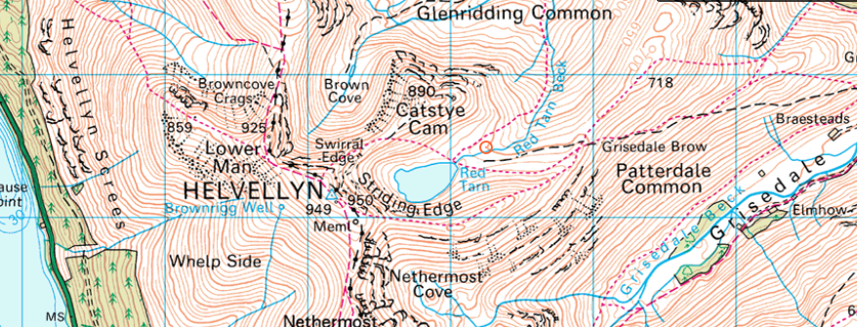
© Crown copyright and database rights (2014) Ordnance Survey
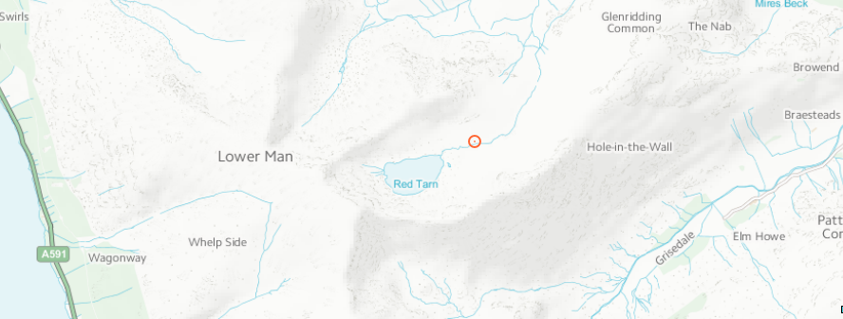
© Crown copyright and database rights (2014) Ordnance Survey
- What evidence can be seen on the map and the image that this area was glaciated?

- What type of feature of glacial erosion now contains the lake called Red Tarn?
- From looking at the map extract, label the summit (highest point) of Helvellyn onto the second image. Also add labels for ‘Striding Edge’ and ‘Helvellyn Screes’ onto the second image.
- Scree slopes are slopes of broken up, sharp and angular pieces of rock. Describe the weathering process that produced this scree.

- Name two other landscape features of glacial erosion that can be seen in the map and the image, and describe their locations in relation to the summit of Helvellyn.

- Look at the Grisedale valley and find the 700 metre contour line at the top of its northern slope. Estimate the height difference between the top of this slope down to the valley floor. (Hint: the thick contour lines are in 50 metre intervals.)

- Now take a diagonal line from north-west to south-east across Grisedale valley and sketch a rough cross-section diagram in the space below.

- Describe the cross-sectional shape of this valley. Why does this valley shape give evidence for the former presence of a glacier?

- If you were to take a field trip to the Grisedale valley, what further evidence of glaciation could you look for that is not easily identifiable from the map?

- Extension activity: visit Illustrated Glossary of Alpine Glacial Landforms website http://www4.uwsp.edu/geo/faculty/lemke/alpine_glacial_glossary/glossary.html and compare the photos of glacial landforms with each related contour map.

