Festival impacts: Map interpretation exercise
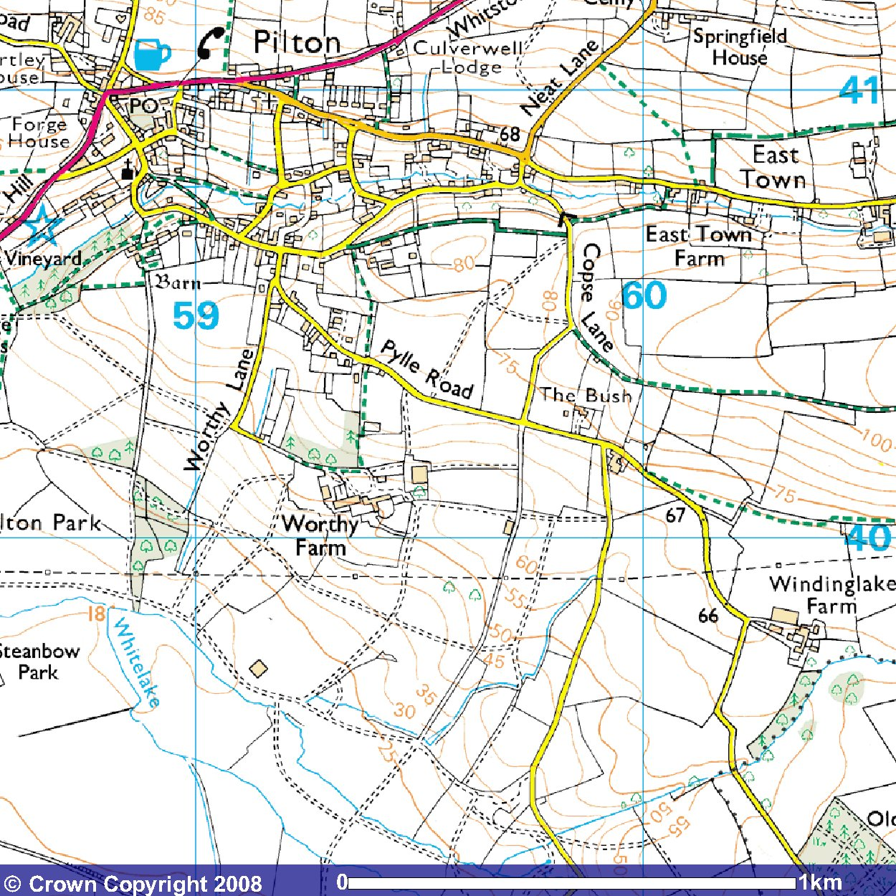

1:25,000 map extract showing Worthy Farm, the Glastonbury Festival site.

Image from the Ordnance Survey 'Get-a-map service. Reproduced with kind permission from Ordnance Survey/ Ordnance Survey
Northern Ireland.

Use the map extract above to answer the questions on the following page.

10 question quiz!



- What are the names of the two roads close to Worthy Farm which are likely to be severely disrupted by traffic over the festival weekend?
________________________________________________________________ ________________________________________________________________

- The people living at which farm might find it difficult getting in and out during that weekend?
________________________________________________________________

- What problems do you think may be caused by big water and sewage tankers coming to and fro from the site? Refer to the map in your answer.
________________________________________________________________ ________________________________________________________________ ________________________________________________________________

- If the wind was blowing due north during the festival, who might be affected by air and noise pollution?
________________________________________________________________

- If the wind was blowing strongly to the south / south-west, which natural feature at the bottom of the site might end up with lots of litter in it?
________________________________________________________________

- Give the compass point of the part of the site least likely to be affected by flooding if there was torrential rain.
________________________________________________________________

- Approximately how far is it from Worthy Farm (the main farm building at the top) to the main A361 road running through Pilton?
________________________________________________________________

- If you were trying to leave the site at peak time and crawling along at 0.5km/hour, how long would it take you to get to this main road?
________________________________________________________________

- Find the name of a road which sounds like it should be ‘tidy’!
________________________________________________________________

10. Do you think that this lane will be clean and tidy? Explain your answer!
________________________________________________________________ ________________________________________________________________ ________________________________________________________________



