MODULE 10: HOW IS INDONESIA’S PRECIPITATION CHANGING?

STUDENT ACTIVITY 1 & 2

Activity one
The first part of the graph below with the black and brown lines represents the period 1960 – 2009. The blue, green and red lines represent the predictions of change according to which of the three greenhouse gas emissions scenarios, A2, A1B and B1 is used with the climate model.

GRAPHIC 10.1
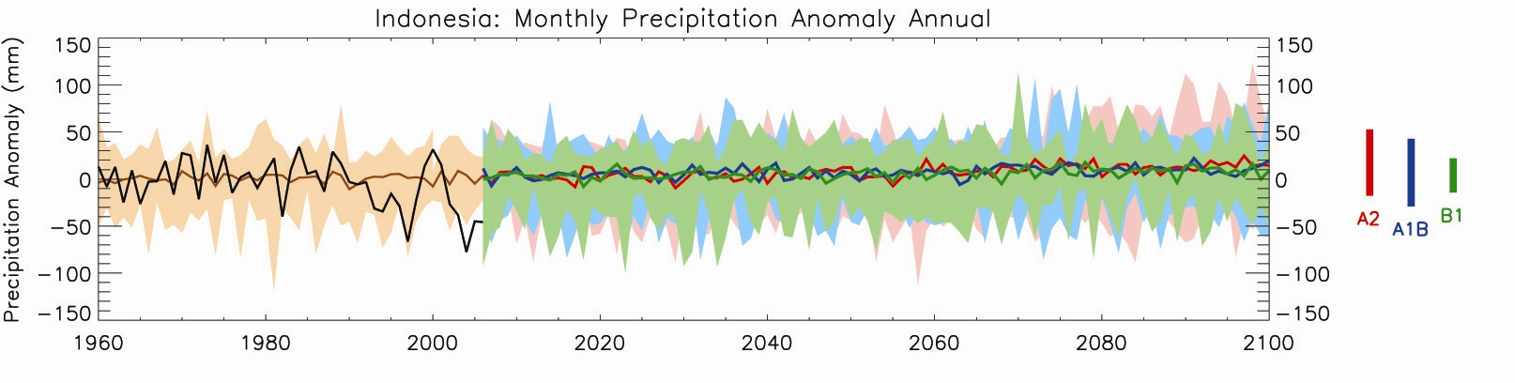
- The black line shows the precipitation anomaly for each year from 1960 to 2000.
- This is the difference, compared to average precipitation recorded between 1970 and 1999 shown by the brown line.
- The brown shading shows the range of precipitation anomalies.
- The green, blue and red lines show projected future precipitation from 2009 to 2100, according to three different emissions scenarios – B1 green (low), A1B blue (medium) and A2 red (high).
- The coloured bars summarise the range of precipitation for each emissions scenario, which was explained in Module 2.

- What is the general trend of the brown line?
- What happens to the black line?

Activity two
- What are the general trends of the precipitation in these scenarios?
- Which regions might have more rainfall and which ones less? Think of proximity to the sea, global wind patterns, altitude and latitudinal effects.

PERSONAL Activity
What will be the effects of changes in precipitation and temperature where you live?
How will a change in the amount of precipitation affect your lifestyle?

