Africa – a continent of contrasts

Lesson 5: Ghana – an African success story

Key Ideas:
- Ghana is a country in west Africa
- Ghana is an example of a successful African nation. In spite of problems and challenges, it has made progress and improved the lives of the majority of the people in recent years.
- Ghana has a number of successful export products but is also actively seeking to promote new products.
- The high cost of imports, particularly oil is a problem for the balance of trade in Ghana.

Starter activity:
Using the Ghana’s export products photo set discuss the range of items that Ghana exports to make money. Is there a common link between the kinds of exports that Ghana sells? What might each of these products be used for?

Main activity:
It is difficult with young students to set the scene but according to the World Bank Ghana has, relative to other African countries, a successful economy and this is providing benefits to the people although it is accepted that there are many problems and progress is sometimes slow.

“Since 1983, when the Economic Recovery Program was launched to save the economy from collapse, emphatic results have been recorded, in spite of periodic lapses. Today, Ghana is one of the best-performing economies in Africa.

Overall poverty has declined from 52% in 1992 to 28% in 2006, and Ghana is on course to exceed the 2015 MDG of halving her poverty. Real GDP growth averaged 5% from 1983-2006. Since 2005 it has hovered at 6%. Following successful HIPC debt relief in 2004, and further cancellations by donors, Ghana’s external debt, about $6 billion in 2001, is almost entirely written off. Good results from the Growth and Poverty Reduction Strategy have enabled a stable economy, with inflation and interest rates nearing single digits. Ghana looks determined for economic takeoff.” (World Bank Report 2008)

There is scope to do quite a lot of work with the data available although some students will need support in terms of how the data is presented and the task they are presented with.

The Excel spreadsheet Ghana Exports Data shows the main products that are exported for the years 2003 – 2007. This is sufficient to look at the relative importance of the main products and the trends in exports over time. Students will need to appreciate that there are wide variations in the value of different export products and that export quantities change from year to year. The data can be simply ranked for importance and then one or two key products graphed to show trends. Once this has been done, a greater understanding of the rankings and the changes can be developed through questioning. Cocoa is a good example to show variations in volume of exports. Gold is a good example to use to show both changes in volume and value. Comparing the years 2005 and 2006 shows some interesting results.

This leads on to the use of the Excel spreadsheet Ghana Exports Commodity Prices Data. The data is quite detailed and shows monthly changes for 2005 to early 2008. There are several key messages in this data which again would benefit from being graphed to show trends. The data could be presented to the students in graph form if the intention was to simply look at the changes. Manganese is the best example of a product which shows large fluctuations in price. The price of gold shows a consistent upward trend for this period. Oil is an interesting dilemma for Ghana – it currently has to import (at great cost) most of it’s oil requirements but the discovery of oil offshore means that in future Ghana could see great benefits from high world oil prices.

The third Excel spreadsheet provides data on Ghana Export Partners. Again this data could be manipulated and presented in various ways and provides an insight into the changes over time.

If you wanted to spend more than a single lesson on this topic, there is much scope to look at individual products in more detail. Cocoa has been a key export from Ghana for over 50 years and there is much good material on the internet on cocoa growing and chocolate.
Oxfam’s Cool Planet website:
http://www.oxfam.org.uk/coolplanet/ontheline/explore/journey/ghana/cocoa.htm
Dubble, the Comic Relief Fair Trade chocolate bar
http://www.dubble.co.uk/bean2bar
Divine, another Fair Trade chocolate bar
http://www.divinechocolate.com/about/bean-to-bar.aspx
Jamieson Chocolate
http://www.chocolatebyjamieson.com/process/index.shtml
This website has a well written section on ‘How to eat fine chocolate’ – worth a read in case you didn’t know!
http://www.omanhene.com/node/3

There is also material available on Ghana’s attempts to market new products – pineapples are a good example of a success story. The story has been slightly complicated by the fact that researchers in Ghana have discovered a new super-sweet variety of pineapple (popular in Europe) which they have nicknamed MD2. It will take a while to plant and establish this new pineapple on farms.
For more information visit these websites:
http://www.modernghana.com/news2/172935/1/ghana-pineapples-preferred-in-germany.html
http://www.fairtrade.org.uk/producers/pineapples/blue_skies_products.aspx

Plenary:
In terms of keeping the economy moving forward, Ghana faces many challenges. One of the dilemmas (not unique to Ghana) is whether to exploit resources which are in areas that are environmentally sensitive and have legal protection that in theory prevents activities such as mining. The Forest Reserves of Ghana are one such example where in the last 10 years, large deposits of gold and other precious minerals have been discovered. The issue provides food for thought and could be the basis for a thoughtful individual homework which could be presented as a piece of writing or as a ‘Should We – Shouldn’t We’ poster of key points.

This URL details the problem:
http://www.minesandcommunities.org/article.php?a=1387
BBC Reports from 2003:
http://news.bbc.co.uk/1/hi/world/africa/2724339.stm

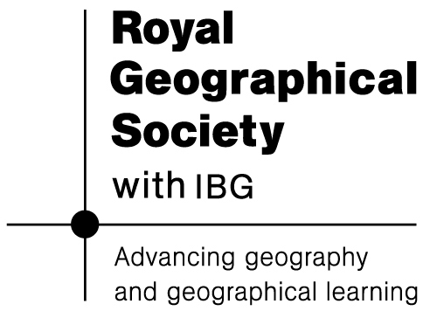
http://news.bbc.co.uk/1/hi/business/2783873.stm

