Ecosystems
A small-scale study of the school grounds

Background

This module has been designed to enable students to learn and practice a variety of fieldwork techniques in their school grounds. It is aimed at Key Stage 3, and would fit into a unit of study on ecosystems; a standard component of the KS3 scheme of work.
Students will be presented with a map of the school grounds, showing several different sites. The fieldwork will involve them investigating both the soils and the microclimate at each site. They will then analyse and compare their findings, and will use thinking skills and independent research to make informed decisions about which is the most suitable site for a vegetable garden.
This activity could be presented as a “fieldwork mystery” where students take on the role of “fieldwork detectives” who investigate the options and make decisions to solve the question “which is the most suitable site for our new vegetable garden?”

Aims

- To learn and carry out a variety of fieldwork techniques to investigate the soils and microclimate in different locations within the school grounds
- To analyse and compare the sites, and make informed decisions about the best location for a vegetable garden

Objective

Students work in small groups and use a variety of fieldwork techniques to investigate each given site. At each site they will collect data on;

- Soil type
- Soil pH Soil data
- Soil infiltration rates
- Aspect of the site
- Temperature
- Wind direction Microclimate data
- Wind speed
- Precipitation

Format

Starter
Show students the start of the PowerPoint presentation. Re-cap / introduce and discuss the key terms to do with ecosystems. Ensure pupils’ understanding through questioning and encourage them to fill in the starter activity sheet.

Main
The aim of the main activity is to use their maps of the school grounds to visit each site and carry out the soils and microclimate fieldwork. The presentation introduces the fieldwork.
Background information on the soils in your area can be found at www.landis.org.uk/soilscapes/. The image below is a screen shot taken from this website, of the Llangollen area in North Wales. A report of the soils at your school site can be obtained from www.landis.org.uk/sitereporter/. This will help to decide on the study sites.

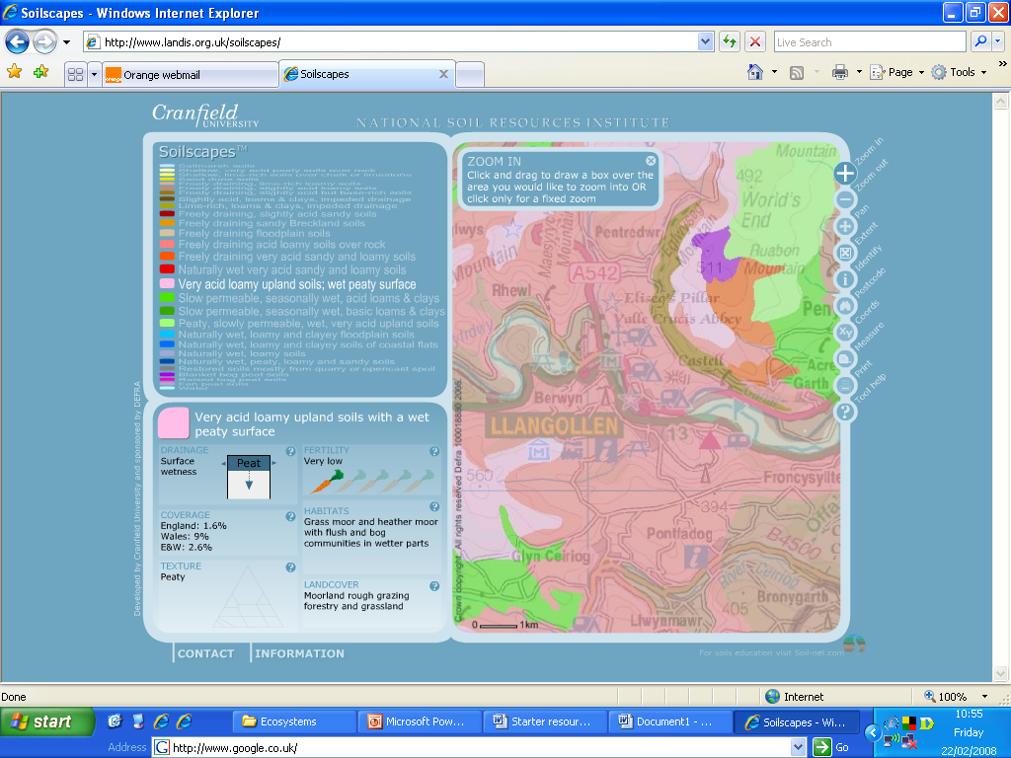

Key to colours
Toolbar to zoom in / out e.t.c.
Key to colours
Toolbar to zoom in / out

More detailed information on the soil
More detailed information on the soil

Before starting, it is important that the students know;

- What techniques they will be using
- Where they will be carrying them out (understanding the school map!)
- How to carry out each technique
- How to record their data

A separate teacher guidance resource has been provided, which gives details on the different fieldwork techniques and where to find information and resources. Each chosen technique should be discussed and demonstrated to the students, and the data-collection table should also be gone through.

The students should work in groups of three or four. Start each group off at a different site, and they should then use their map to locate the other sites and carry out the data collection at each.

Some coordination and monitoring by staff will be required.

Follow-up

The presentation introduces the follow-up activities and also encourages students to think about the wider implications of their ecosystem study, e.g. large-scale ecosystems and biomes.
In order to analyse their data, students should complete the tasks on the ‘follow-up resource 1’ sheet, which will summarise their findings. There are instructions and tasks on this sheet, which take them through each set of data they have collected.
Once they have analysed the data, they should have a good idea about the conditions at each site. The ‘Follow-up resource 2’ asks them to decide on the best site for the vegetable garden, and then decide on what would be the most suitable vegetables to grow here. They must conduct independent research (web-links have been given) and use this, along with the data they have collected, to make decisions and justify them.

Differentiation / Extension

During the fieldwork - more able students can complete all tasks at every site. Alternatively, different groups of students could be given just one or two sites which they are in charge of, and the results can then be shared once back in the classroom.
More able students could be encouraged to design and make their own fieldwork equipment for soil infiltration, wind direction, and wind speed. This could be developed into a cross-curricular ‘project’ between Geography and Technology or Science, which could be written up more formally.
Differentiated resource links have been provided in the ‘additional teacher information –fieldwork techniques’ resource.
In the follow-up, teacher and peer support is important in completing the ‘follow-up resource 1’ sheet. Guidance has been given for each task, but lower ability pupils could work in pairs or be provided with a writing frame. There are extension tasks for more able students on this sheet.
During ‘follow-up resource 2’ tasks 1 (a) and (b) can be discussed as a class to help get them started. The research can either be carried out independently (more able students) or in pairs (less able students). Lower ability students could be provided with some basic printed information about different soils and vegetables to help them, rather than trawling through often complicated and detailed websites.
An extension of this fieldwork activity could be to ask students to not only think about a vegetable garden, but to draw up a ‘plan’ for the whole school grounds. Based on the data they’ve collected, they could decide on the best location for seating, a wind turbine for renewable energy, a conservation area / wildflower meadow, etc.
An extension resource looking at biomes has been provided. In this activity, students make links between the variations they’ve found in their small-scale study and variations on a biome-scale. They research the different abiotic features of different biomes and then use this information to decide on the best location for different ‘Educational Eden-Zones’ within the school grounds.

Embedding this fieldwork activity

The National Curricula for both Geography and Science include the study of ecosystems. This fieldwork activity would fit nicely at the end of the unit, where the theory could be revised and students could be given the opportunity to learn and practice various fieldwork techniques. This will become important for those who take GCSE geography and carry out coursework investigations.
There are strong cross-curricular links, and these could be further developed through cross-curricular projects.

Adapting this activity for alternative sites

Due to the nature of the activity, it should be straight forward for most schools to carry out. The number of study sites can be adapted to suit the school grounds, available time and ability of the students. If the school already has a vegetable garden, the study could be adapted to ask ‘why was this site chosen?’, or ‘is this the best location for it?’

Resources

- PowerPoint presentation
- Map / plan of the school grounds, showing study sites
- Other resource sheets for starter and follow-up activities
- Field work resource sheet for data collection
- Soil type ID key – resource ideas and links given in teacher information resource
- Internet access for research

