What has the most impact on the environment of Antarctica?

Cut out each card and in your groups decide what has the most impact on the environment. Place them in order using the grid below.

Climate Change  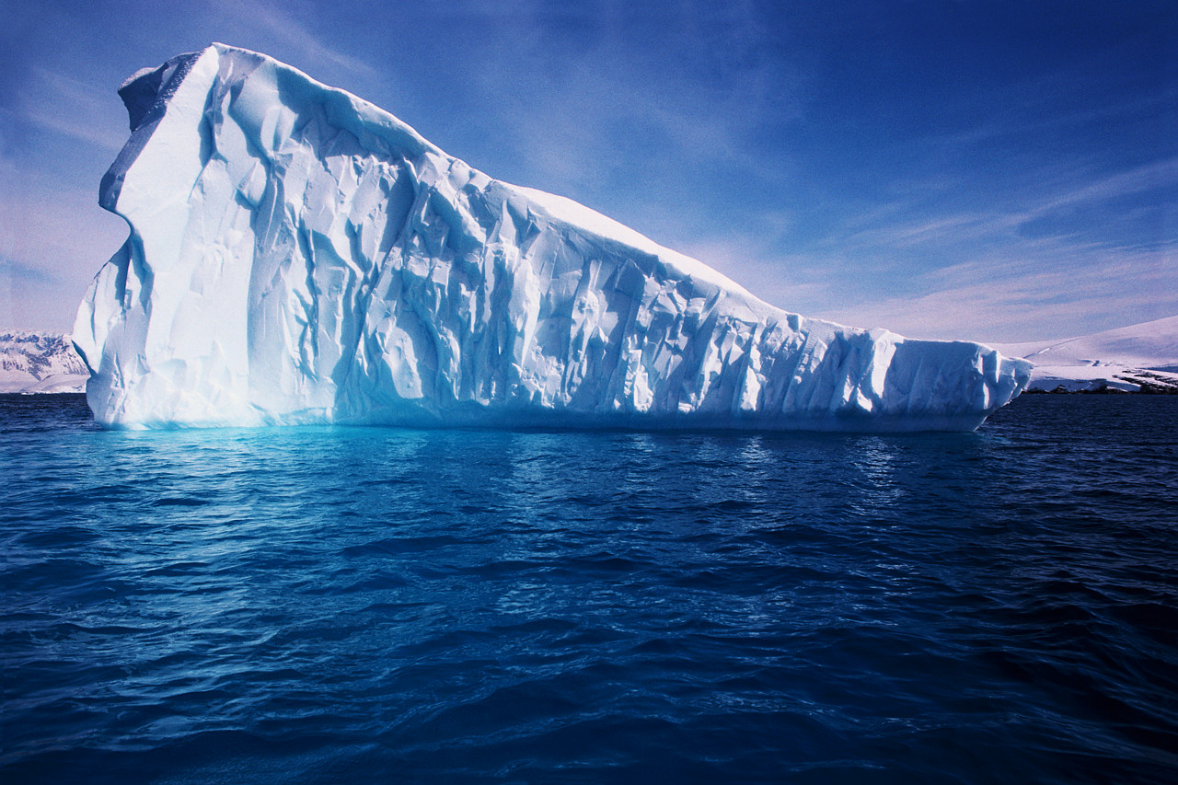 | Less ozone | Whaling  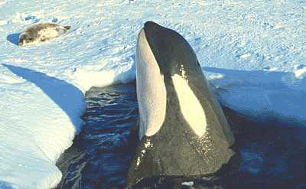
Sealing  Hunting of seals for fur and oil  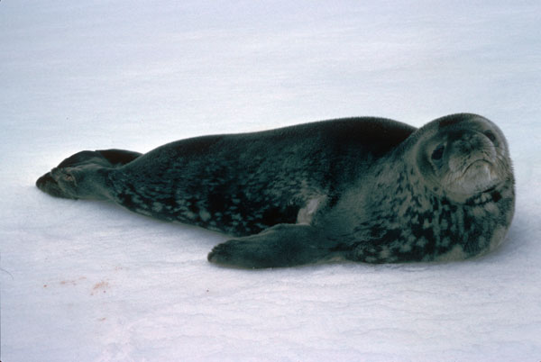 | Fishing  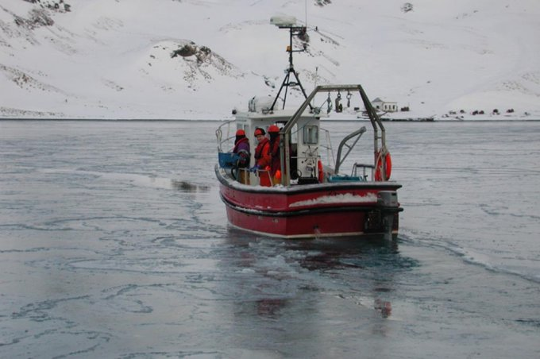 | Research stations  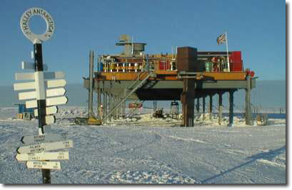
Transport  Ships for scientists, tourists  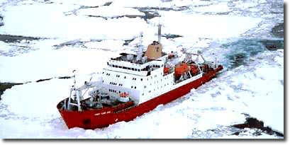 | Tourism  Tourists going ashore on ships  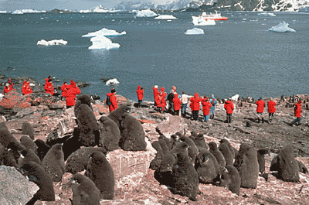 | Global Highway  A 1,000-mile road to link McMurdo Station on the Antarctic coast to the Amundsen-Scott base

Rank 1

Rank 2
Rank 2

Rank 3
Rank 3
Rank 3

Rank 4
Rank 4
Rank 5

