Cool Biz

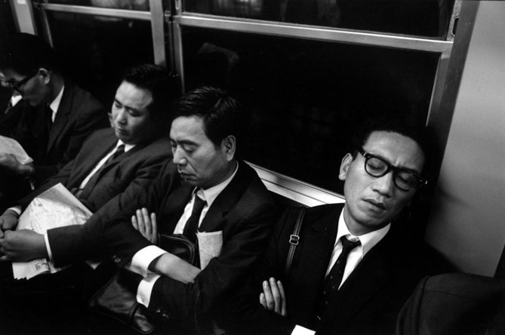
The Japanese government started the Cool Biz campaign in the summer of 2005 to help save energy. The campaign tried to persuade office workers to abandon their jackets and ties as they were asked to cut down on using air conditioners in the office.

It asked businesses to set air conditioners at 28°C making the standard tie and jacket unbearably hot. Many office workers used to a formal dress code at work said how uncomfortable they felt in more casual clothes. Attending a formal meeting without a tie or in short sleeves is thought to be impolite, although today younger employees are beginning to dress casually in the summer heat. Demand for casual business wear amongst those in their twenties and thirties is on the rise and designers and manufacturers have been developing cooler and lighter informal business wear over the past four or five years.

Politicians dressed casually by wearing short sleeved shirts and wearing trousers made from light weight material. The government carried out a survey in October 2005 and estimated that that the campaign resulted in a 460,000 ton reduction in CO2 emissions, the equivalent volume of CO2 emitted by about 1 million households for one month.

