Where do most billionaires live?

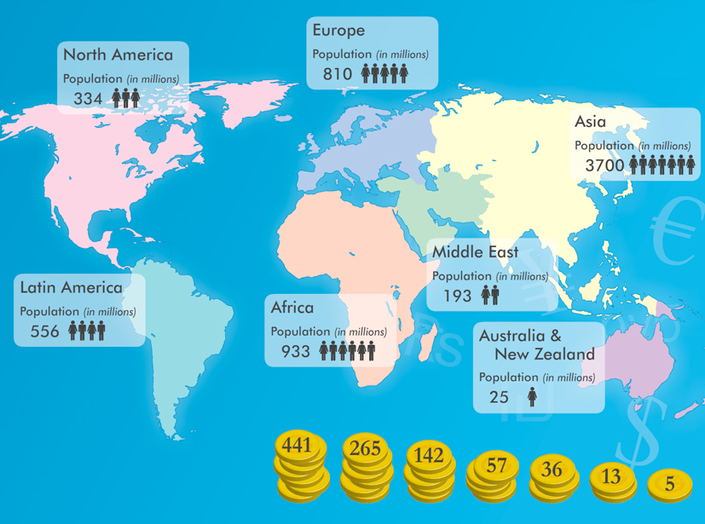
The number of billionaires in the world is growing all the time. But where do these billionaires live? Which region has the most? And is there a link between number of billionaires and population size?

Have a look at the map above. Each pile of coins shows the number of billionaires who live in one of the regions on the map. Can you guess which pile of coins goes with which region?
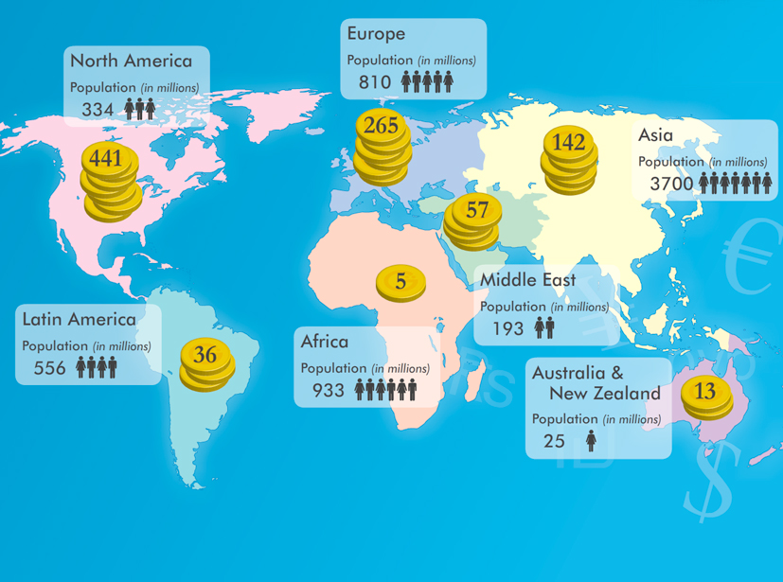

As you can see, the number of billionaires is not proportional to its population.
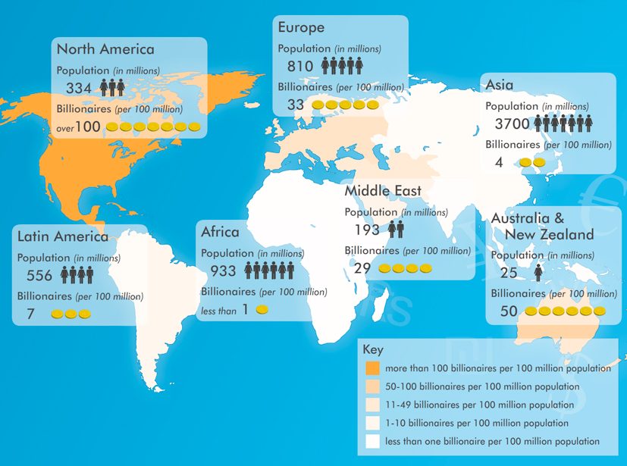

This choropleth map shows the number of billionaires per 100 million population.

Region | Population (millions) | Billionaires total | Billionaires per 100 million population
Africa | 933 | 5 | 1
Asia | 3700 | 142 | 4
Australia & New Zealand | 25 | 13 | 50
Europe | 810 | 265 | 33
Latin America | 556 | 36 | 7
Middle East | 193 | 193 | 29
North America | 334 | 441 | Over 100

