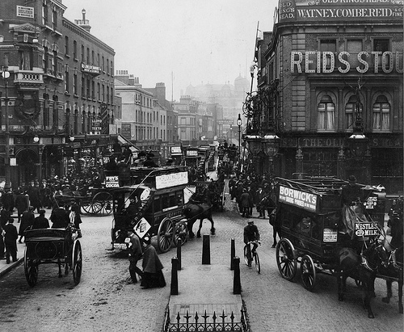
Our Place in History

Lesson 2: Local people

Key ideas:
- The population of an area can change over time.
- People’s experiences of an area may change over time.

Starter activity:
Higher or lower
The aim of this lesson is to look at the population of the local area and to try to describe and explain patterns in the data. In this starter activity pupils are given a series of different factors which may cause the population to either rise or fall. They have to decide what would happen to the population with each factor and be able to explain their decisions.

Main activity:
Population trends
The main aim of this and the following activity is to try to encourage pupils to be able to describe and explain population patterns in the local area in an engaging and interactive way. This first activity asks pupils to practice an important and traditional skill of being able to plot geographical information on a graph. The data they are plotting is population data for the local area, the main source of this information being from the census.

Being a graph!
This second activity links to the first and brings a new meaning to the familiar concept of ‘living graphs’. Pupils physically recreate the graph they have just plotted with metre rulers being used for the axis, pupils taking the place of the plotted points and string used to join them together. Pupils can then be interviewed to explain why they think the population data has this pattern. They could link back to the starter activity for help, and could be asked to think about which of the factors are most likely within the context of their local area.

Living histories
The second aspect of this lesson is to examine people’s changing experiences of the local area. This can be done in two ways. Firstly, a person who has lived in the local area for some considerable time could be invited into the lesson to provide an oral history of the local area. Pupils could prepare questions which they can ask about the local history.

Blue plaque
If it is not possible to invite someone in to give an oral history, the pupils could complete this activity instead. It asks them to investigate – ideally through the system of blue plaques – famous people who have lived in the local area. Whilst the blue plaque system is an excellent way of identifying famous local people, some towns – my own included – do not have a comprehensive system. In this case pupils could choose a famous local person and write a biography of them.

Plenary:
My local history
It is important to see geography through the pupils’ eyes and so the plenary to this lesson asks them to think about the changes to the local area that they have seen in their lifetime. They should discuss this with their neighbour before sharing ideas as a class.




