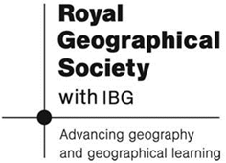
Information Sheet:
The Environment

Indonesia is an archipelago located between Asia and Australia and between the Pacific and Indian Oceans. Both oceans have affected the diversity of seaweed species. It possesses largely coral reef coastline, more than 81.000 km in length of coastal line and occupies an area of 8.5 million km2. The archipelago consists of 17,000 islands. Kalimantan is the biggest island follow by Papua, Sulawesi, Sumatera and Jawa island respectively. Many islands characterize part of coastline is a large and suitable environment for seaweeds.

Information on the route the researchers took: http://huggingthecoast.net/?page_id=181

