Trolley Talk
Fieldwork booklet

You are going to be investigating how sustainable your local stores and supermarkets are. You are going to collect data in each store or supermarket on;

- Packaging of fruit and vegetables
- Range of UK-grown fruit and vegetables sold
- Range of recycled products sold
- Range of eco-friendly products (e.g. Ecover) sold
- Range of fair trade products sold
- Checkout bags
- Recycling facilities at the store

You should make sure that you read the instructions carefully before completing each table of data clearly, accurately and fully. This will enable you to draw comparisons between the different stores or supermarkets and make decisions about which is the most sustainable.

Start by filling in the names of each store or supermarket you are going to be investigating at the top of each table.

Data Table 1: Packaging of fruit and vegetables

Go into the fruit and vegetable aisle(s) or section of the store. Read each question in the left hand column of the table carefully. Look around the fruit and vegetable area and decide whether the answer is ‘yes’ or ‘no’. Place a tick in the appropriate column. Do this for each store or supermarket until the table is complete.

 |  | Name of store / supermarket
Is there evidence of shrink-wrapping Clingfilm on cucumbers and /or other vegetables? | Yes
 | No
Is there evidence of small packs of fruit or vegetables in polystyrene trays? | Yes
 | No
Are you able to buy most fruit and vegetables loose (not pre-packaged)? | Yes
 | No
In your opinion, is there evidence of severe excess packaging in this store? | Yes
 | No

Data table 2: Range of British-grown fruit and vegetables (air miles)

Stay in the fruit and vegetable aisle(s) or section of the store. Read each question in the left hand column of the table carefully. Look around the fruit and vegetable area and decide whether the answer is ‘yes’ or ‘no’. Place a tick in the appropriate column. Do this for each store and supermarket until the table is complete.

 |  |  | Name of store / supermarket
Find the following items and see whether they’ve been produced in the UK | Apples | Yes, all varieties
 | Apples | Yes, some varieties
 | Apples | No
 | Potatoes | Yes, all varieties
 | Potatoes | Yes, some varieties
 | Potatoes | No
 | Leeks | Yes
 | Leeks | No
 | Carrots | Yes
 | Carrots | No
 | Cauliflower | Yes
 | Cauliflower | No

Data table 3: Range of recycled products sold

You need to try and locate the items listed in the left hand column of the table. If you can’t find them, tick ‘no’, and if you can tick ‘yes’. Then see whether the supermarket also sells its own brand of the product. If it does, also tick ‘own brand sold’. Complete the information for every store and supermarket you visit.

 |  | Name of store / supermarket
Recycled bin bags | No, not sold
Recycled bin bags | Yes, sold
Recycled bin bags | Own brand sold
Recycled toilet tissue | No, not sold
Recycled toilet tissue | Yes, sold
Recycled toilet tissue | Own brand sold
Recycled kitchen roll | No, not sold
Recycled kitchen roll | Yes, sold
Recycled kitchen roll | Own brand sold

Data table 4: Range of ‘Ecover’ products sold

You are going to try and locate the ‘Eco-friendly’ products listed in the left-hand column of the table (most will be in the household / domestic / cleaning area). ‘Ecover’ is a brand of eco-friendly domestic and cleaning products, and is the one you’re most likely to find. If you can’t find them, tick ‘no’, and if you can tick ‘yes’. Complete the information for every store / supermarket you visit.

 |  | Name of store / supermarket
Eco-friendly laundry liquid and / or powder and / or tablets | Yes
Eco-friendly laundry liquid and / or powder and / or tablets | No
Eco-friendly fabric softener | Yes
Eco-friendly fabric softener | No
Eco-friendly washing up liquid | Yes
Eco-friendly washing up liquid | No
Eco-friendly dishwasher tablets and / or rinse aid | Yes
Eco-friendly dishwasher tablets and / or rinse aid | No
Eco-friendly surface cleaner | Yes
Eco-friendly surface cleaner | No
Eco-friendly toilet cleaner | Yes
Eco-friendly toilet cleaner | No
Eco-friendly floor soap | Yes
Eco-friendly floor soap | No
Eco-friendly shower gel | Yes
Eco-friendly shower gel | No
Eco-friendly hand soap | Yes
Eco-friendly hand soap | No

Data table 5: Range of Fairtrade products sold

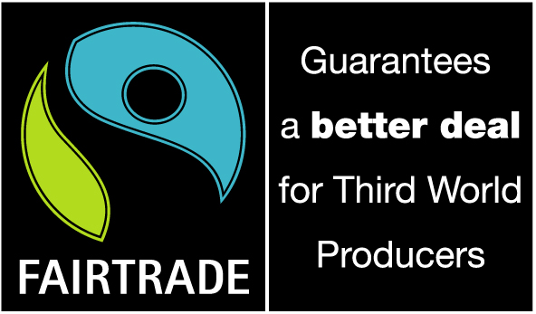
You will have to do a bit of searching to find the products listed in the left hand column. You must look for the Fairtrade symbol, which look like this: (image from www.fairtrade.org.uk).

Tick ‘yes’ if you find the Fairtrade item, and ‘no’ if you don’t. If the store / supermarket produces its own-brand Fairtrade version of the item, tick ‘own brand sold’.

 |  | Name of store / supermarket
Coffee | Yes
Coffee | No
Coffee | Own brand sold
Tea | Yes
Tea | No
Tea | Own brand sold
Hot chocolate / cocoa | Yes
Hot chocolate / cocoa | No
Hot chocolate / cocoa | Own brand sold
Chocolate bars | Yes
Chocolate bars | No
Chocolate bars | Own brand sold
Sugar | Yes
Sugar | No
Sugar | Own brand sold
Wine | Yes
Wine | No
Wine | Own brand sold
Bananas | Yes
Bananas | No
Bananas | Own brand sold

Data Table 6: Checkout bags

Go to the checkout and have a look at the bag options available. Complete the following table by answering the questions in the left hand column for each store / supermarket you go to.

 |  | Name of store / supermarket
Are the carrier bags made from recycled plastic? | Yes
Are the carrier bags made from recycled plastic? | No
Are the carrier bags recyclable? | Yes
Are the carrier bags recyclable? | No
Are the carrier bags bio-degradable? | Yes
Are the carrier bags bio-degradable? | No
Are there ‘bags for life’ (strong, re-usable bags) | Yes
Are there ‘bags for life’ (strong, re-usable bags) | No
Is the use of these bags being promoted? (e.g. through signs) | Yes
 | No
Are there incentives for customers to use less plastic bags? | Yes
Are there incentives for customers to use less plastic bags? | No
Is there a carrier bag recycling point for customers to return their bags? | Yes
 | No

Data Table 7: Recycling facilities

You need to find the recycling facilities at the store / supermarket, if they have any. These are usually located in the car park, although there may be a ‘station’ for recycling of their shopping bags in-store. Fill in the table by placing a tick next to the items / materials which can be recycled.

Name of store / supermarket
Item
Paper
Glass
Cans
Clothes
Plastic
Cartons
Books

