Adaptations to our architecture

As the temperatures get warmer in the United Kingdom, architects will be required to change how they build our homes and offices. Traditionally we have constructed our homes to keep us warm, however, this will need to change if we need to keep cool in the sweltering winter months. We also need to develop sustainable architecture, which will minimise the carbon emission of our homes, at present vast quantities of carbon are wasted through poor insulation and high heating bill. In an attempt to show how this may change in the future, pioneering developments have been appearing on our landscapes.

BedZed

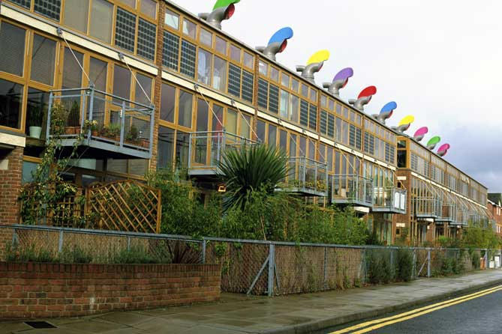

Beddington Zero Energy Development (BedZED) is the UK's largest carbon-neutral eco-community – the first of its kind in this country. BedZED was developed by the Peabody Trust in partnership with Bill Dunster Architects and BioRegional Development Group, environmental consultants. The development holds 82 energy efficient houses, a nursery, organic café/shop and clubhouse, which have all been designed to not only reduce the environmental impact of the buildings but also of the residents who live there.

Key Features

Energy Efficiency

- All the new houses face south, which maximises their exposure to solar radiation. This radiation is converted to clean energy by Photovoltaics, saving 200 tonnes of Carbon emissions every year.
- A sunspace ‘buffer zone’ on the south of every building stores solar radiation through out the summer, providing up to 25% of the home heating needs in the winter.
- Sunlight’s are positioned to maximise light into the dwellings reducing the need for electricity.

Waste Reduction

- Low flush toilets and spray taps reduce water consumption
- Uses rainwater, not the water you drink, for flushing toilets
- Roof garden harvests water for own irrigation and also insulates the house
- All materials used in the construction were sourced from within a 35 mile radius and insulated by jacket around each house.

Clean Power Sources

- The homes and offices at BedZed are provided with heated water by an on site power plant, this is fed by wood cutting that are destined for landfill and are carbon neutral.
- A green transport plan has been developed which encourages resident to walk, cycle and use public transport. A car pool has been successfully set up, in which residents share cars to reduce carbon emission.

Links

http://www.peabody.org.uk/FileStore/PressRoom/downloads/BedZEDfactsheet.pdf- BedZed fact sheet from the site developers

http://www.bioregional.com/programme_projects/ecohous_prog/bedzed/bedzed_hpg.htm- Solutions for sustainability, an overview of the BedZed project

http://www.architecture.com/go/Architecture/Debate/Sustainability_2668.html- RIBA website, which provides information on pioneering developments in the UK, including BedZed and Millenium Village Greenwich.

http://www.housesofthefuture.com.au/hof_houses01.html- Six houses of the future from Australia, good ideas to browse through, including a cardboard house.

