
Are you flood ready?

There are FOUR types of flooding and nearly EVERYONE in the world is at risk from at least one of these.

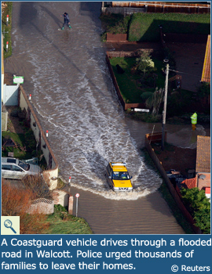
- River flooding – the river has burst its banks. This is due to heavy rainfall that has run off the land surrounding the river (this area is called the river valley and its boundary is called the watershed). River flooding is made worse when river bank defences fail; it is also made worse by concrete (as rain can’t soak into the soil and more heads to the river).

- Coastal flooding – this can sometimes happen when there is a high tide and a storm is blowing at the same time. Winds drive the high tide further inland than usual.
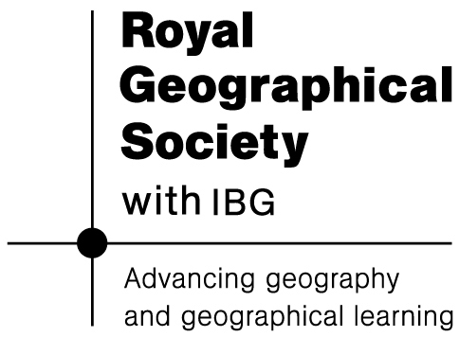

- Pluvial flooding – this is a weird word, what can it mean? Basically, when heavy rainfall collects in hollows and depressions where homes are located, local floods can occur. This can happen far from a river. Lots of families are at risk from pluvial flooding who don’t realise it. Blocked drains and sewers make things worse as rain cannot drain away. We didn’t realise just how bad this could be in the UK until the floods of June 2007.


- Plumbing flooding – Broken pipes (when water in them freezes and expands) or broken boilers can cause floods. Old pipes and taps can break. It’s made worse when people don’t know where their stopcock is and cannot turn off the water quickly. Even someone living on the 39th floor of a building can be flooded by a burst pipe on the 40th floor!

