Lesson 2
Can the internet unlock Africa’s human resources?

Starter
Different types of resource

African nations have often suffered from on-going power and wealth struggles linked with the ownership of natural resources. These have frequently been a cause for conflict in West Africa (the issue recently gained a great deal of publicity during the 2010 trial of Charles Taylor, the former Liberian president, who was accused of war crimes while involved in the 2002 civil war in Sierra Leone. The troubles in Sierra Leone were linked with a struggle by different groups of people to take possession of the diamond trade).
Specification advice

Students of all A-level boards ought to be familiar with the importance of human resources as a core factor explaining the geography of globalisation. For Edexcel, this is a compulsory AS-level topic. For the IB diploma, it is a core element of Global Interactions (the HL extension paper). For other boards, it is a very popular optional topic.

West Africa is rich in natural resources. The soils contain gold, ores and gems; the valuable crops that grow there include cocoa, coffee and timber. Yet this is an area with a history of great unrest, with blood regularly split - as vying factions try to wrest control of the sources of natural wealth. It has even been suggested that Africa suffers from a resource curse.
Key terms

Natural resource Some part of the physical environment that has been used to satisfy human needs and wants. Natural resources may be renewable (sustainably managed forest, wind power and solar energy) or non-renewable (fossil fuels).

Under-development theory A view that suggests some place are less developed than they might otherwise be on account of external interference such as colonialism and neo-colonialism.

Resource curse theory The view that natural resource endowment may retard rather than accelerate economic and social development for some places, on account of the role resources often play in triggering war, corruption or the neglect of other development paths.

Human resources The working-age people found in a place who can generate wealth with the skills and capabilities they possess.

In many countries, minerals or oil make up as much as 80 per cent of government income. Obtaining profit from the natural resources distracts governments from more demanding forms of taxation. It may be that this undermines the relationship between the ruler and the ruled. Leaders neglect to maintain the country’s infrastructures and instead rely on their own cosy relationships with foreign mining and oil companies. This lack of balance allows corruption to flourish.

One way to break this cycle is to develop new forms of commerce that are based on human resources - the skill and creativity of people. So delivering reliable online connectivity to Africa becomes vitally important if people are to be given the tools and skills they need to fully harness their capabilities in the global marketplace.

Main activity
(1) Technological “leap-frogging” in Africa

The need for connectivity

As a result of the failure of a recent US-led trade plan for Africa, experts identified the main obstacles to development in the poorest parts of the continent. They made the following observations:

- African countries suffer from systemic poverty
- African countries have extremely low wages
- Industry production costs are too expensive
- Intermittent power supplies deter investors
- Poor transport systems deter investors
- Government corruption deters investors and builds poverty
- African manufacturers struggle to compete with the efficiency of China

These findings come after the failure of a 10-year plan called the African Growth and Opportunity Act (Agoa). It extended access to the US market for producers in 40 African states. Initially it was thought that a lack of access to the US market could be one reason why development in Africa was taking place more slowly than in, say, China. However the experiment suggests that there are many other factors to consider too: problematic African infrastructure seems to be especially at fault. Could ‘leap-frogging’ towards high-speed internet access help make infrastructure problems a thing of the past?

Delivering connectivity through “leap-frogging”

Providing Africa with the connectivity it needs - both for education and new forms of commerce - has become a much more realisable goal in recent years with the advent of new digital technologies.
Key terms

Leap-frogging This term describes what happens when a society moves straight to adopting a new, advanced form of technology without having invested in an earlier version (e.g. societies that adopt mobile phones without previously having landlines).

Switched-on place This term describes a place that is physically connected to electricity supplies and has internet access; it is also a metaphor for places that have become hubs for globalisation and are well-connected due to global flows of investment or labour.

- The mobile phone is playing a leading role in creating switched-on places across the planet, including many of the world’s poorest societies. In 2009, there were an estimated 4.3 billion mobile subscriptions worldwide: roughly six per ten people alive today. Cheap mobiles are increasingly affordable to all but the world's very poorest subsistence and slum communities.
- Broadband connectivity is improving all the time. Although access to the internet generally remains very poor in East Africa, Kenya’s growing call centre industry is starting to attract interest and investment from the fibre optic cable companies that build global broadband networks.
- Other notable technological changes across Africa include the recent arrival of innovative wind-up radios designed by Trevor Baylis. Cheap laptops for children are championed by many organisations, including OLPC (One laptop Per Child) and Intel.

Case Study: “East Africa finally joins broadband revolution”

The recent arrival of the 10,625-mile Seacom cable, has drastically lowered the cost of high-speed internet services and telephone calls. East Africa was previously dependent on expensive and often unreliable satellite links, which prevented the spread of affordable internet access.

The $600m (about £360m) Seacom cable, which is owned mainly by African investors, now links South Africa, Tanzania, Kenya, Uganda and Mozambique with London, Marseille and Mumbai. In Kenya, the cheaper bandwidth has boosted the nascent call-centre and outsourcing industry.

Internet service providers are hoping the growth in web usage will now follow a similar path to that in the mobile phone sector, where the number of lines has grown from 15,000 to 22 million – one for every two Kenyans – in a decade. With laptops still too expensive for many people, it is expected that cheap, web-enabled phones will play a major role in spreading internet access.

Adapted friom: http://www.guardian.co.uk/technology/2009/jul/23/east-africa-broadband-revolution

Less than two years after completing its undersea link connecting southern and eastern Africa to the rest of the world via India and Europe, SEACOM reported (18 April 2011) that:

- Major internet hubs are now in place in Dar es Salaam, Johannesburg, Maputo, Marseille, Mombasa and Mtunzini.
- African countries are now independently communicating with one another through a single seamless network (without Internet traffic being transferred via Europe).
- Although the majority of internet content consumed in Africa is still non-African (flowing from Europe and North America into Africa), a rapid increase in African content is predicted.

Source: http://www.seacom.mu/news/article-4/seacom-s-evolving-network-drives-african-internet-growth/

Case Study: Ghana’s SOFTtribe company

Herman Chinery-Hesse is the chairman of Ghana’s SOFTtribe company, one of the leading software houses in West Africa. He has been described by the BBC as “Africa’s Bill Gates”. Chinery-Hesse believes that technology is vital if the value of African human resources is to be unblocked: "If Africa misses the current global IT boat, there may never again be an opportunity for rapid wealth creation on the continent."

He adds: "Technology is the only way for Africa to get rich. We don't have proper infrastructure and we can't compete in manufacturing. But if you put me behind a PC and tell me to write software for a Chinese customer, then I can compete brain for brain with anyone trying to do the same thing in the US."

His own company, Black Star Line, is an e-commerce company. Recently, Black Star Line helped the chief of a Ghanan village to realise a clever business plan. The village has four huts have been modernised and are now marketed online to newly-married Europeans who are in search of an “eco-honeymoon” destination. Thanks to Black Starline, the village now earns up to £1000 a week - an “unthinkable” amount of money previously.

Chinery-Hesse believes that Africa is full of small-time shops and traders who will soon be plugged into global trade. It is also becoming easier to send migrant remittances back home in a more direct electronic fashion. He sees all of this as a great benefit because: “I dislike reliance on international aid. What I have described does not involve the government therefore less possible corruption.”

Source: watch the lecture at: http://www.21stcenturychallenges.org/focus/herman-chinery-hesse-thesofttribe/

See also: http://www.bbc.co.uk/news/world-africa-14793780

Main activity
(2) Changing Kenya

Nairobi, the capital city of Kenya, is a two-speed society. It is home to shopping centres and cinema multiplexes, but also to the Kibera slum.

Students may be familiar with the Kibera slum after comedian Lenny Henry, actress Samantha Womack, TV star Reggie Yates and TV presenter Angela Rippon spent a week living and working there. A BBC Comedy Relief press release described the Kibera slum as Africa's largest slum and noted that:

- being offered work as a sex worker is “the only way to make money for many women in the slum”.
- the highest paid job in Kibera is cleaning out the public pit latrine toilets.

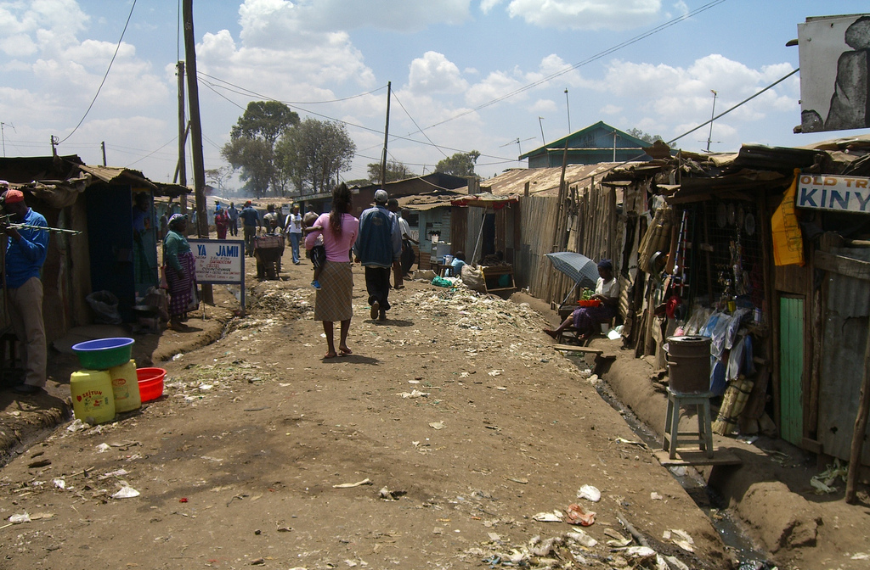

Full name: The Republic of Kenya
Population: 41 million
Capital: Nairobi
Life expectancy: 56 years (men), 57 years (women)
Main industries: agriculture, tourism
GNI per capita: US $770

(Image shows Kibera slum, Nairobi)

Rising fuel and food prices threaten recent progress made to lift some people out of poverty. According to one report by the Financial Times (2011), many of the city’s wage earners can barely afford petrol to keep their cars running. “Once they have exhausted their fuel, they just park the car and wait for next month’s pay-cheque.”
Teaching tip

Find out more about Kenya’s two-speed society in the recent Financial Times report “Aspiration drives Kenya’s status struggle”
http://www.ft.com/cms/s/0/83410af0-a7ed-11e0-afc2-00144feabdc0.html#axzz1Sp6ilxcx.
Watch the Comic Relief visit to Kibera at http://www.comicrelief.com/about-us/film/2011-07-25/lenny-goes-back-kibera).

Only 1.6 per cent of Kenya’s 41m people can afford to spend more than $10 a day, one of the lowest figures for the continent. Many Kenyans are highly dependent on the $1.9 billion in remittances sent home by friends and family who are working abroad. Kenya is a place that desperately needs new investment and employment. Can internet connectivity help bring these things? Some people are hopeful that English-speaking Nairobi can become a global call centre hub.

Case study 1: Kencall call centres

With the arrival of the new international fibre cables, Kenya is increasingly being seen as an up-and-coming call centre hub. For instance, the company Kencall has been in business since 2006 and now provides call centre services for a wide variety of companies in the UK and USA, including Orange.

- The company has a 250-seat call centre in Nairobi.
- The new international cables have provided unlimited bandwidth. Prices have fallen from around US$6,000 to US$600 per month, allowing them to offer cheaper services, competing with other countries like India.
- Other African out-sourcing call centre hubs include South Africa, Mauritius and Ghana.

Sources: http://www.cio.co.ke/Top-Stories/kencall-sees-the-growth-of-new-local-outsourcing-opportunities.html and http://www.kencall.com/

Case study 2: Nairobi iHub

Erik Hersman is the developer of Nairobi iHub - a modern version of the 1990s European telecottage idea (a shared space where ICT facilities have been made available to local people).

In terms of technology, Africa has progressed much further in the last five years than anyone could have predicted. In Hersman’s view, once people are provided with tools and resources, they make progress rapidly, often in innovative ways: it is “ingenuity born of necessity”.

“iHub is an open space for the technologists, investors, tech companies and hackers in the area. This space is a tech community facility with a focus on young entrepreneurs, web and mobile phone programmers and designers. The iHub will have a redundant 10Mbs connection, hardwired and WiFi, and it’s freely available to any tech person in Nairobi to use once they become members.

“Membership is free, our only requirement is that you are indeed involved in the tech space as a programmer, web designer or mobile application developer.

“Finally, we’re putting our networks into place to give special access to the entrepreneurs and startups who need space to meet with funders and local businesses. We’re trying to create the place where seeds are planted and are easily found by the people with money to help them grow. The iHub is what we as a tech community make it. It is a blank canvas, a big open room with a great view and wonderful location, but still an empty room that needs some input from people within the community to design, and create a culture around.”

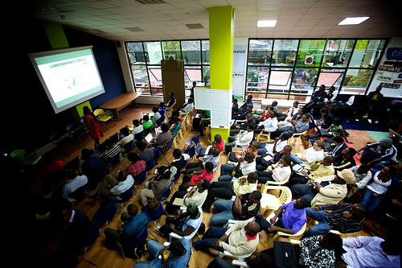

Above: Inside the iHub

Sources: http://ihub.co.ke/pages/home.php and http://whiteafrican.com/2010/01/25/ihub-nairobis-tech-innovation-hub-is-here/

Plenary
Is the least connected continent “leap-frogging” to success?

Study the two pictures (see separate document) showing contrasting views of Kenya’s future. After what you have learned from this scheme of work, which vision seems most likely to come true?

In the first lesson, students were encouraged to question the automatic assumption that technology will quickly transform all people’s lives in Africa. This is because some serious obstacles to progress remain, notably:

- low literacy levels, limiting some people’s interactions with computer technology.
- intermittent, unreliable or absent electricity supplies needed to power ICT (although battery and wind-up power sources are available).
- governance concerns (corrupt or undemocratic regimes, which may not deliver the services people need).

However, the evidence seen in this lesson relating to Kenya (which is based on lectures recently presented at the Royal Geographical Society) suggests that some real progress has been made in delivering new ICT-led work opportunities in Nairobi. Although ICT currently contributes only a small proportion of GDP, further investment and innovation in technology may well begin to transform the lives of more people.

Time permitting, to complete the scheme of work, students can watch the segment of Eric Hersman talking about the rapid changes now underway in Kenya. Some key facts mentioned include:

- There are now 9 million internet users in Kenya: that’s 22% of the population (6 million of whom are accessing the internet via their mobile phones).
- There are 22 million mobile users in Kenya, up from 8 million in 2006. Over half the country’s population have “leapfrogged” from having no means of communication to having mobile phones, many with 3G access.
- Mobile coverage is available across 87% of Kenya.
- Texts cost one fifth of what they did five years ago.

