Lesson 1
Teaching tip

As an extension exercise, students can comment on the extent to which the table and graphic are in fact an gross over-simplification (some urban architecture is attractive, some rural housing is not whilst education provision in London is improving rapidly for example).

‘Escape to the countryside’: investigating a rural sense of place
Specification advice

Edexcel, OCR, AQA, WJEC and IB Diploma centres will all be investigating aspects of migration and population change in rural and urban areas. Important themes such as urban stress are taught as part of migration studies and also in urban studies. These resources encourage students to think about diverse types of rural and urban area, which can help unlock higher mark bands.

Starter
‘City vs. Country’

- Is life better in the city or the country? This perennial debate is linked with an important internal migration movement found within some developed countries such as the UK, France and the USA.
- This urban-rural migration involves people leaving cities and migrating to rural areas (in direct contrast to the internal rural-urban movements typically seen in the world’s less developed countries).
- Also known as counter-urbanisation, this urban-rural movement is explained by a set of push and pull factors which relate to people’s experiences, aspirations and, importantly, their perceptions of different places.
- In groups, students can quickly list what they believe to be the main rural pull and urban push factors that might influence people. They can compare their findings with the table below.

Urban push: the city perceived as a risky, unhealthy and ugly place | Rural pull: the countryside perceived as a safe, healthy and beautiful place
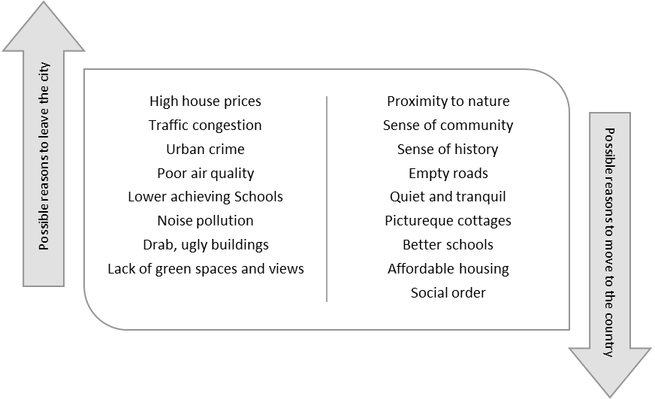

At the outset, it is important for students to recognise that this imagined distinction between rural and urban places (‘rural good, urban bad’) is highly time and space specific, and far from being either accurate or a universal truth.
Key terms

internal migration Movement within a country, in contrast to international migration

counter-urbanisation The movement from urban to rural areas beyond the suburbs and the city green belt. This is also known as rural-urban migration

gentrification The movement of middle-income and high-income groups into places that were previously working-class urban or rural neighbourhoods

urban rebranding A strategy for urban re-development that involves creating a new city image, usually linked with consumption and entertainment, not traditional city industries. The result is a post-industrial city
- It was not a common perception in the UK in the 19th Century, when rural areas were still very deprived and under-developed in terms of infrastructure and services.
- It is not true for many developing countries today, where some rural areas still suffer from extreme poverty, limited employment opportunities and periodic famine.
- Some people would argue it is less true for developed countries than it was 50 years ago. Cities have ‘cleaned up their act’ and urban living is very much in vogue due to gentrification and urban rebranding. This has helped create post-industrial cities that are important sites for art, culture and consumption in malls and leisure spaces).

Main activity
(1) Why do some people want to live in the countryside?

In search of utopia

The word ‘utopia’ was first used by Thomas More in the 1500s to describe a perfect community and place. Rural areas are frequently portrayed as utopian places in popular culture. Arguably, this has an important influence on urban-rural migration.

Writers such as the cultural theorist Raymond Williams and the geographer Stephen Daniels (Nottingham University) have studied the importance of particular representations of rural life and landscapes within British culture. They, and other writers, have analysed how rural life is portrayed in a range of different media and walks of life in ways that can make some people long to move to the countryside:

- TV and film The rural village is often portrayed in television and films as a place where neighbours are always friends, and people can leave their houses un-locked. Students may have grown up with children’s TV programmes like Postman Pat and Balamory, which give a highly idealised sense of rural place. As adults, we are exposed to the TV serialisation of Jane Austin novels, the rural-based and extremely popular Downton Abbey or the Escape to the Country series in which people house hunt for their perfect country home.
- Advertising Advertisements for rural holidays in Country Living magazine affirm there is a relationship between moving to green landscapes and gaining an improved quality of life. A typical advert promises the chance to ‘Escape to award-winning country hotel situated in 24,000 acres of blissfully tranquil countryside’.
- National culture Some important national myths have a strong association with a rural sense of place, such as the Arthurian legends and the hymn Jerusalem which features the line “in England’s green and pleasant land.”.
- Literature As far back as the Ancient Greeks, country living has been praised in European literature. Theocritus and Virgil would later influence Milton and Tennyson. The rural writing of Jane Austen and Thomas Hardy remains very popular to this day. In a European context, the geographer David Harvey has analysed the importance of the ‘Black Forest farmhouse’ in German literature.
- Art The rural landscape paintings of Constable and Turner often portray beautiful, idyllic places.
Thinking critically (teaching tip)

Some students may point out that there is another, parallel ‘rural tradition’ in popular culture which portrays rural places as being frightening, lawless, isolated and threatening. The genre of horror films has always taken advantage of this: many classic horror films are set in wild places. In comedy films and TV shows, rural communities are often unfairly portrayed as eccentric or even ‘backwards’ when compared with city people – such as in the depiction of the ‘quite village’ of Sandford in the film Hot Fuzz. This negative vision of rural places sits alongside the ‘rural idyll’ in popular culture.

At a time when national cultures are changing rapidly, in part because of globalisation, the countryside can signify stability. Rural landscapes can provide a comforting sense of the past in people’s imagination. The age of rural buildings, a perceived stability in the appearance of the rural landscape and the proliferation of important historical landmarks and antiquities found in the countryside: all of these help to evoke nostalgia.

In a troubled present, and faced with an uncertain future, it is understandable to see why some people love the countryside.

Is there any actual evidence that rural living makes people happier?

Speaking at London’s Royal Geographical Society in 2014, Dr George MacKerron (Lecturer in The Economics of Environment, Energy and Climate Change at the University of Sussex) presented evidence from the Mappiness sampling study.
‘We have found that people are substantially happier in green and natural environments than they are in urban environments. This provides new evidence about the link between nature and wellbeing, and could ultimately provide new insights for policymakers.’
Find out more about Mappiness

Mappiness is a ‘happiness mapping’ iPhone app. So far, over one million responses have been recorded using Mappiness. ‘We designed Mappiness to crowdsource data and help us understand the impact of a person’s immediate surroundings on their wellbeing, teaching us more about the geography of happiness.’ Find out more at: http://www.mappiness.org.uk/

The Mappiness sampling study has generated an enormous amount of quantitative data that captures people’s everyday mood. The iPhone app stops people at random moments in the day and asks how they feel ‘right now’. It also asks what kind of place are they in, and then records their GPS position to work out exactly where they are. This information is mapped and analysed.

Using all of the data generated by the study, the researchers have been able to make certain conclusions about the influence that a ‘green environment’ can have on people’s happiness.

- Natural land cover does have an effect on mood and all the evidence suggests that people are happier in green environments (the researchers take into account other environmental factors like whether the sun was shining).
- The study found people living in a marine or coastal margin environment are happiest (estimated at 6% happier than other people).
- In general, people who live in a natural environment (woodland / forest / coast / mountain) are 2% to 3% happier than those in a continuous urban environment.
Thinking critically about the data

What if people are happy because they are in a natural environment within the city? This is the ‘Buckingham Palace problem’ for Mappiness researchers.
What if it is not the environment that is making people happy but other factors? People may be visiting the coast with their friends: is it the coast or the friends that make them happy?
Perhaps people think ‘I am so happy I shall visit the countryside’. Therefore it is not the countryside that is the root cause of happiness.
What if people simply feel happy in the countryside because they normally live in the city and they just enjoy a change of scenery?
Also speaking at London’s Royal Geographical Society in 2014, Leo Hollis used income inequality data to support an argument that urban living can make people unhappy. He argued: ‘We are increasingly unequal. In London, the top 10% is 300 times richer than the bottom 10%. This inequality affects the space of the city. There are no-go areas, areas where the poor are stuck, areas where the rich have cut themselves off from the rest of the city.’

Another line of argument is the Biophilia Hypothesis which states there is a correlation between poor mental health and high density urban living (due to nuisances like neighbour noise and traffic congestion). In contrast, it is believed that mental health is improved by the positive influence of living close to nature. Edward O. Wilson introduced and popularised this argument in his book Biophilia (1984). The term biophilia literally means ‘love of life or living systems.’

However, many factors determine whether migrants actually feel happier, such as the social makeup of the community they have re-located to (and whether incomers are made to feel welcome), neighbour noise (famers can be noisy too!), isolation (not all areas have good mobile and broadband reception, or easy access to shops and important services. The reality of rural life could be hours behind the wheel of a car taking children to school and picking up groceries!)

Main activity
(2) What kinds of people move to which kinds of countryside?

Counterurban migrants are people who have moved from urban to rural areas, beyond the suburbs. This drift back to the land has been helped by improvements made to the infrastructure of rural areas since the 1950s (including electrical supplies, the road network, telephone lines, radio and TV reception; more recently, the provision of broadband internet and mobile telephone masts).

Some of the movement has been people-led: the principal aim of the migrants is to become country-dwellers, be they retired pensioners, artists or entrepreneurs who are determined to establish some kind of foothold to livelihood in an attractive and peaceful rural setting. The notion of a ‘rural idyll’ is ever-present in such accounts of counterurbanisation. The idyll is a cultural construct consisting of a strong belief in the spiritual value of rural landscapes and the benefits of belonging to a small tightly-knit community living close to nature.

Other movements are better described as job-led, with expanding rural employment opportunities attracting unemployed and dissatisfied workers from core areas. The movement is thus also economically-motivated, rather than being entirely attributable to personal taste or landscape aesthetics.

The table below shows several different types of migrant who can be observed in most rural communities, each of whom has been attracted to the countryside for quite specific reasons.

1 Early retirees | Increasing rates of redundancy and early retirement have bolstered the traditional trend of the elderly seeking to spend their retirement in a rural environment. Parts of Devon, Cornwall, Norfolk, Suffolk, Cambridgeshire and Kent are home to a significantly higher percentage of the over-65s (40%) than the national average of 21%.
2 Tourism entrepreneurs | As incomes in the UK have risen, the leisure sector has expanded. Migrants can use their savings to establish hotels, tea-rooms, theme parks or craft centres in those areas of natural beauty which are most frequently visited by day-trippers and holiday makers. Political factors matter here – funding is widely available in most rural areas to help entrepreneurs succeed. For instance, Development Boards for the Highland and Islands of Scotland and Mid-Wales were established after 1965 to help subsidise the costs of new business ventures, and these were seized upon by migrant entrepreneurs with their eyes firmly fixed on the growing market for tourism. Grants from the EU, or the National Lottery, can also help fund new ventures.
3 Rural ‘teleworkers’ | Since the 1990s, teleworking has begun to provide a new opportunity to work from home in some of Britain's most remote rural locations. High-technology work can be conducted just about anywhere where broadband internet is available. Farmhouse conversions, in acres of rolling countryside, now house state-of-the-art offices: these places are ideal working conditions for a range of professional and creative occupations including consultants, architects, designers and writers. See this Geography in the News for the impact of Broadband on Cornwall http://www.geographyinthenews.rgs.org/member/newscasestudies/article/?id=1762
4 Public sector workers | Wherever rural regions receive an influx of population for all of the reasons thus far outlined, there are new opportunities for employment in support services such as education, health, retailing and administration. This is known as a multiplier effect. Many teachers, police officers and nurses are glad to seize the opportunity of relinquishing stressful urban posts in favour of servicing a more peaceful and relaxed rural community, should a position open up.
5 Artists and alternative lifestyles | The hippies of the 1960s were idealists whose motto was ‘turn on, tune in and drop out’. Initially, many migrated to rural areas such as Cornwall or the Highlands and attempted to adopt a ‘self-sufficient’ lifestyle. Today, a more pragmatic generation of artists and idealistic people have migrated from the cities to areas such as Glastonbury or Hebden Bridge in Yorkshire. They often make a living producing art, crafts, organic food or herbal remedies.

Main activity
Key terms

post-productive countryside A rural place whose economy is no longer based on agriculture

ageing population This is a population whose median age is increasing, usually due to longer life expectancy and youthful out-migration and / or declining numbers of births

rural idyll The way in which the countryside becomes romanticised in popular culture
(3) Migration brings change to rural areas

It is an irony that migrants bring changes to the places they move to, and in ways that sometimes destroy the very qualities that they had originally sought! It is not hard to imagine how a quiet and peaceful rural village soon loses those valued characteristics if far many people move there!

Problems often arise in relation to the arrival of counterurban newcomers in established rural communities. This is because rural regeneration cannot be envisaged as a simple ‘replacement’ of population and jobs lost during the industrial and agricultural revolutions. Notable problems include:

Rising house prices and community disintegration | House prices can rise due to demand from incomers. While this benefits some established residents, it may mean that prices rise beyond the means of the children of established residents to buy a home when they grow up and leave school; this leads, over time, to the out-migration of the village’s original residents’ children.
Hostility and vandalism | The older rural community may even object to newcomers in an openly hostile manner. During the 1970s, extreme Welsh nationalists burned down the second homes of many English people in parts of rural Wales!
Culture clash | New and old value-systems can clash over land management issues. Migrants may object to long-established everyday aspects of country life, be it fox-hunting or the controversial land-use practices of local farmers (such as excessive use of nitrates or hedge-row removal).
Loss of identity | A place’s sense of historical ‘authenticity’ can be lost if newcomers make too many changes to the landscape (building modern house extensions, for instance).
No rejuvenation of services | Village services are not always rejuvenated as result of counterurbanisation. Migrants may be elderly or else affluent enough to send their children to prestigious schools elsewhere. They may bulk-buy in the nearest large town rather than using the local corner-shop.

However, impacts such as these are not suffered in all rural contexts. Often, in-migration can bring positive changes too. In particular, the arrival of new people has been very welcome in areas that had haemorrhaged population in the 1960s and 1970s. In the 1981 Census, it became clear that remote rural regions were experiencing population growth for the first time since the mid-Nineteenth Century. Whole regions which had appeared to be in a state of inexorable decline were showing sudden signs of regeneration.

Rural Scotland, for instance, following a -1.9% fall in population during the 1960s, displayed a net gain of 9.6% in the inter-Census period from 1971 to 1981. Since 1981, this trend has continued and in some instances accelerated, especially in attractive and accessible regions such as the Yorkshire Dales. Without some in-migration, rural areas such as these might have faced an unsustainable future. The diagram below summarises the important benefits.
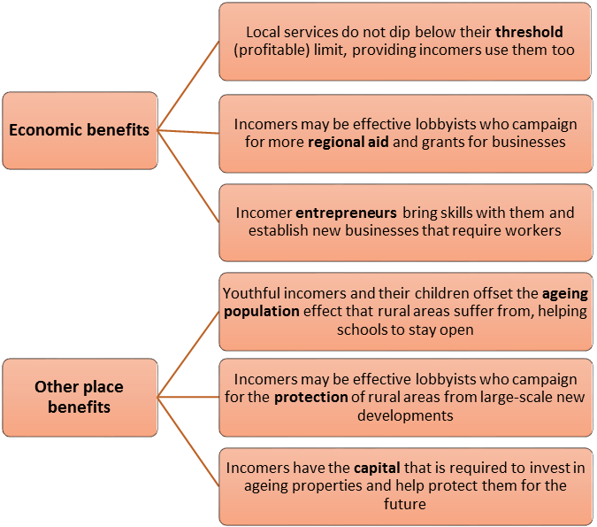
In many cases then, the incomers have helped build a new post-productive rural landscape. The result has been a far more dynamic and diverse economic landscape than in the past. While heritage and the natural environment have been successfully preserved, new opportunities for employment have also been provided, for instance in internet and technology companies started up by incomers in Cornwall or the western isles of Scotland.

Plenary
The dangers of over-generalisation

Writing in 1993, a team of rural geographers led by Terry Marsden suggested that rural Britain, with its complex mix of economic, social and political elements, can sometimes be described as contested countryside. In slightly remoter areas, including parts of the national parks, there are many rural districts where the needs of older residents still impact upon political decision-making, in ways that clearly conflict with the interests of incomers.

In contrast, Marsden argued that much of southern lowland England is now almost wholly dominated by the interests of politically and economically powerful incomers. These are areas of preserved countryside.

This type of analysis is important as it shows us that the impact of migration on rural areas varies considerably from place to place. So too do the impacts that migrants have on rural environments. Also, migrants may have a very different experience depending on what kind of rural environment they move to live in. Some migrants may not find happiness - instead they may find it hard to fit in and difficult to make a living. Whereas others may arrive in a community that is more diverse and welcoming.
Lesson 1 assignment

As a possible homework, students can read the document ‘Investigating a rural sense of place’ as a possible homework or extra class activity. Discussion questions are included.

Lesson 2
The benefits of cities: investigating an urban sense of place

Starter
The fastest phase of urban growth in human history

Since 2008, more than half of the world’s population has lived in towns and cities. The world is currently experiencing the largest phase of urban growth in human history. Some of the data used to support this generalisation are staggering, as the following information, also included in the accompanying PowerPoint presentation, shows.

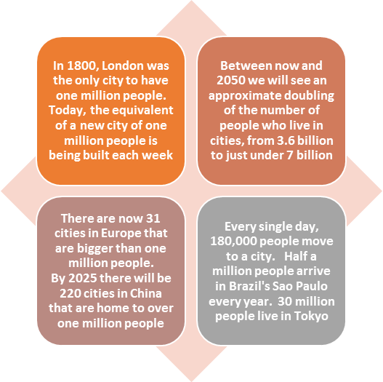

With the current rate of urban growth, we could see 75% of the world’s population living in cities by 2050, with much of that growth happening in Asia and Sub-Saharan Africa. There used to be just a few megacities (populations of more than 10 million). Now there are 23.

City | Country | Population | Size (sq km)
- Tokyo | Japan | 37,239,000 | 8,547
- Jakarta | Indonesia | 26,746,000 | 2,784
- Seoul | South Korea | 22,868,000 | 2,163
- Delhi | India | 22,826,000 | 1,943
- Shanghai | China | 21,766,000 | 3,497
- Manila | Philippines | 21,241,000 | 1,437
- Karachi | Pakistan | 20,877,000 | 803
- New York | USA | 20,673,000 | 11,642
- Sao Paulo | Brazil | 20,568,000 | 3,173
- Mexico City | Mexico | 20,032,000 | 2,046
Teaching tip

Before showing students the table (left), which is also include in the PowerPoint, ask them to guess what the world’s ten biggest cities are, and the numbers that live in each city.

Main activity
(1) Is city living good for us?
Speaking at London’s Royal Geographical Society in 2014, the writer and urbanist Leo Hollis said: ‘I believe that cities are good for us. There is something in the 7,000 year history of the city that changes who we are. Cities make us richer and more productive in our work. It (city living) might even make us happier!’
In support of this argument, consider the following three propositions, each of which can be debated in class:
People like living with other people | - According to Leo Hollis: ‘People are hard-wired to be together and this happens in cities’. There have been a number of studies that have tried to focus on urban interactions and to understand them better. The physicist Geoffrey West specialises in Complexity Theory. He created a vast data set, wherein he inputted as much information as he could about city living. ‘He discovered that as cities grow, as the connection of people within the cities grow, they become richer and more productive. They can also become more sustainable and more creative.’ Find out more at: https://www.ted.com/talks/geoffrey_west_the_surprising_math_of_cities_and_corporations  - In The Death and Life of Great American Cities, the ‘bible’ of the new urbanist movement, Jane Jacobs wrote about life in Manhattan, where she saw: ‘This interweaving of lives, created something that was more than a sum of its part. An electricity, that could not be engineered; that came about naturally from the complexity an urban a street.’
Cities help human development | - The very word civilisation derives from civis, or city. The level of urbanisation of a country is still taken, along with such essential indicators as life expectancy, to represent advancement and development. Linear models of development and demographic transition such as that developed by Rostow in his Stages of Economic Growth (1960) associate urbanisation with ‘take-off’ and material advancement.  - For true modernists urban living unequivocally equates with progress, advancement and liberation. Architects such as Le Corbusier, the positivist movement in social science and futurist art all embraced the city and the machine with visionary zeal, believing it promised human progress. For them the true utopia was urban, not rural, in character.  - In poorer countries, urban living is unarguably the best way to gain access to vital health, education and data services (which are too expensive to provide coverage for in rural areas, where people are more dispersed). In developed world cities, 70% of people have smart phones; but not all rural areas have reliable reception.
Cities are good for the environment | - The average US citizen uses three times as much energy for personal transport as the average European. It is not just because American cars are bigger but because they travel further as many more people live in rural areas. Within the UK, the highest per capita carbon footprints are found in the rural Highlands of Scotland for the same reason. In contrast, compact urban development cuts transport energy use and residential energy use too, due to the urban heat island effect. Compactness has huge environmental benefits. People don’t have as far to travel, good are easier to distribute, waste is easier to manage.  - Cities can also be designed to provide some of the ‘green’ environmental benefits we associate with rural areas. Ebeneezer Howard's (1850-1928) Garden City movement envisaged utopian cities that would include many green spaces. The UK New Towns Act of 1946 was a partial attempt to put these ideas into practise.
In Lesson 1, we explored the negative side or urban living that encourages some people to migrate to the countryside. But clearly there are plenty of positives to city life too.
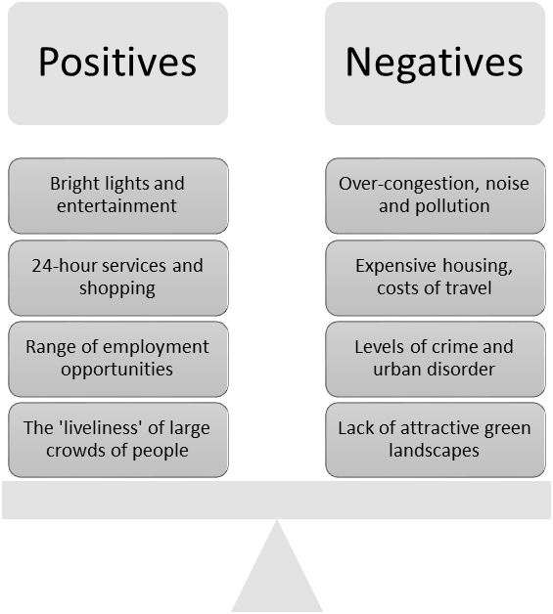
Teaching tip
Start off by asking students to list all the things that make city living a good experience, and which they would miss if you moved away (or, if they live in the countryside, things that they find attractive about the idea of city living).
Next, ask them to recall some of the negatives that appeared in the Wordle illustration, back at the start of lesson one.
What does the overall balance show? Are they broadly in favour or urban or rural living?

Main activity
(2) Global urban futures

All around the world, exciting solutions are being developed to help accommodate the increasing urban population. How can we house an additional two or three billion urban dwellers by 2050, while also doing our best to make sure people feel a positive sense of place for where they live?

Speaking at the RGS-IBG, Author and historian Leo Hollis was adamant that urbanisation need not be a negative experience. ‘Cities seem to amplify the dangerous division between us,’ he says. ‘But they also offer the best possibility for finding a solution. There is an overlooked power to urban life that can be found in the dense interweaving of everyday lives that make cities unique, and promises a more equitable, creative and sustainable future.’

However, the sheer scale of the world’s largest urban regions make it a challenge to match this kind of rhetoric with what is likely to be reality for the people who live there. According to the United Nations, the three biggest urban mega-regions (all in developing countries) are:
Key terms

Carbon-neutral city A city that is being governed in sustainable ways that help reduce its carbon footprint, ideally to zero.

Eco-city A newly-built urban area designed to boost sustainability with as little environmental impact as possible. Intelligent design of buildings, amenities, public transport systems, cycle-ways, water utilities and recycling facilities can all contribute to this goal.

Edge city Suburban areas become edge cities when they have undergone major growth during the last 30 years and the resulting perception is of a new urban place with its own concentration of retailing and office activities.

Instant city A term coined by National Geographic (2008) to distinguish the rapid design and construction of large settlements in China from past waves of New Town construction in other countries.

Megacity A city or city region whose population is at least 10 million.

Megaregion A merging of megacities to form vast urban areas which may stretch hundreds of kilometres across countries and be home to more than 100 million people.

Metacity The United Nations term for a city or city region whose population is at least 20 million.

Smart city New cities planned from scratch to be energy-efficient and networked, with computers that allow intelligent control of traffic and infrastructure.

- Hong Kong-Shenhzen-Guangzhou, China (This region is home to about 120 million people).
- Nagoya-Osaka-Kyoto-Kobe, Japan (This region is expected to grow to 60 million people by 2015).
- Rio-Sao Paulo region, Brazil (43 million Brazilians already live here).

To put all of this in perspective, in 1970 there were just three megacities, London New York and Tokyo (each with populations of more than 8 million – which used to be the definition of a megacity). But by the start of 2010, ‘Tokyo was top of the list of the world’s largest cities, New York was only just scraping into the top 10, and London had dropped off the bottom. New York will join it in megacity oblivion in less than a decade and, with the exception of Tokyo, every other megacity will be in what is referred to as the ‘global south’ (Financial Times, 06 April 2010).
So what can kind of urban futures do people face in the world’s growing numbers of megacities and megaregions? The table below (from the RGS-IBG Geography in the News service, 2010) summarises broad regional trends and highlights interesting areas of innovation that aim to maximise quality of life for citizens.
China & India | India’s total urban population is now 30% (of 1.2 billion people) and Mumbai, Delhi and Kolkata are all major megacities. China’s percentage is 43% (of 1.3 billion people). Three major megacity clusters exist in China’s Yangtze River Delta (including Shanghai), Pearl River Delta (including Shenzhen, which used to be just a fishing village) and the Bohai Sea rim (including Beijing). There are also 60 smaller Chinese cities with populations greater than one million and by 2025, according to one estimate, there will be more than 220 Chinese cities with more than a million people each. Both China and India are currently building literally hundreds of instant cities from scratch. The Chinese government has pledged to build 400 new cities between 2000 and 2020 (this ambition was announced in 2001 by China’s State Minister of Civil Affairs, Doje Cering). India and China both also have plans to ‘leap-frog’ a stage of urban development and build brand-new smart cities and eco-cities.
North America | With less strict planning controls than the UK, growth of edge cities continues to be a hallmark of the US urban environment, notably so along the west coast from California to Seattle. Cities like Los Angeles grew 45% in numbers between 1975-1990, but tripled their surface area at the same time. ‘Southern California, from Los Angeles to San Diego, has become a vast, dispersed city of smeared suburbs, strip developments and gentrified but sparsely inhabited downtowns. It bursts across the Mexican border into Tijuana, which has become, in effect, its transnational suburb.’ (Financial Times, 06 April 2010). Technology and the ability to work from home has more recently encouraged a dispersal of population away from traditional core areas and into lower-ranked cities within urban hierarchies. For instance, Wenatchee is a fast-growing city near Seattle where people work from home 3 days a week but commute 300 km to Seattle for two days per week of ‘face time’ with colleagues. The fastest-growing urban areas in the USA are dispersed like this (Financial Times, 08 September 2010).
Middle East | Cities such as Dubai or Riyadh have become amazing technoscapes (the world’s tallest building is the 828-metre tall Burj Khalifa in Dubai). These cities’ carbon footprint is large due to the demand for air conditioning driven by an arid climate. Fears of water security are a big issue that may threaten the long-term sustainability or urban growth in this region. 30% of the world’s entire desalinisation capacity is already found in UAE (Dubai) and Saudi Arabia where the expensively-produced freshwater product meets growing demand from major urban populations. But for inland cities like Sana’a in Yemen (population: 2 million), distance from the sea makes this an expensive option and future growth could slow as a result.
Africa | Continued periurban growth and reliance on the informal sector remains a hallmark of African megacity and smaller city growth. Infrastructure in existing cities is often lacking; but hurriedly-constructed overhead cabling and railways can now be seen in richer cities along the west Africa urban coastal corridor. This 600 km-long urban area runs through Nigeria, Benin, Togo and Ghana. The megacity of Lagos and other major cities such as Ibadan, Accra and Porto-Novo are all becoming regional economic hubs.

For more information on global Megacities see this link http://www.rgs.org/OurWork/Schools/Teaching+resources/Key+Stage+3+resources/Global+Learning+Programme/Discovering+megacities.htm
Plenary
Making the most of urban living
- We are now very much an urban species. By 2050, three-quarters of the global population are expected to live in cities and we will be building the equivalent of a new city the size of Birmingham every week for the next 30 years.
- But rapid urbanisation brings challenges, not just to the physical environment but also to quality of life and people’s subjective feelings of wellbeing, happiness and life satisfaction.
- Reflecting on everything they have studied about these issues, do students aspire to a future life in the countryside or the city? If the latter, what kind of city and type of urban living appeals most?

