Lesson 2: Mapping Mountains
Factsheet for teachers

OS Explorer Map OL17

This lesson teaches map skills through the use of OS Explorer Map OL17. An extract of this map is provided, covering the area between grid squares 5952, 5752, 6657 and 6652. The questions posed in the main teaching and main pupil activity relate to this specific extract. The key and scale of OS Explorer Map OL17 are also used.

It is recommended that a copy of OS Explorer Map OL17 is also shown to pupils and that further questions are devised by the class teacher and higher ability pupils themselves using the whole OS map.

Purpose of the lesson

The purpose of this lesson is to apply many existing map skills to a case study of Snowdon. Class teachers wishing to update their own subject knowledge could refer to the KS2 map skills subject knowledge animation (available from spring 2015 via www.rgs.org/rlg).
Compass directions: The four points of a compass are north, south, east and west. The eight points of a compass are north, north east, east, south east, south, south west, west and north west. When referring to direction using maps, be careful not to say the ‘top’ and ‘bottom’ of the map. Always use the four or eight-point compass points; the ‘top’ of the map is always the north.

The key: Pupils should understand that information can be represented pictorially on a map and that these symbols all refer to something in the real world. Symbols used in the key to represent parking, viewpoints, nature reserves, public conveniences, camp sites, public telephones, visitor centres and other tourist features will all be covered.
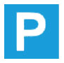
Parking


Viewpoint

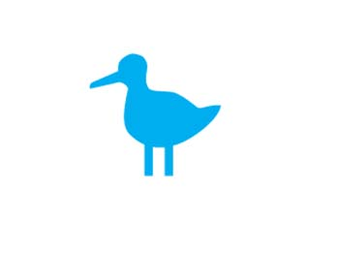
Nature reserve


Public conveniences
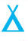

Camp site

Public telephone


Visitor centre

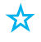
Other tourist feature

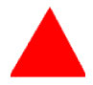
Youth hostel

Depictions of footpaths, railway stations, railway lines and crags (rock faces) and trig points will also be addressed.

Footpath

Railway station

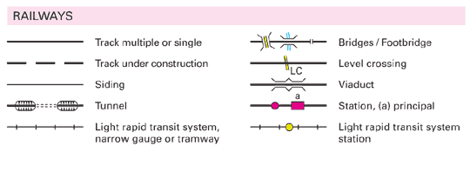
Railway line

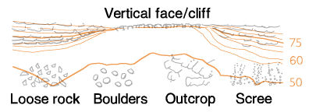
Crags


Trig point

Trig points and spot heights: Trig points mark the height of land. They are depicted on an OS map and are visible on the landscape, either as concrete blocks or piles of boulders. Spot heights also mark the height of land and appear on maps as small red numbers, but are not featured tangibly on the landscape.

Contour lines: These are brown lines on the OS map. Each contour line joins land of equal height and is measured in metres. The closer together contour lines are drawn, the steeper the land. The further apart contour lines are drawn the more gentle the slope.

Four and six-figure grid references: Grid references help to locate places on a map. The grid references are written with no spaces in between any of the numbers. In a four-figure grid reference the first two numbers equate to the x axis and the last two numbers equate to the y axis.

In a six-figure grid reference the first three numbers equate to the x axis and the last three numbers equate to the y axis. Additionally, in six-figure grid references the third and sixth numbers represent tenths of a grid square.

Grid squares: To understand the locations of a grid square look right then up from a grid reference.

Scale: When pupils are calculating the distance between two points on a map the easiest way is to use the edge of a piece of paper. Mark the start point on the paper and turn the paper to follow the pathway depicted on the map, marking the turns and twists as you go. Alternatively, pupils may prefer to use string or thick cotton to follow the pathway. Then, place the paper or the length of string, with the start and end point clearly marked, along the scale depicted on the bottom of the map to find the distance in kilometres.

The History of OS Maps
In the late 1790s Europe was in turmoil and the government had very real fears that the French Revolutionaries might invade. As a consequence the government ordered the Board of Ordnance to begin a survey of the south coast. The first map was produced in 1801. Today, much of the work of Ordnance Survey is digitalised. New features of the landscape are added on a daily basis, in fact 10,000 changes are made to the computerised OS MasterMap of Great Britain every day.

The Seven Highest Peaks
The highest peak on each continent:
Mount Everest, 8848 metres located in Asia (The Himalayas spans Pakistan, India, Tibet (China), Nepal and Bhutan.)
Aconcagua, 6962 metres, located in Argentina, South America
Mount McKinley, 6194 metres, located in Alaska, North America
Kilimanjaro, 5895 metres, located in Tanzania, Africa
*Either El’brus 5642 metres located in Russia, or Mont Blanc 4810 metres located on the Italy and France border, Europe.
Vinson Massif, 4897 metres, Antarctica
Mount Kosciusko, 2228 metres, located in New South Wales, Australia
*The highest peak in Europe is either El’brus or Mont Blanc- depending on whether Russia is included as part of Europe.

The Main Mountain Ranges

Himalayas, Asia
Alps, Europe
Rocky Mountains, North America
Andes, South America

The Highest Peaks in the UK

Ben Nevis, 1344 metres, Scotland
Snowdon, 1085 metres, Wales
Scafell Pike, 987 metres, England
Slieve Donard, 850 metres, Northern Ireland

What is a mountain? Definitions vary. One convention, often used in the UK, is a peak above 3000 feet.

