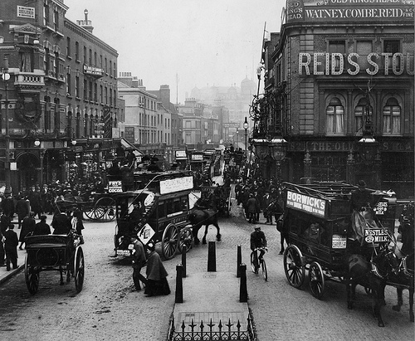
Our Place in History

Lesson 1: Setting the scene

Key ideas:
- The terms ‘local’ and ‘history’ differ depending on the context in which they are used.
- There are many sources of evidence which can be used to investigate local history.

Starter activity:
Local History?
This unit begins with an activity in which pupils think about what is meant by ‘local’ and ‘history’ in the context of this unit. The aim is for pupils to understand that both terms are flexible and they should discuss in pairs the meanings of these words before feeding back to the class. Whilst the definition of local will probably depend on the size of the settlement in which the school is located, for most of the unit ‘history’ will mean ‘the last 200 years’ as this is the period of time for which we have most data.

Main activity:
How can we find out about our local history?
The aim of this activity is for pupils to think about where our evidence comes from and also to think about its reliability. Pupils are given a selection of different sources of evidence and they have to select three to put into their ‘local history toolkit’. They should be able to justify their choices and explain how they would provide evidence. As an extension, they could pick one source which they definitely would not use and explain why, or they could select one of their three sources which they definitely would not be without.

How has our local area been described in the past?
This second activity asks students to engage with a source of evidence describing their local area. This is a challenging activity as students will not be familiar with using evidence from c.1850. However, by highlighting different elements – facts and figures and descriptions of human and physical geography – they should be able to get a feel for what the local area was like in the past. Annotating the text is, again, very difficult, but teachers could steer pupils to look at population in particular as a likely change.

Plenary:
Crossword time
The aim of this activity is to highlight the main sources of evidence which can be used in the study of local history. However, it also introduces some elements of future lessons to provide a taste of what pupils can expect. There is an answer sheet which goes with this activity so teachers can provide support for less able students by suggesting the start and end letters of words.




