United States of America
Assessment

Pupils take on the role of British Ambassador to the United States.

Pupils should be presented with a scenario where a new ambassador will be arriving to take over the post and they need to produce a guide with important information about the USA based on the top 10 things they have learnt throughout the unit.

You can give pupils the option to design this guide themselves, selecting images from the unit, or sourced themselves. Alternatively, a worksheet is provided on the next page.

Welcome to the USA!
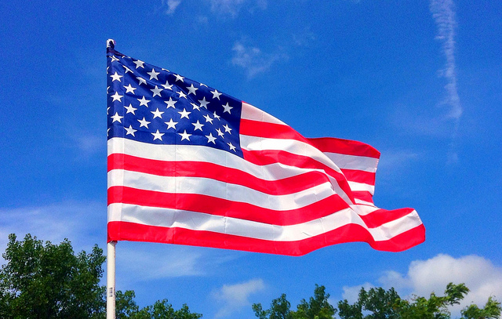
USA Flag, Mike Mozart © Flickr
We hope you enjoy your visit! Here are ten top facts about the USA to guide your stay
1.__________________________________________________________ ____________________________________________________________
2. __________________________________________________________ ____________________________________________________________
3. __________________________________________________________ ____________________________________________________________
4. __________________________________________________________ ____________________________________________________________
5. __________________________________________________________ ____________________________________________________________
6. __________________________________________________________ ____________________________________________________________
7. __________________________________________________________ ____________________________________________________________
8. __________________________________________________________ ____________________________________________________________
9. __________________________________________________________ ____________________________________________________________
10. _________________________________________________________
____________________________________________________________

