
Are you flood ready?

Extreme Weather
factsheet

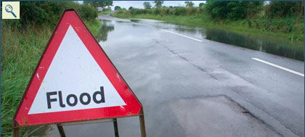

- The average number of climate-related disasters in Europe has doubled in the last ten years.

- 20,000 deaths are attributed to the European heat-wave of 2003.

- 600,000 people were affected by the European floods of 2002, with economic losses topping £10 billion and causing 100 deaths.

- The most dramatic flooding in UK history was in 1829, when the River Findhorn, in Scotland, rose in height by 15 metres.

- The heaviest rain recorded in 24 hours in the UK was 279.4mm in Martinstown, Dorset, in 1955.

- The worst flash flood in the US occurred in 1972, when 237 were killed along Rapid Creek in South Dakota. 140 campers also died in the Big Thompson canyon near Denver, Colorado.



- 1,442 people died in storms in the US between 1994 and 2000. Each year, damages amount to around $1 billion.

