Stonehenge Briefing Document

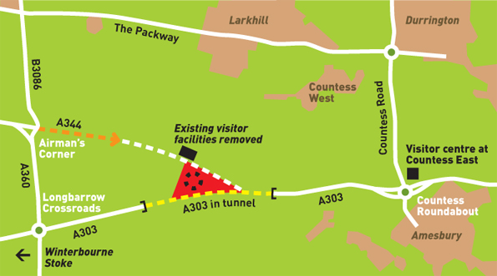

Background: Stonehenge is a prehistoric monument located in the English county of Wiltshire, about 8 miles (13 km) north of Salisbury. It is one of most famous prehistoric sites in the world - a circular setting of large standing stones. Archaeologists believe the standing stones were erected around 2200 BC. The site and its surroundings were added to the UNESCO's list of World Heritage Sites in 1986. Stonehenge itself is owned by the State and managed by English Heritage while the surrounding land is owned by the National Trust.

‘Wonder of the World’ or ‘National Disgrace’?

In 1993, the area surrounding Stonehenge was criticised by Parliament's House of Commons Public Accounts Committee as 'a national disgrace'. They said is ruined by three main factors:

- Roads: On one side the busy A303 rushes past, and on the other side the A344 passes very close to the ancient site.
- Visitor Facilities: These are located right next to the monument and were not built to cope with the nearly 1 million visitors it now receives per year. An audio tour and leaflet to guide people around the monument as well as three information boards are provided but some modern tourist these days expect more help in understanding such a significant site.
- Car Park: The car park is now too small to cope with the number of cars, especially during the summer months. This encourages people to park illegally on the roadside, resulting in serious road safety problems. The car park is also visible from the stones and detracts from the spiritual atmosphere of the monument.

Solution One

- Put together by a group called The Stonehenge Project http://www.thestonehengeproject.org/ put in charge of finding a solution to the problems at Stonehenge. The group is made up of:
  - representatives from national and local government,
  - the Highways Agency,
  - English Heritage, http://www.english-heritage.org.uk/server/show/nav.876
  - the National Trust

- The proposals that they have put forward are known as the “Published Scheme”

Roads

- Removing the roads from around Stonehenge would dramatically improve the situation

1998 | Scheme includes a shallow 2.1km tunnel, improvements at the Countess Roundabout and Longbarrow Crossroads, at a cost of £192m.
2004 | Proposal accepted. However, the cost of the proposed tunnel had risen significantly since 1998 so the Government asked for a review of the scheme.
2006 | Traffic Data has been collected and further analysis is currently being undertaken.

Visitor Centre
- A new location of the new visitor centre…

1996 | English Heritage and the National Trust propose a visitor centre at Countess East linked by road train to Stonehenge, but the bid for funding the project was rejected
1997 | The Government proposes a visitor centre at Larkhill. Rejected by locals because of concerns about the impact of tourist traffic.
2007 | Planning permission awarded for a visitor centre at Countess East, 2 miles to the east of Stonehenge. All car and coach parking will be at the visitor centre, and a visitor transit system will take visitors to within walking distance of the Stones. It will cost £67.

Solution Two:
- The action group Heritage Action, made up of members of the public campaigning to protect Britain’s ancient sites, have put together an alternative proposal to ease the problems at Stonehenge:
- They feel that the ‘Published Scheme proposals above are:
  - too damaging for the environment
  - too worried about cost instead of protecting the monument
- They are campaigning for the Government to:
  - Pay for some immediate work to improve the existing visitor centre and car park– this will maintain the facilities until the new centre is completed.
  - Abandon the “Published Scheme” because the shallow tunnel would only be partially underground and would mean that the traffic noise would still be heard from the stones and would look unsightly.
  - Implement a plan to create a deep 4 km tunnel completely underground, leaving the stretches of the A303 and A344 to be grassed over.

Interest Groups

- ENGLISH HERITAGE – They are responsible for protecting and promoting historic sites in England and run operations at Stonehenge.
- NATIONAL TRUST – Owns most of the land at the Stonehenge World Heritage Site and therefore wants to see it improved by the long tunnel proposal.
- UNESCO – (United Nations Educational, Scientific and Cultural Organisation) designated Stonehenge as a World Heritage Site in 1986. They say how World Heritage Sites should be protected and make sure that this is done.
- GOVERNMENT – As they will be funding the majority of the project they need to make sure that the project will be value for money, as well as protecting an ancient monument of global significance.
- HIGHWAYS AGENCY – Responsible for maintaining and developing the roads in England and Wales. They will be responsible for building the new tunnel.
- LOCAL PEOPLE – Want the impact of relocating the road and visitor centre to be reduced, but also want the monument to be preserved.
- PLANNING INSPECTORS – responsible for giving approval for the building of the new visitor centre. They take in to account the impact on the local inhabitants, existing roads, local scenery, and recommend alternatives.
- TOURISTS – want easy access to the site, lots of information about its history, good facilities such as toilets and a café, and all for a reasonable price.
Key Words

- Public consultations – ideas for the site are presented to interested members of the public, who have the right to give their opinion about the ideas.
- Planning permission – all new buildings have to be given permission by the Planning Inspectorate. They take in to account the impact on the local inhabitants, existing roads, local scenery, and recommend alternatives.
- World Heritage Site - A cultural or natural site, monument, city or habitat that is considered irreplaceable and threatened, and therefore deserving of protection and preservation by UNESCO
Related Links

http://www.thestonehengeproject.org/history/findingasolution.shtml
http://www.heritageaction.org/?page=heritagealerts_stonehengeoldachievablestonehenge
http://maps.google.co.uk/maps?sourceid=navclient&hl=en-GB&ie=UTF-8&rlz=1T4DMUK_en-GBGB212GB212&q=stonehenge
http://arts.guardian.co.uk/news/story/0,,1889436,00.html
http://news.bbc.co.uk/1/hi/england/2299033.stm

