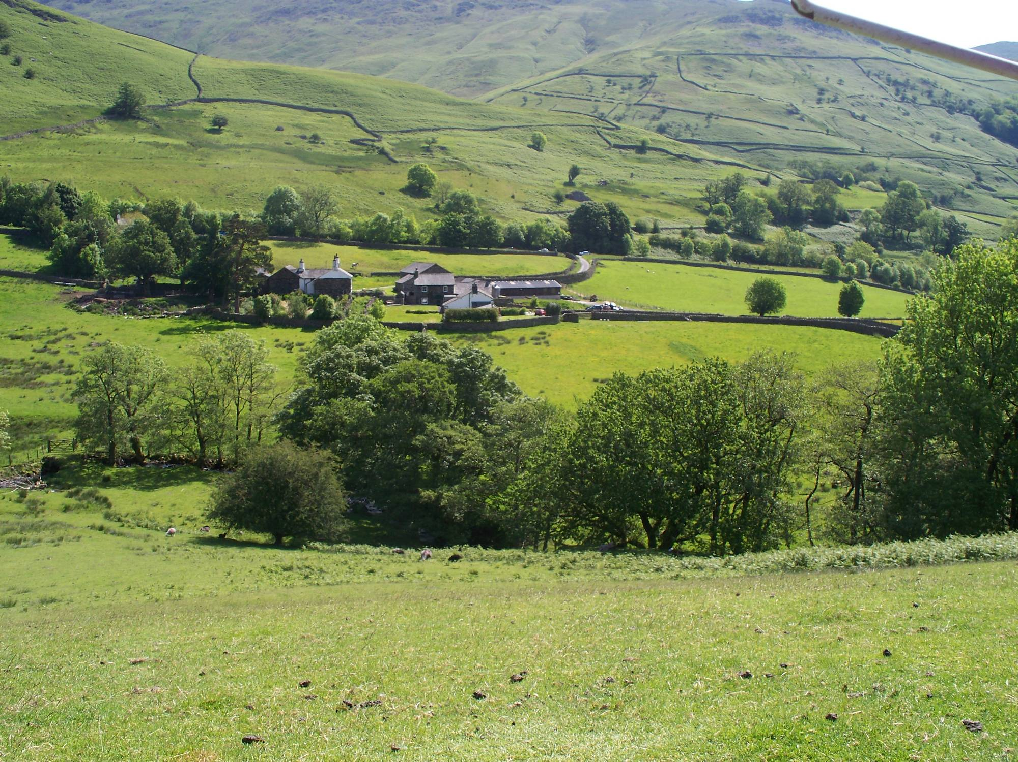

An introduction to the Lake District National Park through ‘sense of place’ activities

Name: ........................................................................................

Date: ......................................................
Aim of the day:

To compare two contrasting locations in the Lake District National Park through ‘sense of place’ activities.

Location:

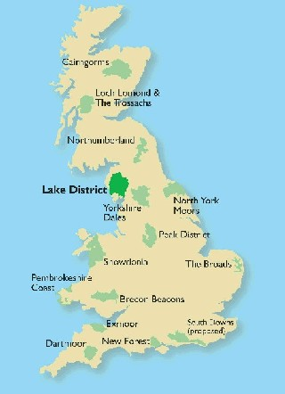

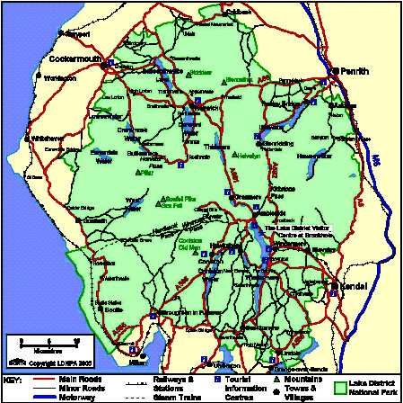

Site:

- Great Woods. Grid reference: 2127 (OS Map: 90)
- Bowness. Grid reference: 4097 (OS Map: 96)

Background:

The Lake District National Park is located in North West England in the County of Cumbria. It was designated as a National Park in 1951. It is the country’s largest National Park, covering 885 square miles, and includes England's largest lake (Windermere – 11 miles long and 1 mile wide) and highest mountain (Scafell Pike – 978 metres). The Lake District National Park is easily accessible from the M6 and this makes it a popular tourist destination. 83% of the park’s 8 million annual visitors arrive by car.

SITE 1 – GREAT WOODS

a) Starter – Thought Shower

Spend a few minutes taking in your surroundings, then write down three initial thoughts about this place in the thought bubbles below. You can include sights, sounds, smells, feelings and emotions – whatever you like!


b) Soundscape

Close your eyes and hold up both fists. Every time you hear a different sound, hold up one finger. Once you’ve heard ten sounds, record them in the table below. Don’t forget to add whether they were human or natural sounds.

Sound | Human/Natural | Sound | Human/Natural

c) Human Camera

Work in pairs to take ‘human photos’ of the landscape. One person should direct the other (who should have their eyes closed) to a viewpoint. The second person now opens their eyes and describes the view they can see. Take it in turns and take two ‘photos’ each: one close up, and one panorama. Now write down two observations and one question about what you’ve seen:

Small-scale | Large-scale

d) Field Sketch

Finish this sketch of Great Wood, including Keswick and Derwent Water. Make sure you add some more annotations and give your sketch a title!

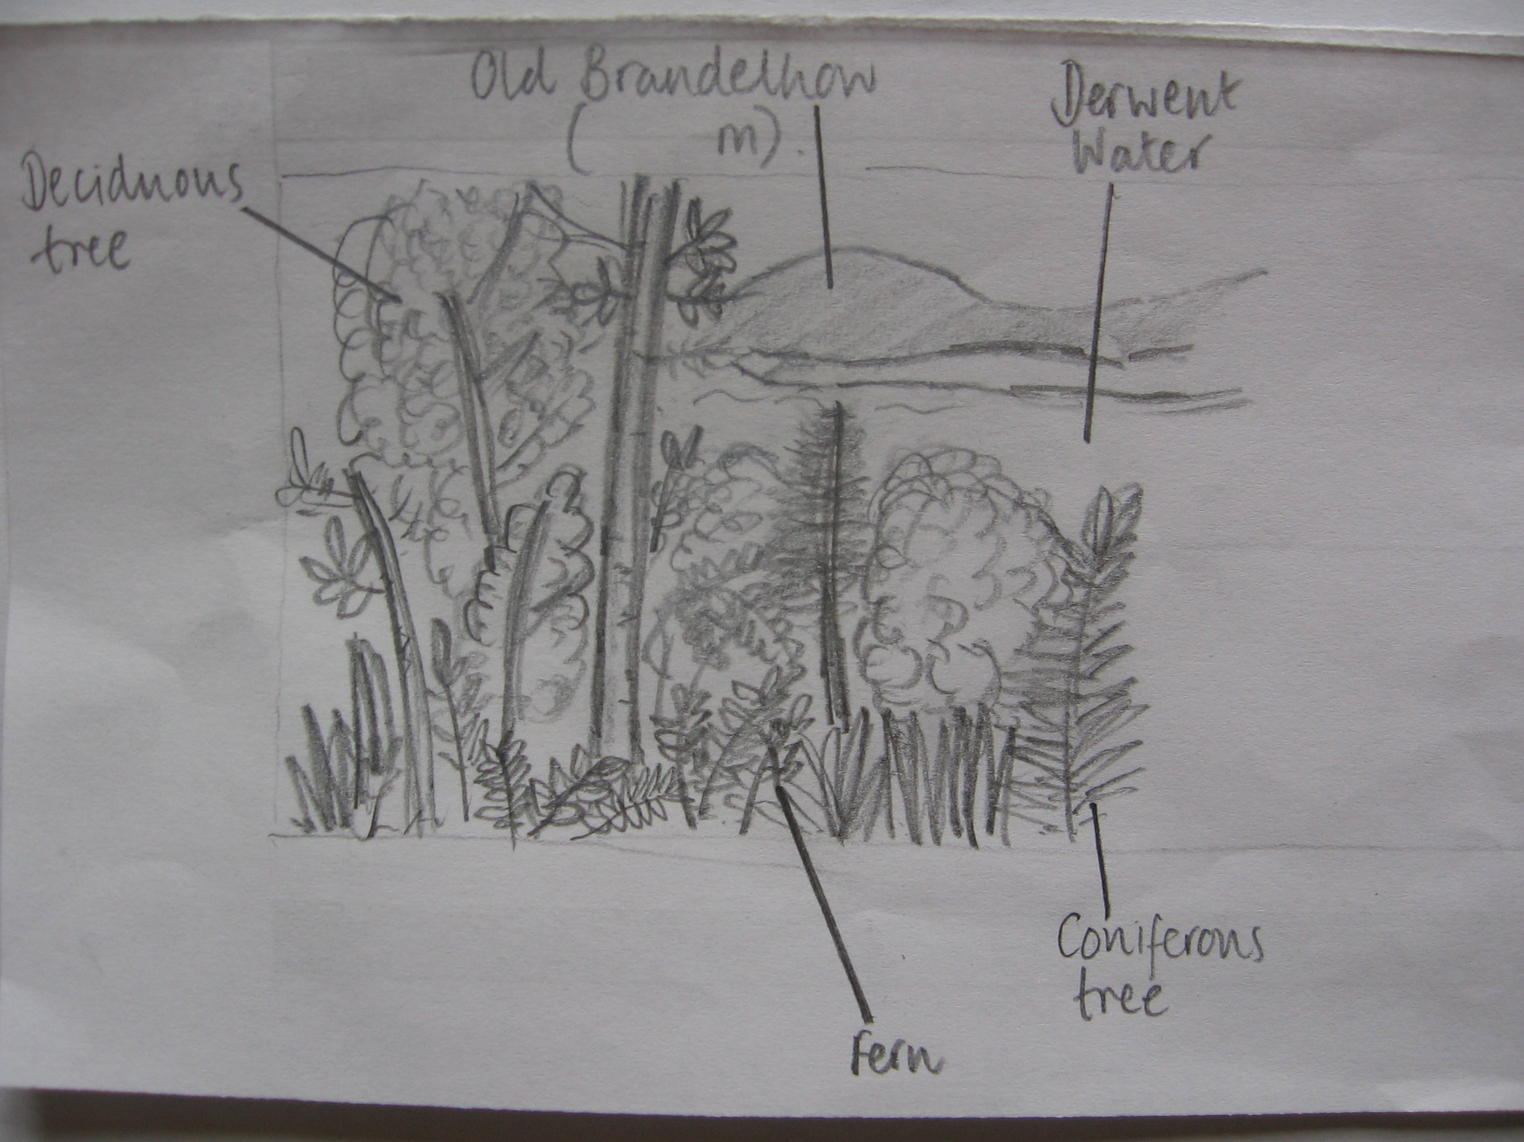

Title: ____________________________________________________________
e) Bi-polar analysis – Environmental evaluation

The table below is called a ‘bi-polar analysis’. In this case, it’s an environmental evaluation which allows you to give positive or negative scores to different aspects of the environment. Once you’ve scored each feature, you can add up your total score for the site. Your teacher will ask you to share your score and talk about your reasons for giving the score.

Location ______________________________

Feature (good) | 5 | 4 | 3 | 2 | 1 | 0 | -1 | -2 | -3 | -4 | -5 | Feature (bad)
Attractive landscape |  |  |  |  |  |  |  |  |  |  |  | Unattractive landscape
Clean fresh air |  |  |  |  |  |  |  |  |  |  |  | Polluted air
Good habitat for wildlife |  |  |  |  |  |  |  |  |  |  |  | Poor habitat for wildlife
Interesting |  |  |  |  |  |  |  |  |  |  |  | Boring
No litter |  |  |  |  |  |  |  |  |  |  |  | Lots of litter
Peaceful and quiet |  |  |  |  |  |  |  |  |  |  |  | Noisy and busy
Built environment suitable for its surroundings |  |  |  |  |  |  |  |  |  |  |  | Built environment not suitable for its surroundings
Column total:

Total landscape score:

f) Analysing images

Your teacher will give you some photographs to look at. They show a woman in the Lake District in the 1980s. Write a caption to go with each photo. Here are some things to think about:

- What do you see in the photographs?
- What do you think the woman is doing there?
- How do you think she feels?
- Why do you think she feels this?

Your teacher will now read you the captions that the woman (Ingrid Pollard) included with her photos.

- Were you correct in your thoughts?
- How do your captions differ to Pollard’s?

Finally, your teacher will read you a famous poem by William Wordsworth about the Lake District. It was written in the early 19th Century.

- How do Wordsworth’s views of the Lake District differ from those of Ingrid Pollard?

Read through your copy of the poem again and underline any

- Descriptions of the place
- Feelings about the place

g) Your turn...

Write your own poem to describe the Great Woods site. Include your own thoughts and feelings about the place. You will have 25 minutes to write your poem.

Use the activities you have just completed to help you – think about the sounds you hear and your observations of what you see.

Think about the type of poem you would like to write – it could be a haiku, an acrostic poem, a rhyme, a sonnet a song or it could even be a rap!

Write your poem in the space on the next page of the booklet. If you finish early, you can decorate it – perhaps using some natural materials (leaves, etc.) as paints…!

h) Final thought shower

Now that you have developed your sense of place at this site, write down three final thoughts about the place in the thought bubbles below. Have your views or feelings changed at all? Why might this be?

SITE 2 – BOWNESS

a) Starter – Thought Shower

Spend a few minutes taking in your surroundings, then write down three initial thoughts about this place in the thought bubbles below. You can include sights, sounds, smells, feelings and emotions – whatever you like!

b) Soundscape

Close your eyes and hold up both fists. Every time you hear a different sound, hold up one finger. Once you’ve heard ten sounds, record them in the table below. Don’t forget to add whether they were human or natural sounds.

Sound | Human/Natural | Sound | Human/Natural

c) Human Camera

Work in pairs to take ‘human photos’ of the landscape. One person should direct the other (who should have their eyes closed) to a viewpoint. The second person now opens their eyes and describes the view they can see. Take it in turns and take two ‘photos’ each: one close up, and one panorama. Now write down two observations and one question about what you’ve seen:

Small-scale | Large-scale

d) Field Sketch

Finish the sketch of Bowness, including human and physical features. Make sure you add some more annotations, on both halves and give your sketch a title!

Title: ___________________________________________________________

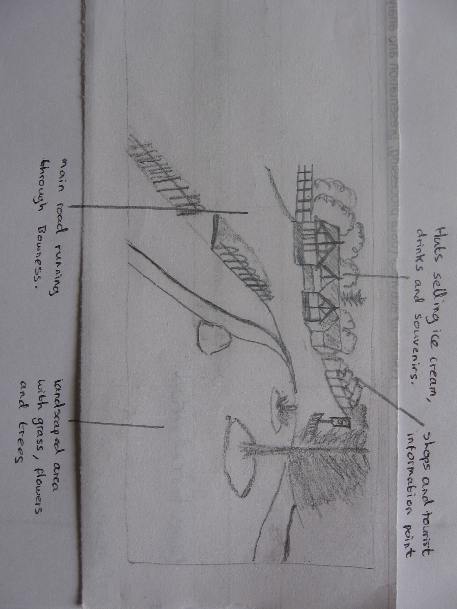

e) Bi-polar analysis – Environmental evaluation

The table below is called a ‘bi-polar analysis’. In this case, it’s an environmental evaluation which allows you to give positive or negative scores to different aspects of the environment. Once you’ve scored each feature, you can add up your total score for the site. Your teacher will ask you to share your score and talk about your reasons for giving the score.

Location ______________________________

Feature (good) | 5 | 4 | 3 | 2 | 1 | 0 | -1 | -2 | -3 | -4 | -5 | Feature (bad)
Attractive landscape |  |  |  |  |  |  |  |  |  |  |  | Unattractive landscape
Clean fresh air |  |  |  |  |  |  |  |  |  |  |  | Polluted air
Good habitat for wildlife |  |  |  |  |  |  |  |  |  |  |  | Poor habitat for wildlife
Interesting |  |  |  |  |  |  |  |  |  |  |  | Boring
No litter |  |  |  |  |  |  |  |  |  |  |  | Lots of litter
Peaceful and quiet |  |  |  |  |  |  |  |  |  |  |  | Noisy and busy
Built environment suitable for its surroundings |  |  |  |  |  |  |  |  |  |  |  | Built environment not suitable for its surroundings
Column total:

Total landscape score:
f) Collage Time!

Collect as many items as you can find that you think represent this place. You will be using them back at school as materials for a collage showing your sense of this place. Try finding leaflets, feathers, leaves and so on. You can also take photos to include in your work.

g) Final thought shower

Now that you have developed your sense of place at this site, write down three final thoughts about the place in the thought bubbles below. Have your views or feelings changed at all? Why might this be?

